GDP  (Australia) | Population (Australia) | Consumer Sentiment Index  (Australia) | CO ₂ -e emissions  (Australia)
$704,169m (+0.7%) | 27,536,874 (+0.53%) | 95.3 (+4.3%) | 452.38m tonnes (2.8%)
GDP  (Victoria) | Population  (Victoria) | Consumer Sentiment Index  (Victoria) | CO ₂ -e emissions  (Victoria)
$173,587m (+1.2%) | 7,053,122 (+0.65%) | 97.0 (+9.2%) | 84.16m tonnes (2.0%)
In the last quarter, Australia's GDP increased by 0.7%. For Victoria, GDP increased by 1.2%. Population was up nationally, and up in Victoria. Consumer sentiment was up across the nation and up in Victoria. Total CO₂-e emissions for the latest quarter increased by 2.8% in Australia and increased by 2.0% for Victoria.
ECONOMY PEOPLE COMMUNITY ENVIRONMENT
Merri-bek City Council

JOB IMPACT
Net Positive
Estimated Impact on FTEs

Impact of Change in Total Local Spend

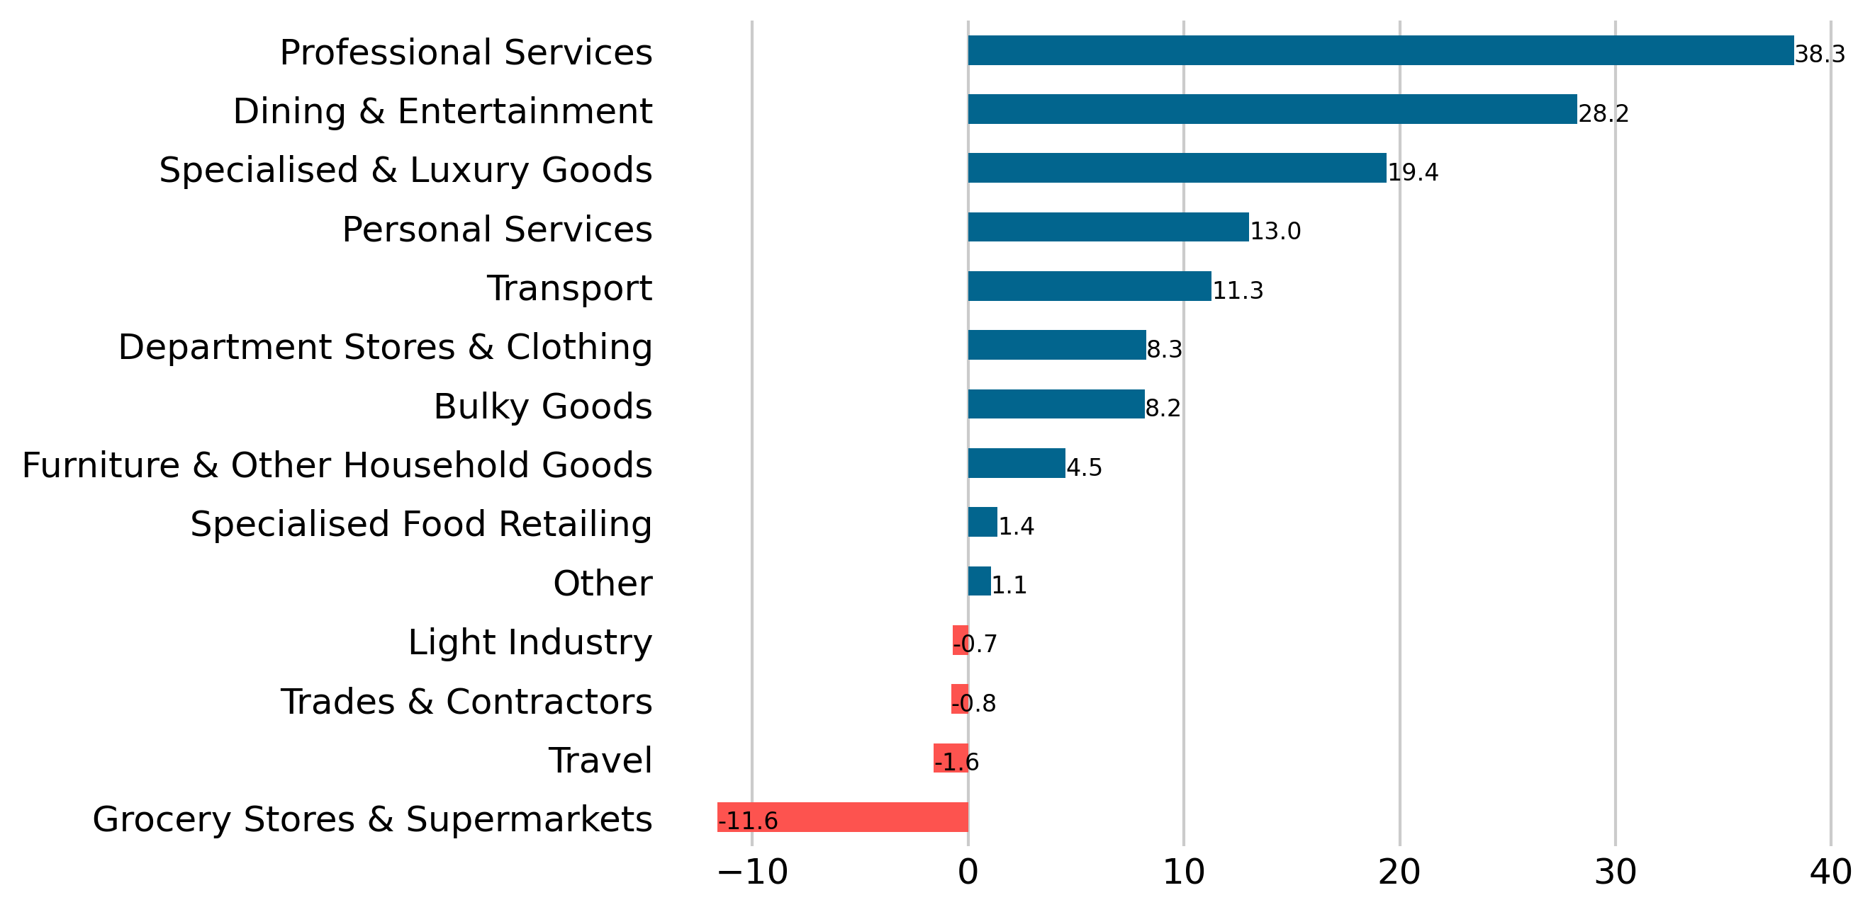
Largest Increase 38.3 FTEs, Professional Services
Largest Decrease -11.6 FTEs, Grocery Stores and Supermarkets

CONSUMER EXPENDITURE
Trending Flat
Trend
Change in Total Local Spend
Daily Spending
Average Daily Spend by Day of Week
Peak Day Saturday 06 September 2025: $8.68M
Trough Day Sunday 13 July 2025: $5.01M

Quarterly Economic Snapshot

Victoria | Moreland
0.5% | 2.6%

Day | Total | Resident | Visitor
Mon | $5.91M (+7.1%) | $2.65M (+5.3%) | $3.13M (+8.1%)
Tue | $5.81M (-0.6%) | $2.54M (-0.7%) | $3.14M (-1.2%)
Wed | $6.1M (-1.9%) | $2.63M (-3.0%) | $3.32M (-1.5%)
Thu | $6.57M (-3.6%) | $2.85M (-5.4%) | $3.59M (-1.3%)
Fri | $7.38M (+7.6%) | $3.27M (+7.2%) | $4M (+9.0%)
Sat | $8.03M (+1.3%) | $3.43M (-1.5%) | $4.48M (+3.2%)
Sun | $5.64M (+2.6%) | $2.68M (+3.0%) | $2.92M (+2.2%)
Jul-25 to Sep-25


Sources: ABS Quarterly Population Estimates (ERP); ABS Australian National Accounts: National Income, Expenditure and Product,
ABS Census 2021; Spendmapp.com.au, Australia's National Greenhouse Accounts
SELF-SUFFICIENCY
Low

WALLET SHARE
Going online

Merri-bek City Council
The Commuter Effect

Escape Spend and Commuting

Share of Resident Wallet

Latest and Previous Quarter

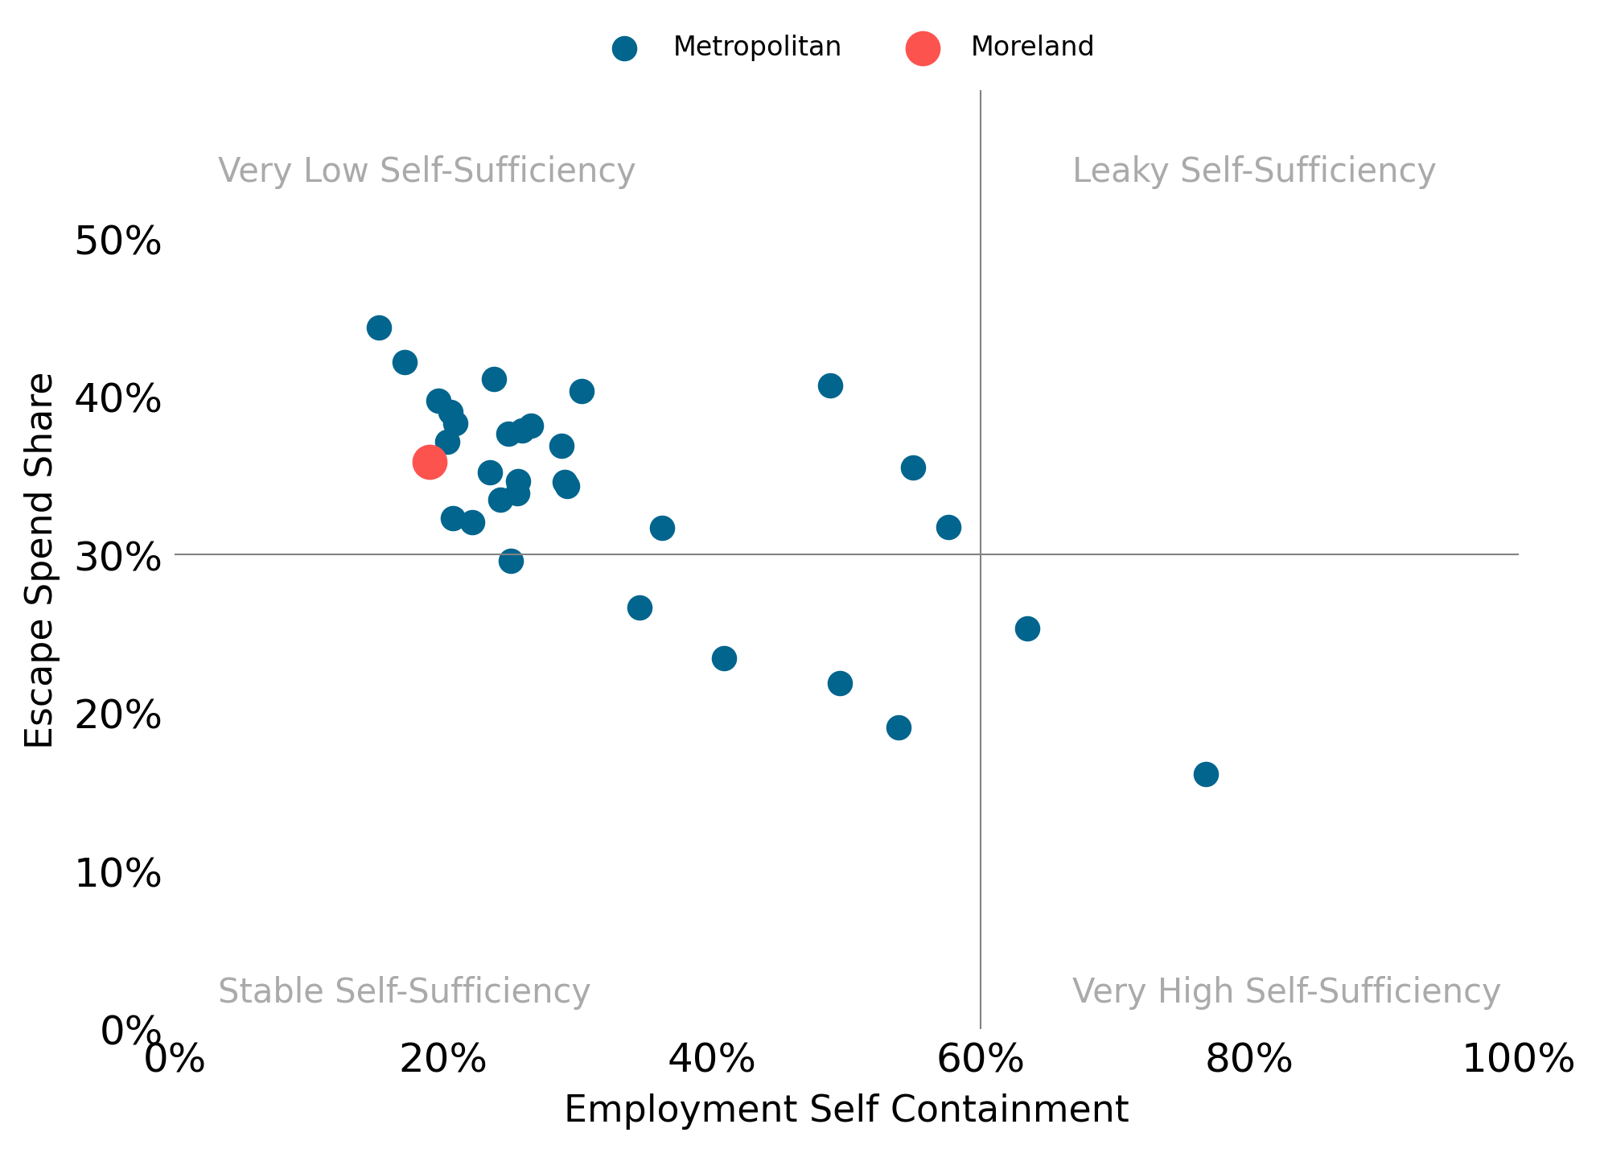
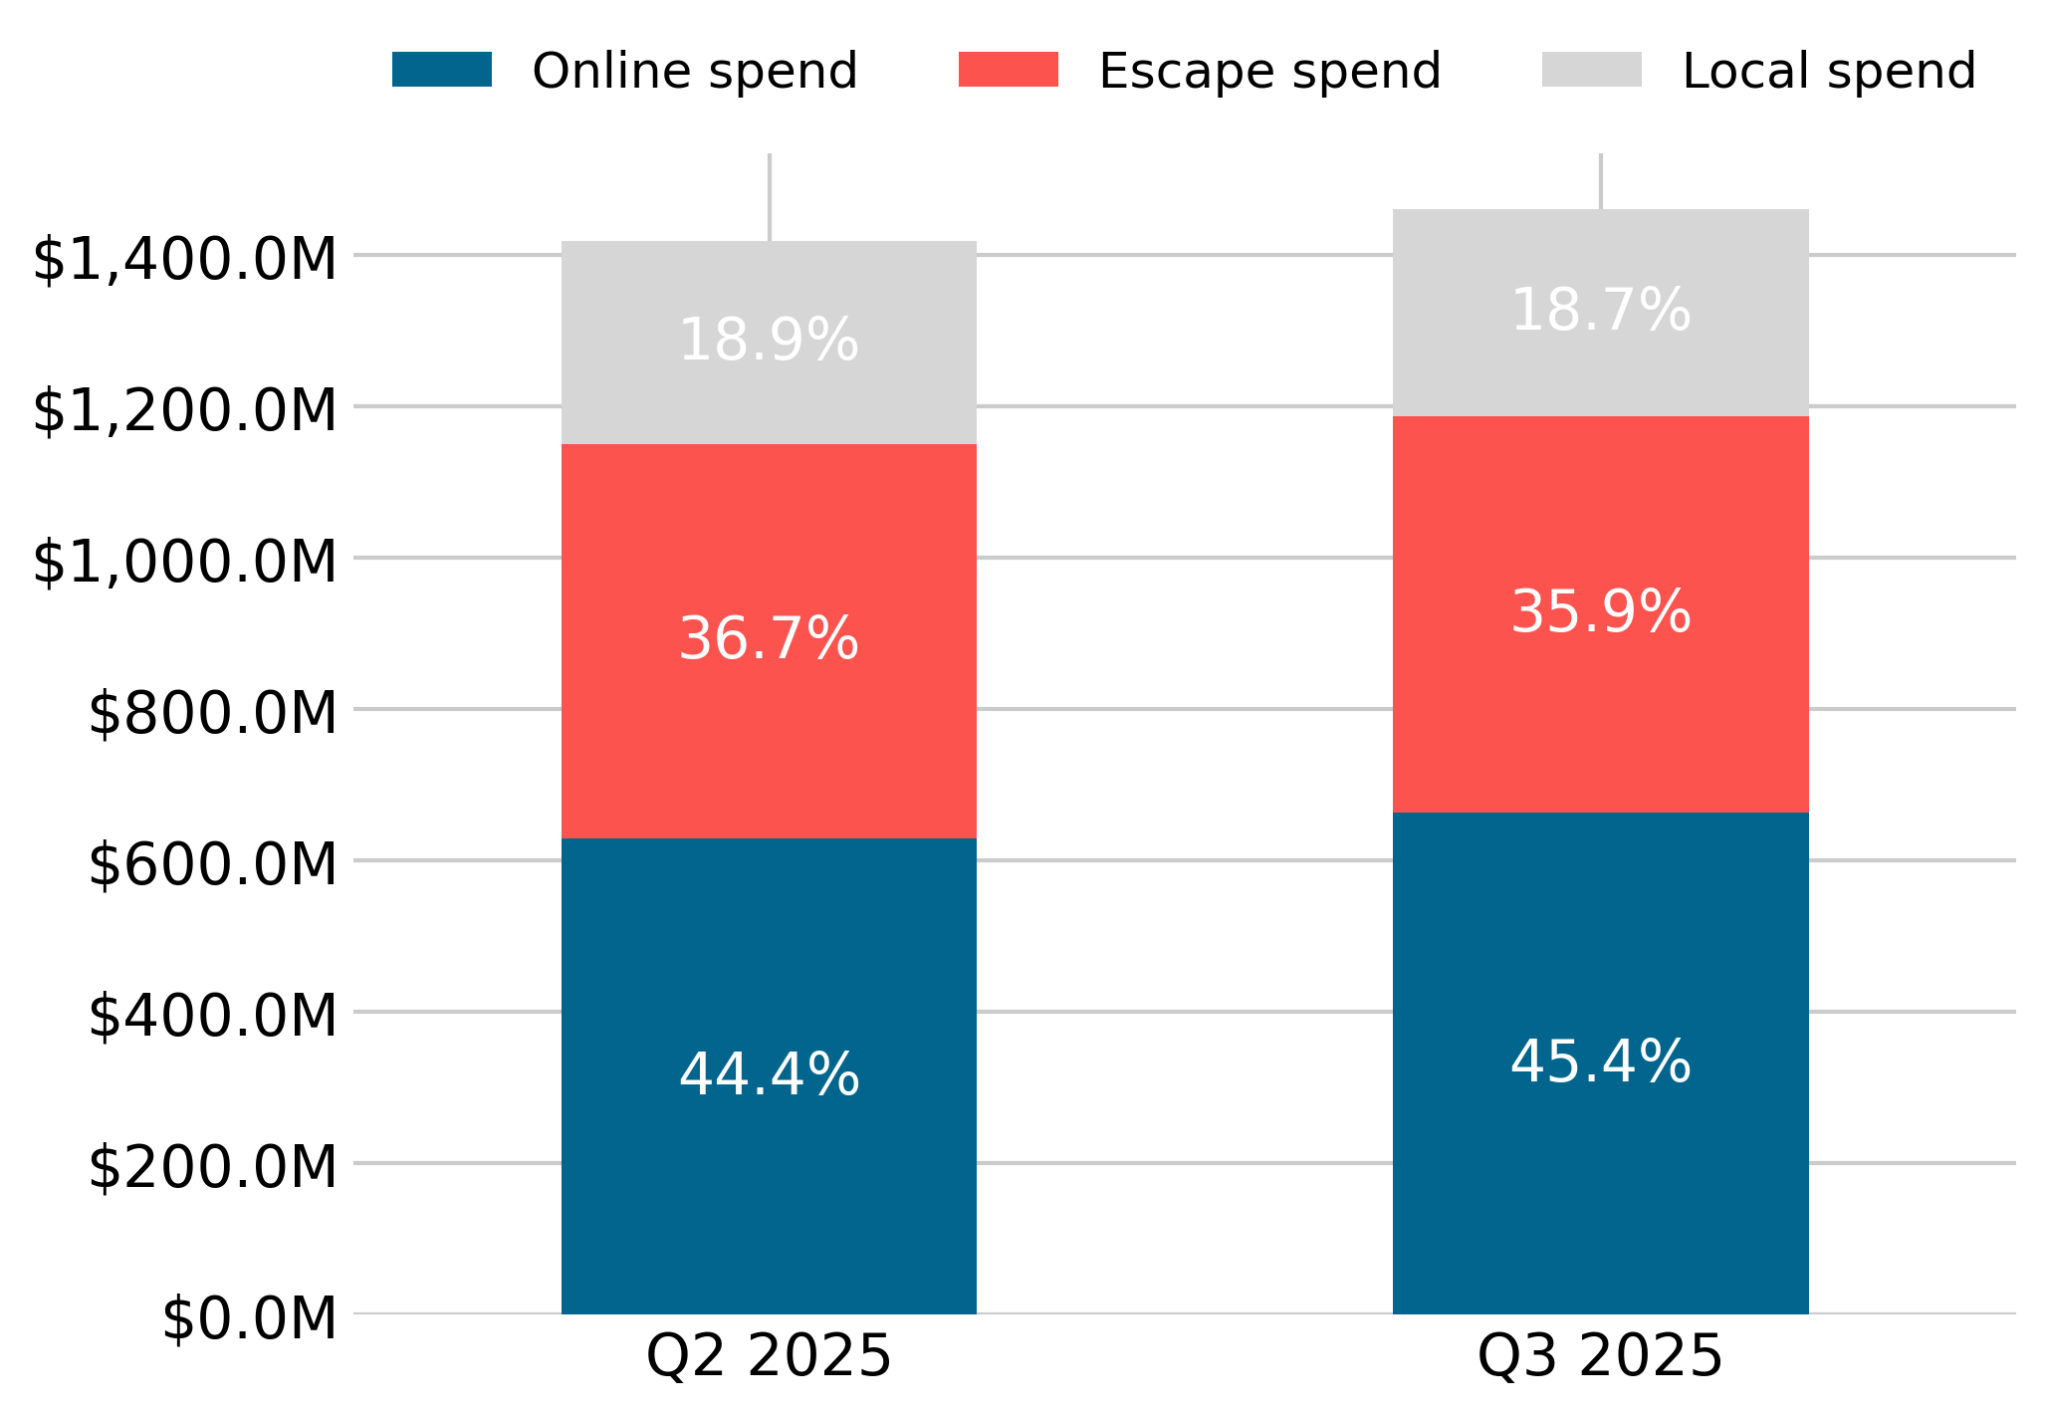

Quarterly Economic Snapshot

Spend | Victoria | Moreland
Local Spend | -0.7% | -0.2%
Escape Spend | -0.3% | -0.9%
Online Spend | +1.0% | +1.0%
Jul-25 to Sep-25
Compared with the previous quarter, in Q3 2025:
- Moreland saw more online spend as a share of Resident Wallet; and
- Online spend in Victoria saw the greatest increase in share.

Compared with other Metropolitan councils, in Moreland:
- There is leaky economic self-sufficiency.
- There is low employment self-containment (based on the last Census).
- Resident Escape Spend has a high share of Resident Wallet.

Disclaimer
This document has been prepared by Geografia Pty Ltd for Merri-bek City Council and is intended for its use only. Any use of material from the report should be appropriately cited (i.e. source: Spendmapp by Geografia). While every effort is made to provide accurate and complete information, Geografia does not warrant or represent that the information contained is free from errors or omissions and accepts no responsibility for any loss, damage, cost or expense (whether direct or indirect) incurred as a result of a person taking action in respect to any representation, statement, or advice referred to in this report.

Change in Resident Wallet Share
Trend

