GDP  (Australia) | Population (Australia) | Consumer Sentiment Index (Australia) | CO ₂ -e emissions  (Australia)
$643,563m (+2.1%) | 26,124,814 (+1.64%) | 91.3 (-2.2%) | 464.77m tonnes (-6.0%)
GDP  (Victoria) | Population  (Victoria) | Consumer Sentiment Index  (Victoria) | CO ₂ -e emissions  (Victoria)
$151,018m (+1.8%) | 6,656,281 (+1.68%) | 88.8 (-3.4%) | 80.06m tonnes (-3.8%)
In the last quarter, Australia's GDP increased by 2.1%. For Victoria, GDP increased by 1.8%. Population was up nationally, and up in Victoria. Consumer sentiment was down across the nation and down in Victoria. Total CO₂-e emissions for the latest quarter decreased by -6.0% in Australia and decreased by -3.8% for Victoria.
ECONOMY PEOPLE COMMUNITY ENVIRONMENT
Merri-bek City Council

CONSUMER EXPENDITURE
Trending Flat
Trend
Change in Total Local Spend
Daily Spending
Average Daily Spend by Day of Week
Peak Day Thursday 17 April 2025: $9.23M
Trough Day Friday 18 April 2025: $3.21M
JOB IMPACT
Net Positive
Estimated Impact on FTEs

Impact of Change in Total Local Spend

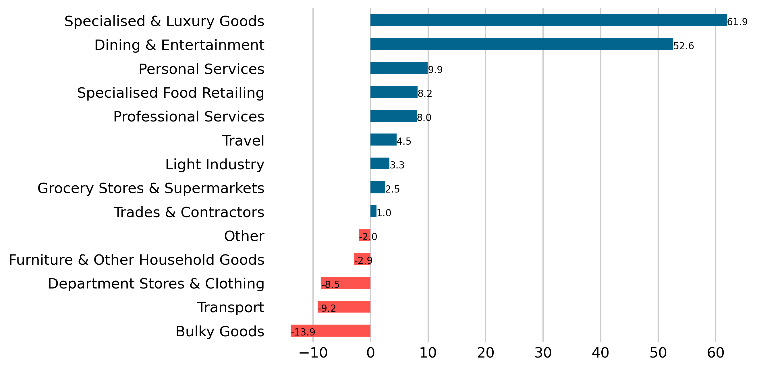
Largest Increase 61.9 FTEs, Specialised and Luxury Goods
Largest Decrease -13.9 FTEs, Bulky Goods

Quarterly Economic Snapshot

Victoria | Moreland
1.5% | 2.0%

Day | Total | Resident | Visitor
Mon | $5.51M (-1.0%) | $2.52M (-2.2%) | $2.9M (+0.5%)
Tue | $5.84M (-3.0%) | $2.55M (-4.9%) | $3.18M (-1.4%)
Wed | $6.22M (+4.6%) | $2.71M (+2.8%) | $3.37M (+6.1%)
Thu | $6.82M (+5.6%) | $3.01M (+5.0%) | $3.64M (+5.4%)
Fri | $6.86M (-7.4%) | $3.05M (-7.6%) | $3.67M (-7.3%)
Sat | $7.93M (+4.9%) | $3.48M (+3.2%) | $4.35M (+7.1%)
Sun | $5.49M (+2.5%) | $2.61M (+1.8%) | $2.85M (+3.9%)
Apr-25 to Jun-25

Sources: ABS, Cat. Nos. 3101.052, 5206.001, 5206.027; ABS Census 2016; Spendmapp.com.au; industry.gov.au; DISER, 2020
SELF-SUFFICIENCY
Low

WALLET SHARE
Going online

Merri-bek City Council
The Commuter Effect

Escape Spend and Commuting

Share of Resident Wallet

Latest and Previous Quarter

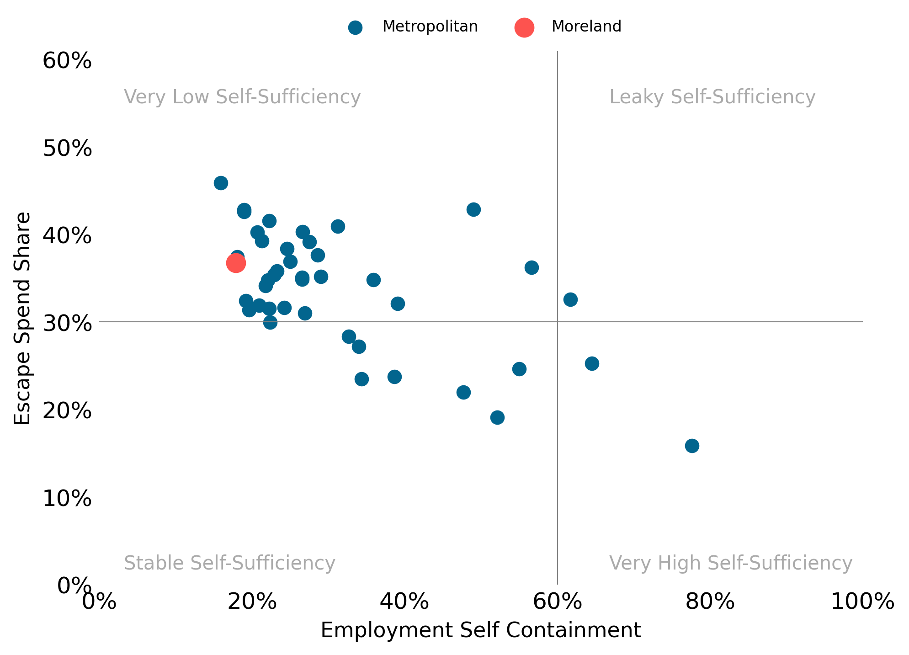
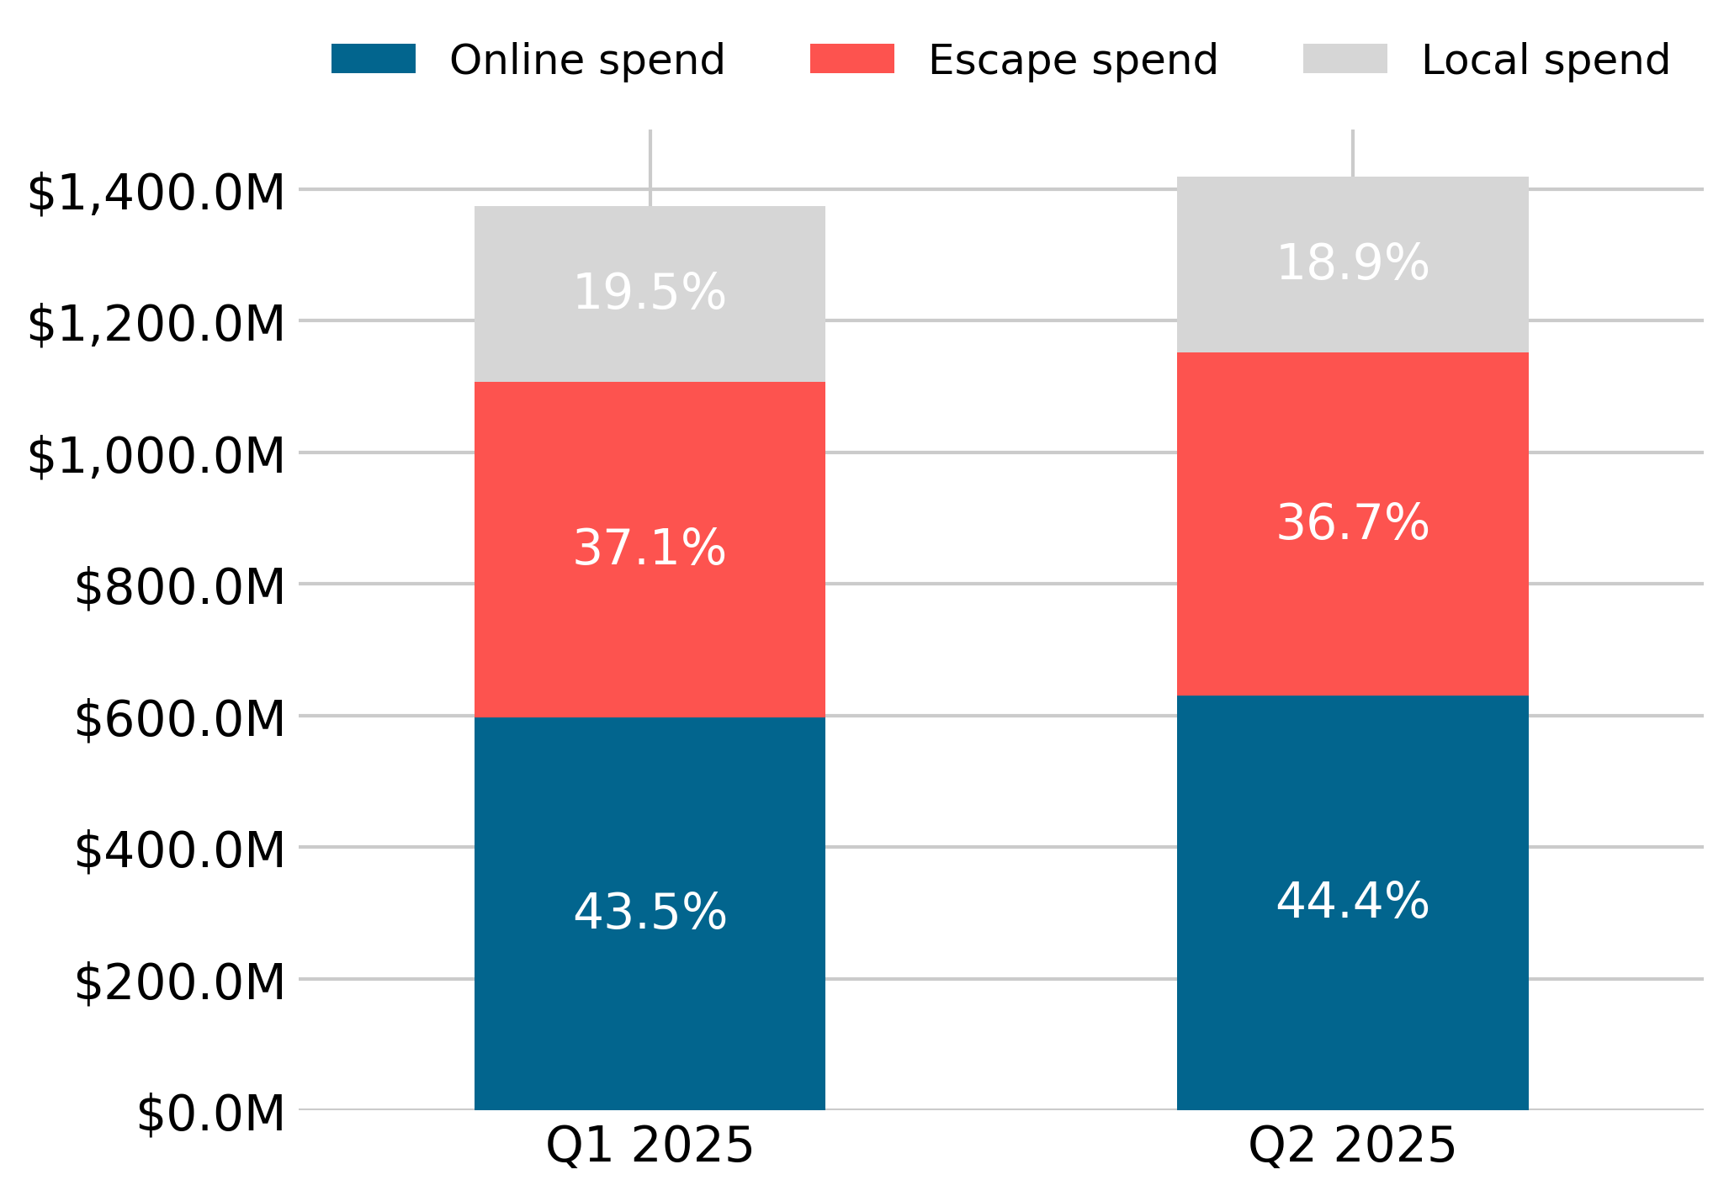

Quarterly Economic Snapshot
Spend | Victoria | Moreland
Local Spend | -0.5% | -0.6%
Escape Spend | -0.1% | -0.3%
Online Spend | +0.6% | +0.9%
Apr-25 to Jun-25
Compared with the previous quarter, in Q2 2025:
- Moreland saw more online spend as a share of Resident Wallet; and
- Online spend in Victoria saw the greatest increase in share.

Compared with other Metropolitan councils, in Moreland:
- There is leaky economic self-sufficiency.
- There is low employment self-containment (based on the last Census).
- Resident Escape Spend has a high share of Resident Wallet.

Change in Resident Wallet Share
Trend
Disclaimer
This document has been prepared by Geografia Pty Ltd for Merri-bek City Council and is intended for its use only. Any use of material from the report should be appropriately cited (i.e. source: Spendmapp by Geografia). While every effort is made to provide accurate and complete information, Geografia does not warrant or represent that the information contained is free from errors or omissions and accepts no responsibility for any loss, damage, cost or expense (whether direct or indirect) incurred as a result of a person taking action in respect to any representation, statement, or advice referred to in this report.

