APPENDIX B

BACKGROUND DOCUMENT REVIEW
Edgars Creek Conservation and Development Plan
Edwardes Lake to Merri Creek

1. STRATEGIC DOCUMENTS

1.1 Moreland Open Space Strategy, Moreland City Council, Adopted 2012

The purpose of the Open Space Strategy is to "provide Moreland City Council with the priorities for public open space so that it can plan and develop its open space to preserve and enhance its environmental values and provide for community needs."

The central purposes of the Strategy are to:
- Understand supply and demand for open spaces
- To identify deficiencies
- To secure appropriate additional open space where possible
- To protect existing open space and its values
- To improve its quality through better planning and management

The Strategy also identifies that "Moreland's waterways are the distinctive natural feature of the municipality, requiring consideration as to how these can be protected as an important natural resource, whilst providing important opportunities for community recreation."

The Strategy identifies seven key goals when providing recommendations for issues arising in the Strategy, including:
- Providing parks close to home
- Having a mix of open space types and experiences
- Balancing use with protection of natural values along waterways.
- A greener more liveable Moreland
- Making the most of open space through effective management
- Enhancing participation and use of open space
- Developing a network of shared trails

The Strategy identifies most of the Edgars Creek open space corridor as District Open Space and Linear Reserves and the reach between Kodak Bridge and Livingstone Street as Local Open Space. Edgars Creek provides the major bushland open space in the suburb of Coburg and functions primarily as a Conservation (Flora and Fauna) area, with Sport function on the floodplain adjoining Golf Road and at the athletics track. The former VicRoads land has no identified function. The whole of the creek open space corridor is identified as a priority area requiring master planning.

Actions in the Strategy that apply to the Edgars Creek Open Space corridor include:
- Develop a strategic works program for waterway revegetation for Edgars, Merlynston and Westbreen Creeks, in conjunction with the Creek Management Bodies, Friends Groups and Melbourne Water
- Prepare a conservation and development plan for Edgars Creek identifying appropriate recreational opportunities along its reaches and including the reclamation and revitalisation of natural areas along Edgars Creek. Investigate and provide opportunities to improve access for use and maintenance of the area, particularly on the eastern bank behind the industrial estate
- As opportunities arise, acquire land to create a vegetated buffer of a minimum 30 metres wide measured from the edge of the embankment on each side of the creek corridor along Merri Creek, Moonee Ponds Creek, and Edgars Creek (where possible). A minimum of 50 metres wide from the creek edge on each side should be sought to create a public open space corridor
- Negotiate with owners of other authority land that Council maintains as public open space, to ensure appropriate zoning and designation of land as public open space and/or transfer management to Council, for example: land along Edgars Creek, Coburg North and Outlook Drive, Glenroy.
The Strategy assumes that the following principles will be upheld in the planning and development of all open spaces in Moreland:
Conservation and environmental sustainability
- Protection and active management of all remnant indigenous vegetation sites as irreplaceable natural heritage assets.
- Conservation and interpretation of places of cultural and archaeological heritage
- Sustainable planting and landscape design reflecting site context, water sensitive urban design, landscape character, functional requirements, and/or specific design features.
- The utilization of up-to-date, sustainable environmental design in open space management.
Access and inclusion
- Consultation with park users and adjacent residents as part of the planning and design process for all substantial open space development and projects.
- Inclusion of people with a wide range of ages, cultural backgrounds and abilities through open space design and development.
- Movement between and through open spaces for walking, cycling, fauna, and surrounding municipality's networks.
- Design and maintenance of open space that will provide a high degree of security for users.
- Allocation of resources for equitable distribution, development and maintenance of open space, and for a range of uses.
- Promotes sharing of open space rather than exclusive use by a user group or commercial activity.
- Maintain and improve open space to manage the increasing demand for open space from population growth, increasing housing densities, building heights and the loss of private open space.
Acquisition and disposal and alienation of open space
- Open space should be protected from overshadowing, encroachment by non-recreational and support infrastructure, including car parks and signs, and development that restricts public access or surveillance.
- Acquisition of land for public open space may be required: in areas of identified need; for local parks; in activity centre areas; to create access to existing parks, or to consolidate or extend open space corridors.
- Prior to disposal of open space there will be a comprehensive assessment of existing and potential use and value of the space.
- Proceeds from any sale of public open space will be used for open space development or acquisition.

1.2 Darebin Open Space Strategy 2007-12, Darebin City Council, 2007

The Darebin Open Space Strategy 2007-12 is a review of the previous strategy prepared in 2000. The review of the Strategy was conducted to consider key emerging issues including:
- Implications of the State Government planning framework: Melbourne 2030 and provision of open space in areas of increasing residential density. In particular the identified Activity Centres of Preston, Northcote and Reservoir anticipate an increase in residents in established areas where backyard sizes are decreasing as a result of subdivision and demands for open space within these communities is increasing.
- Climate change and the potential impacts of reduced rainfall in conjunction with higher temperatures.
- Development of criteria to assess open space provision and consider future acquisition and disposal of open space.

The Strategy notes that the vision for the next ten years for open space in the City of Darebin is:
"A well connected network of accessible open spaces that meets the diverse needs of the community and provides a range of social and environmental benefits."

This vision is to be achieved through the following key principles:
- The enhancement of the open space network will achieve a range of social, environmental and community aspirations.
- Distribution of parks will ensure that residents have access within their local neighbourhood.
- Across the open space system, accessibility for a range of abilities and disabilities will be achieved.
- A diverse range of open spaces throughout the City of Darebin will offer outdoor recreation opportunities for all sectors of the community.
- The community values open space that is appropriately maintained in accordance with its category and its associated uses.
- It is important that open space meets the changing needs of communities as population grows and trends change.
- Linkages and linear parks enhance the open space network and provide valuable connections.
- Management and maintenance practices for open space will respond to the issues arising from climate change and the need for alternate water sources.
- High level of public awareness and involvement will maximise use and engagement by the community in the open space network.
- Restoration and rehabilitation of the creek corridors will ensure that environmental values are preserved for future generations.
- Council is committed to high standards of master planning, landscape outcomes, conservation of natural and cultural heritage and presentation of open space.
- Affordable and achievable maintenance will ensure that the provision of open space is sustainable into the future.

The Edgars Creek Corridor between Edwardes Street and Jenkins Street in Reservoir West (11.78ha) is identified in the Strategy as a Neighbourhood Park level and classified as Conservation Parkland.

The actions identified in the Works Program relating to Edgars Creek include:
- Investigate the opportunities for the establishment of a continuous publicly owned corridor for ecological and recreational values along the Merri, Darebin and Edgars Creeks.
- Prepare and implement an Interpretations Strategy to explain natural and cultural features to open space users via a range of means, of communication, with a focus on Bundoora Park and the creeks.
- Continue to develop annual works programs in conjunction with the management bodies for each waterway, and Melbourne Water.
- Review land ownership in the creek corridors to ensure there is a continuous ecological and recreation corridor.
- Implement the Weed Control Program along waterway corridors and in general parkland.
- Undertake a review of all linear reserves to determine viability for recreational use. Prepare a linear reserves master plan to ensure that recreation opportunities and landscape amenity are provided for.
- Connect Edwardes Lake with Merri Creek by trail, in co-operation with Moreland City Council. Continue development of a shared footway and green corridor along Edgars Creek between Edwardes lake Park and Mahoneys Road.

1.3 Merri Creek and Environs Strategy, 2009 - 2014

The intent of this Strategy is to provide direction to the managers of the waterway corridors of the Merri catchment, which includes the Merri Creek and its tributaries flowing from the Great Dividing Range through to the northern suburbs of Melbourne. Edgars Creek is one of the nine major tributary systems that flow into the Merri Creek.

The key goals for the Merri Catchment in the Environs Strategy include:
- Water goal - Sustainable water use and healthy waterways, wetlands, estuaries, coasts and bays.
- Land goal - Healthy land used appropriately and productively.
- Biodiversity goal - Healthy and enduring ecosystems with a diversity of habitats and native species.
- People goal - The community valuing, understanding and celebrating the region's catchment assets and working to achieve sustainability.
The Strategy notes that the vision for the Merri catchment waterway corridors is:
"To achieve healthy living streams flowing through the attractive environments which provide habitat for native animals and are valued by the community as peaceful, passive open space havens. To protect the natural and cultural features of the Merri catchment waterway corridors through sensitive management which will provide a lasting benefit for the community."

Actions in the Strategy that apply to the Edgars Creek Open Space corridor include:
- Prepare Development or Management Plans as required for development or consolidation of open space at the following primary nodal points where land use is not an issue, or following the resolution of such issues and those of land ownership (if applicable): Edgars Creek, north of the Merri confluence to the ex-Kodak bridge.
- Develop agreements to provide access through the following sites, or secure their whole or partial tenure for an open space, conservation or urban floodway function by clarification of ownership and planning anomalies at the time of review of Planning Schemes, development of appropriate zoning, negotiation with owners at the time of rezoning or through land purchases: West bank Edgars Creek – Murray Road upstream to the ex-Kodak land, Coburg.
- Develop detailed plans for public access along Edgars Creek, including trail link from Merri Creek to Edwardes Lake.
- Following detailed plan development, construct trail link from Merri Creek along Edgars Creek to Edwardes Lake.

1.4 Moreland Indigenous Vegetation Assessment Final Report, Merri Creek Management Committee, 2012

This report was commissioned by Moreland City Council in February 2010 as an update to the 1998 Moreland Remnant Vegetation Assessment. A total of 351 patches of remnant vegetation were surveyed, including the 330 patches of already identified in the 1998 report. Of the 171 ha or remnant vegetation in Moreland in 1998, the latest survey indicated that only 141 ha remain and these are moderately to severely degraded. The report assesses the quality and significance of each remnant patch, and includes the list of species identified as well as areas of revegetation. The greatest threat to remnant vegetation in Moreland is weed invasion and the report identified 8 weed species as having the highest priority for control and another 39 species as being of high priority.

The recommendations made in report are categorized under 6 main goals including:
- Goal 1: Improve the connectivity and long-term security of indigenous habitats and species
- Goal 2: Maintain the diversity of indigenous habitats and species in terrestrial, aquatic and marine environments
- Goal 3: Achieve sustainable populations of indigenous flora and fauna species
- Goal 4: Achieve a net gain in the quantity and quality of indigenous vegetation
- Goal 5: Increase the capacity and participation of people and organizations in catchment management
- Goal 6: Seek continuous improvement in the planning and management of indigenous vegetation by Council and other agencies in Moreland

The recommendations specific to Edgars Creek include:
- Continue the management of the Edgars Creek corridor from Merri Creek to Kodak Bridge (site 412 in the report) and expand on the revegetation plots to enhance connectivity between patched of endangered EVCs within this reach.
- From the Kodak Bridge to the northern council boundary at Carrington Road (site 413 in the report), the site is identified in the report as an important part of the regional-scale Edgars Creek Corridor.

1.5 Darebin Draft Natural Heritage Plan, 2011

The National Heritage Plan was prepared as part of the overall Darebin Heritage Study prepared by Context Pty Ltd for Darebin City Council.

The aims of the Darebin Heritage Study include:
- Assess, document and protect sites of cultural heritage as well as natural heritage and pre-European contact Koori heritage over the entire municipality.
- Develop a framework (Heritage Plan) for the protection of important natural and cultural heritage places and the proactive management and sustainable use of heritage assets.
- Provide detailed statutory implementation recommendations.
- Ensure that the Heritage Study takes a holistic approach to the assessment of significance.

The aims of the Natural Heritage Plan include:
- Assess and document the areas identified as being significant through preparation of Statements of Significance.
- Where possible relate the Statements of Significance to the Thematic Environmental History.
- Undertake community consultation with relevant individuals, bodies and organizations regarding places of natural heritage.
- Prepare a heritage plan incorporating recommendations for the conservations of the municipality’s natural heritage.
- Prepare recommendations for statutory protection and draft appropriate statutory controls for inclusion in the Darebin Planning Scheme.

The Study identifies the following recommendations for the Edgars Creek corridor from Kia Ora Road to Carrington Road/Jenkin Street:
- Rezone the inappropriately zoned parts of the site to PPRZ and establish an ESO over the entire site (consistent with the ESO downstream) and adjacent properties.
- Protect the geological site from disturbance (e.g. channel modification works) and ensure that rubbish and graffiti are removed. Ensure vegetation on the outcrops is managed appropriately – retention of indigenous species, but weed control, especially Kikuyu would be appropriate. Avoid landscaping that would obscure the outcrops.
- Close the unused ends of the Kia Ora and Kingsley Road reserves and rezone to PPRZ.
The Study identifies the following recommendations for the Edgars Creek corridor from Henty Street to Kia Ora Road:
- Investigate rezoning the whole site to PPRZ.
- Investigate closure of the unused parts of Dromana Avenue and Gumbrae Street.
- Establish an Environmental Significance Overlay over the whole site and adjacent properties.
The Study identifies the following recommendations for the Edgars Creek corridor from Edwardes Street to Henty Street:
- Establish an Environmental Significance Overlay over the whole site, the pub and the first row of houses on the east side of the creek.
- Investigate land acquisition of the unoccupied parts of the site or at least an additional width along the west side of the creek.
- Investigate rezoning the PUZ1 land to PPRZ.

1.6 Three Year Habitat Restoration Strategic Plan 2012 -2014, Friends of Edgars Creek, 2012

The Friends of Edgars Creek (FoEC) was established in 2006 and has completed significant restoration works along the creek between Edwardes Lake and its confluence at Merri Creek. This section of the creek remains largely intact, except for bank stabilization work in completed by Melbourne Water in some areas, and is a reminder of how the creek once was before urbanisation.

The vision of the Friends of Edgars Creek for this plan is:
"Our vision is the ongoing management and enhancement of Edgars Creek, between Edwardes Lake and its confluence with the Merri Creek in a manner consistent with the informal and secluded bushland nature of this reserve area, in a manner sympathetic to its unique geology, indigenous biodiversity and the local community."

The objectives in the plan the Strategic Plan include:
- Establish resilient ecological vegetation class (EVC) habitat areas by consolidating restoration effort in a limited number of areas.
- Increase biodiversity by establishing a range of ecological vegetation class (EVC) projects indigenous to the area.
- Protect remnant vegetation by focusing restoration project areas around significant remnant specimens or communities.
- Link fragmented habitat areas by 'growing out' project areas over time.
- Improve the landscape values associated with significant geological landforms, particularly those identified in Victoria's Resources Atlas.
- Reduce the impact of urban development on the 'secluded bushland character' of the creek reserve through appropriate 'buffer' planting.
- Maximise the effectiveness of maintenance through intensive, localized effort to reduce the impact of invasive weeds and pests.
- Sustain local community involvement through self management, education to build capacity for 'knowledge' custodianship and targeted complementary land management agency support.

Six project sites have been identified for restoration and establishment of viable, self supporting habitats. The sites and their respective habitat restoration objectives include:

Confluence of Edgars and Merri Creek
- The Friends of Edgars Creek have established a cluster of 'tree custodian' planting at the site.
- EVC 654 Creekline Tussock Grassland immediately adjacent to the confluence.
- EVC 851 Stream-bank Shrubland on the rocky banks and beds of the creek which has cut deeply into the plain.
Waterfall area
- Location of the regionally significant Edgars Creek waterfall and exposed Silurian escarpments.
- The FoEC has established significant areas of ecological vegetation class habitat on both sides of the creek since 2006 and have recovered indigenous rock from the M9 water main replacement for use in future landscaping works.
- EVC 654 Creekline Tussock Grassland at the base of the rocky escarpment immediately below the waterfall on the east bank.
- EVC 851 Stream-bank Shrubland on the west banks.
- EVC 895 Escarpment Shrubland generally associated with steep embankments beside watercourses in low rainfall areas, e.g. along the south side of the Ronald Street footpath and adjacent to the waterfall, east side.
Gooseneck Meander Area
- Works have been undertaken by the FoEC since 2007 to restore and maintain stream-bank shrubland and Creekline tussock grassland along the regionally significant gooseneck meander of the creek.
- EVC 654 Creekline Tussock Grassland on the inner bend of the meander (west side).
- EVC 851 Stream-bank Shrubland along the rocky banks and beds of the creek.
- EVC 895 Escarpment Shrubland along the west side of the creek that rises steeply from the floodplain.
Silurian Cliff Area
- Regionally significant exposed Silurian cliff adjacent to the former Kodak site.
- Seven remnant species identified in the area, including Eucalyptus leucoxylon ssp connate which is the only remnant specimen found in Moreland. A mature River Red Gum is also located at the base of the cliff.
- Works have been undertaken by the FoEC since 2009 to establish EVC 654 Creekline Tussock Grassland immediately below the Silurian cliff, EVC 851 Stream-bank Shrubland along the rocky banks and beds of the creek, EVC 56 Floodplain Riparian Woodland upstream along the western bank of the creek and EVC 895 along the west side of the creek that rises steeply from the floodplain.
Plains Grassy Woodland Hilltop Area
- Elevated hilltop with views across the creek and to the city of Melbourne.
- EVC 55 Plains Grassy (She-Oak) Woodland on the hilltop, around an existing ephemeral wetland.
Caravan Park Area
- An area with a number of identified significant remnant specimens including River Red Gum, Yellow Box and Sweet Bursaria.
- The area is infested with weeds and works to restore EVC 56 Floodplain Riparian Woodland, EVC 641 Riparian Woodland and EVC 895 Escarpment Shrubland will be critical in ensuring the integrity of the pocket of remnant vegetation.

1.7 The Merri Creek – Sites of Geological & Geomorphological Significance, Neville Rosengren, 1993

This study identifies sites of geological and geomorphological significance in a corridor of variable width along the Merri Creek valley which traverses Whittlesea, Broadmeadows, Preston, Coburg, Northcote, Brunswick and Collingwood. The study includes tributaries to Merri Creek, including Edgars Creek from its source in Whittlesea to its confluence point with Merri Creek in Coburg. Although much of the area studied has been greatly modified by the impact of European settlement, a variety of authentic geological features are displayed. As many of these are safely accessible to the public, the study identifies that there are opportunities for geological education and interpretation. A total of 38 sites are identified as significant, of which four sites are significant at the State level, 16 at the Regional level and 18 at the Local level.

Four sites of significance are located along Edgars Creek including:
- The Edgars Creek Terrace and Meanders (Goose-Neck), located adjacent to the floodplain between Outlook Drive and Ronald Street. The study identifies the meandering channel as having Local significance as it is a clear example of a confined floodplain and the meander forming at the site is a natural process which illustrates the method by which alluvium is transported and stored in stream channels.
The study recommends that some meander bends be allowed to erode as a natural process to illustrate the natural cross sections of older and more recent alluvium. Any new facilities are to accommodate channel changes. (Refer site 14 in the Rosengren Report 1993).
- The Edgars Creek Waterfall and geological structure located immediately south of Ronald Street footbridge is identified as having Regional significance due to the exposed outcrop of Silurian sandstone (Melbourne Formation) which illustrates the waterfall formation. There are few comparable sites in the Melbourne Metropolitan area. The site was used as a ford crossing for maintenance access and this practice has now been discontinued. The study recommends that this site be retained as an exposed and active stream channel, with the potential for interpretation of this geological feature. (Refer site 15 in the Rosengren Report 1993).
- The cliff of Melbourne Formation (Kodak Cliff) is located on the east bank of Edgars Creek, immediately north of the Coburg Hill residential boundary (Former Kodak site). The 8m high cliff of gently dipping Melbourne Formation is identified as having Local significance as it is the best example of natural vertical section of Melbourne Formation in the catchment. The study notes that the site could be damaged by material or rubbish dumping over the top of bank. (Refer to site 16 of the Rosengren Report 1993).
- The Dolomite Nodules in Reservoir are located on the west bank of Edgars Creek, south of Broadhurst Avenue. The exposed Melbourne Formation sediments and the nodular rocks of varying size are of Regional significance as this is the only example of sub-basaltic material in the catchment. (Refer site 17 of the Rosengren Report 1993). This site is outside the study area for the Edgars Creek Conservation and Development Plan.

1.8 Moreland Integrated Water Management Plan, Moreland City Council, 2009

This Strategy was developed in response to the current and emerging issues that are impacting on the management of water resources in Moreland City Council, including:
- climate change – reduced availability of potable water supplies and added pressures on the stormwater system.
- population growth – higher demand for limited water supplies and pollution pressures caused by urban consolidation.
- regulatory and policy – water restrictions and regulated water management requirements.
- economic – increasing water and sewerage charges.
- knowledge and technology – developments in water recycling, stormwater reuse and stormwater treatment.

Water quality analysis conducted for waterways within Moreland indicated that a number of stream health indicators were outside the State Environment Protection Policy guidelines (Waterwatch 2008). The Strategy notes that in the Merri Creek reactive phosphate, ammonium levels and conductivity (a measure of salinity) were above SEPP guidelines. This can be attributed to various pollution sources such as sewerage discharge, detergents, animal waste and industrial wastes discharged via the stormwater system.

The waterway management actions identified in the Strategy include:
- Incorporate water quality targets into the review of the Moreland Open Space Strategy.
- Identify wetland and other stormwater treatment development opportunities along Merri and Moonee Ponds Creeks and their tributaries for stormwater treatment and ecological purposes.
- Implement the recommendations of the Merri Creek Constructed Urban Wetlands Feasibility Study.
- Identify opportunities to link WSUD objectives with open space management objectives including stormwater reuse and stormwater treatment, biodiversity and habitat enhancement.
- Work with MCMC, MPCCC and Melbourne Water to identify project opportunities which will incorporate stormwater pollution reduction outcomes.

1.9 Merri Creek Constructed Urban Wetlands Feasibility Study Final Report, Sept 2009

This study was prepared to assess the feasibility of wetlands at various locations along the Merri Creek corridor located in Moreland City Council, including Lowson Street and Jukes Road/Emma Street in Fawkner and the Merri Creek-Edgars Creek confluence in Coburg.

The study identifies the public open space near the confluence of Merri Creek and Edgars Creek (to the west of Edgars Creek and to the north of Merri Creek) as a potential site for a wetland, to treat runoff from the 21 ha of residential area between Newlands Road and Merri Creek which drains towards Edgars Creek.
Two potential locations for the wetland are investigated within the public open space – the existing golf driving range (council owned land), and the other approximately 100 metres north (VicRoads owned land). The study notes that:
- The southern site is preferable from a civil engineering/ cost perspective, as less excavation is required.
- The northern site may be preferable from a community perspective as this land is more readily accessible to the public and could serve as a link to the Silurian rock formations and waterfall of Edgars Creek immediately adjacent to the site.

1.10 Three Potential Wetland Sites Along Merri Creek – Geotechnical Surveys, Coffey Geotechnics Pty Ltd, 2010

The aims of the geotechnical investigation were as follows:
- To assess the subsurface conditions at the site relevant to the proposed development.
- To provide preliminary comments regarding the dispersiveness and permeability of the material.
- To provide comments on excavation conditions and batter slopes.
- To provide comments and recommendations regarding subgrade preparation and placement of engineered fill.

- The report notes that the subsurface conditions encountered at Lowson Street and Jukes Road was consistent with Quaternary age Newer Volcanics comprising residual clays overlying variably weathered basalt rock.
- The report notes that based on the subsurface condition at Lowson Street and Jukes Road, it is anticipated that basalt rock underlying residual or clay fills would be encountered during excavation.
- The subsurface conditions at the Merri Creek-Edgars Creek confluence included possible fill material overlying materials consistent with alluvial deposit comprising sand, silt, sandy silt and gravel, which is likely to overlie Silurian aged siltstone and sandstone from the Dargile Formation.
- At the Merri Creek-Edgars Creek confluence, the test pits completed at the golf driving range area revealed clay fills and alluvial clays and silts to depths greater than 3.0m below existing natural surface, with only borehole #19 showing that Siltstone/Sandstone may be encountered during excavation at this location.
- Excavation for the wetlands will extend below average natural surface level to a depth of 2.2m at the Lowson Street site, 1.1m at the Jukes Street site and between 1.65m and 2.65m at the Merri Creek-Edgars Creek confluence site.

1.11 Moreland Bicycle Strategy, Moreland City Council, Adopted Nov 2011

This Strategy was developed to replace the 2000 Moreland Bike Plan and to address the rapid growth of cycling in Moreland which has led to challenges identified in the Strategy including:
- Cycling is now so popular in some areas that some routes are congested during the morning commuter peak.
- In other areas, potential cyclists are choosing not to ride because they lack access to user friendly off-street cycling facilities.
- Some of Moreland's older cycling facilities need major upgrades to meet community expectations of public safety.
- Safety concerns, in particular concern about cycling alongside motorised traffic, remains the most common reason people choose not to ride and not to encourage their children to join ride-to-school programs.
To address these challenges, this Strategy commits Moreland City Council to:
- Upgrade bicycle infrastructure, constructing new on-road and off-street paths that extend the bicycle network further north and into the City of Hume.
- Design for a broader range of bicycles and build places to ride that feel safe, comfortable, attractive and easy to navigate.
- Work with others to create an integrated, sustainable transport network, which includes bicycle routes, end-of-trip facilities, and ‘transfer stations’ – places where people can easily swap between a bike ride and public transport trip.
- Engage in community development activities to make riding a bike more appealing to people who don’t think of themselves as cyclists.
- Amend the Moreland Planning Scheme to encourage developers to improve bicycle access, provide additional bike parking and contribute to bicycle infrastructure upgrades that improve the value of their development.

The Strategy identifies new cycling routes along the Edgars Creek corridor and through to the Elizabeth Street route via the Coburg Hill redevelopment site. This proposed route improves access to open space for future residents of the former Kodak site, and links to open space areas surrounding Edwardes Lake. The Strategy notes that this route:
- Is a proposed 4km bicycle route between Coburg Lake and Edwardes Lake Reservoir, running adjacent to Edgars Creek or along nearby streets.
- Provides links a link to the Coburg Activity Centre for residents of the Former Kodak Site (Melway 18 B9)
- Creates a network of open space shared paths following the Merri and Edgars Creeks.
- If extended by the City of Darebin, provides links to industrial employment areas in Reservoir, and the Reservoir Activity Centre.
- Needs to be designed to protect areas of Aboriginal cultural heritage and environmental significance. Design will also need to minimise flooding risks and avoid sections with steep gradients. These design constraints may result in route that includes a mix of off-street shared paths and on-road bicycle lanes.
- The route includes areas highly valued by Council, local residents and Friends of Edgars Creek group. It is anticipated that improvements to access will encourage greater use of a this open space asset, which in turn will provide passive surveillance to the creek and help deter illegal rubbish dumping.

Actions identified in the report to construct the Edgars Creek and Elizabeth Street Route include:
- Advocate for the City of Darebin to form a partnership with Moreland City Council to design and construct a shared path between Ronald Street, Coburg North and Edwardes Lake, Reservoir that roughly follows Edgars Creek
- Ensure the development of the former Kodak Site includes a bicycle route between Edgars Creek and Elizabeth Street (preferably making of pedestrian crossing lights on Elizabeth Street to create a link to Newlands Primary School)
- Work with the Merri Creek Management Committee, Friends of Edgars Creek and the Aboriginal community to balance the needs of pedestrians and cyclists with the requirements of habitat and cultural heritage protection along the Merri Creek and Edgars Creek Corridors.

High Priority Actions
- Design and construct a 500m long x 3.0m wide concrete shared use path between the Merri Creek trail and the Ronald St – Golf Rd. path and bridge. Path to meet Merri Creek Trail need the confluence of Merri and Edgars Creeks and provide a link between the former Kodak site and the Merri Creek Trail
- Install cyclist and pedestrian way finding signs along the Coburg Lake to Edwards Lake route.

Medium Priority Actions
- Working in partnership with the City of Darebin design a 3km concrete shared path running from the Ronald St. – Golf Rd. Path to Edwardes Lake using either Edgars Creek or Surrounding streets. Project cost covers the contribution of the Moreland City Council only.

Long Term Actions
- Construct a 1.5km long x 3.0m wide concrete shared path between the Ronald St. – Golf Rd. Path to the municipal boundary (corner of Elizabeth St and Jenkin Street).
- Construct up to four new pedestrian bridges, as indicated in the preferred Coburg Lake to Edwardes Lake Trail path alignment.
- Construct boardwalks totalling 100m in length, as indicated by preferred Coburg Lake to Edwardes Lake Trail path alignment.

1.12 Moreland Integrated Transport Strategy 2010-19, Moreland City Council, 2010

The Strategy's key objectives include:
- To achieve a shift toward more environmentally sustainable travel modes
- To support social equity and ensure viable transport options for all sectors of the community
- To improve safety in all modes of transport to support an active and healthy community
- To support economic activity by providing for multi-modal transport links supporting all forms of commerce in the City
The Transport Vision Frameworks for the Strategy includes:
- Walking and cycling are the preferred modes of transport.
- Good public transport services in all areas.
- Streets are community spaces.
- Local access to services, education and employment.

The Edgars Creek corridor is identified in the Strategy as being within 400 metres walking distance from bus routes along Newlands Road, Murray Road and Elizabeth Street. (Fig. 10 Gaps in public transport services in Moreland as at June 2009).

Walking and cycling actions identified in the Strategy include:
- Develop and endorse a pedestrian strategy by June 2010. (Completed)
- Develop and endorse a new bicycle plan by June 2010. (Completed)
- Continue to increase annual funding for walking and cycling infrastructure.
- Improve priority for pedestrians and cyclists.
- Provide high-quality, DDA-compliant walking environments and networks, as identified in Council's pedestrian strategy.
- Continue to support programs that encourage people to walk and ride, particularly children.
- Improve the safety and amenity of cycling and walking networks to encourage more short trips to be made by bike or foot.
- Create new high-quality cycling linkages in Moreland.
- Continue to install bicycle parking facilities for cyclists, especially in activity centres and around transport interchange nodes.
- Continue to promote walking and cycling as feasible transport modes, including events such as Cyclovia, Walk the School Day and Ride to Work Day.
- Encourage local living by supporting local shopping precincts through business development strategies, and advocating against closing essential local facilities such as schools and post offices.
- Ensure that in developing walking and cycling networks, the use of laneways is included.
- Consider options to 'retire' some of the existing pavement by reducing pavement widths, creating malls and road closures, and a safer and more pedestrian-friendly environment.
- Advocate for more pedestrian signals on busy roads and for changes to VicRoad's warrants that currently disadvantage areas without high rates of walking.

1.13 Moreland Pedestrian Strategy 2010-19, Moreland City Council, 2010

This Strategy was developed to identify the current and future needs of pedestrians and establish the strategic direction to support and encourage walking within Moreland. The vision for the Pedestrian Strategy is:
"To make the City of Moreland more accessible to pedestrians, and to encourage more people to walk more often."

The Strategy identifies four key themes under which actions have been developed. The actions that may be relevant to the Edgars Creek Conservation and Development Plan include:
Promoting walking
- Develop walking maps that feature walking trails, historical landmarks and the like within the City of Moreland.
- Provide information to the community about the health, economic, social and environmental benefits of walking.
- Develop and improve signage along pedestrian routes to provide clear information to pedestrians about the transport network, such as locations and distances to roads, train stations, bus and tram stops.
Improving the walking network
- Identify locations and opportunities to secure new rights of way to create links and shortcuts in the pedestrian network.
- Formalise pedestrian desire lines where appropriate.
- Investigate amending the Moreland Planning Scheme to require developers to install 1.5 metre (minimum) wide footpaths on both slides of the street of all new subdivisions.
- Investigate introducing various overlays in the Moreland Planning Scheme to improve pedestrian connectivity and priority. This strategy also proposes to investigate the introduction of developer contributions to fund these acquisitions.
- Investigate the tools and mechanisms that can be used to increase pedestrian permeability in new developments.
Improving the walking environment
- Provide and improve lighting in pedestrian spaces in accordance with Council's Public Lighting Policy & Australian Standards.
- Improve pedestrian spaces and routes so they are accessible to people of limited mobility and comply with the DDA requirements.
- Provide and improve pedestrian facilities along footpaths, shared paths and in parks including seating, lighting, drinking fountains, shade trees and public toilets.
- Encourage developers to use urban design elements to support high-quality walking environments such as passive surveillance of pedestrian spaces and the provision of verandahs and landscaping.
- Adopt the VicRoads shared path code of conduct and install signage along these routes, outlining the responsibilities of each path user.
Implementation
- Review other Council policies that affect the pedestrian environment and network, and ensure that they are aligned with the objectives and actions contained within this strategy.
- Seek support from neighbouring Councils to implement infrastructure along municipal borders.

1.14 Darebin Cycling Strategy, PBAI Australia with David Lock Associates, 2005

The Darebin Cycling Strategy was developed as an updated to the 1998 City of Darebin Bicycle Plan.

The vision for the strategy is:
"To realise more transport, recreation and tourism cycle trips within Darebin, achieved through a greater take up of cycling amongst residents and visitors and a higher frequency of cycle use where people already cycle. This vision will enhance the well being of residents, contribute to the local environment and amenity and support wider health, fitness and environmental improvements."

The Strategy objectives include:
- To develop management structures and processes within Council that support and realise the implementation of the Cycling Strategy.
- To advocate for improved cycle facilities, an increased recognition of cyclists in planning transport and land use and changes to legislation (in particular relating to Fringe Benefits Tax) to encourage cycling at both a Federal and State level.
- To develop partnerships and work with those partners to provide improved cycle facilities, develop cycle skills and increase cycle ownership.
- To extend both on road and off road facilities within Darebin to provide a comprehensive and connected network that meets the needs of cyclists of all abilities and ages and links with the wider metropolitan network.\
- To make cycling within Darebin as safe as possible through the implementation of this Strategy by Council and by working in partnership with others.
- To integrate cycling into transport and land use planning at all levels of Government, through Council's own actions and lobbying for change to the State planning system.
- To actively promote cycling as a healthy, safe and legitimate for of transport to the whole community and in doing so improve the relationship between motorists and cyclists and pedestrians and cyclists.
- To ensure information, from a range of sources, is widely available to the local community to support cycling for transport, leisure and tourism at all levels.

The Strategy identifies a series of issues including:
- Safety issues at certain intersections due to intersection design or conflict with traffic.
- Sections of the proposed Primary Bicycle Network either unsuitable for cycling or lack available space to implement necessary levels of facilities.
- Requirements for on road cycle paths.
- Requirements for off road cycle paths.
- Requirement to upgrade some existing cycle paths and facilities.
- Lack of cycle connections to key land uses.
- Missing or inadequate signage.
- Missing or inadequate lighting.
- Inappropriate planting and/or low branches near paths.
- Requirement for cycle parking and trip end facilities.
- Requirement for cycle links across barriers such as creeks.
- Missing links and lack of continuity identified in the current network.

Recommendations to improve the North-South connections of the bicycle network include:
- Construct path through Edgars Creek Reserve from the boundary with City of Moreland to Edwardes Lake Park. Continue the path northwards along the creek corridor to the boundary with City of Whittlesea and the Metropolitan Ring Road path.
- Gilbert Road was identified as the main north-south cycling corridor between Murray Road and Edwardes Street. Treat intersections to facilitate cycle use, investigate potential to install cycle lanes. Gilvert Road lanes have already been proposed and designed between Regent Street and Edwardes Street. In addition, possible clearway lanes in Gilbert Road between Miller Street and Regent Street could be explored.
- Elizabeth Street forms the boundary between Darebin and Moreland, and therefore any schemes will be a partnership between the two municipalities.
- Remark traffic lanes on Edwardes Street west of Banbury Road to include exclusive bicyle lanes. Since parking restrictions are already in place this option is only feasible if Lakeside Secondary College access to connect to Merri Creek is approved.

As advised on Darebin City Council's website, Council is conducting a review of the Darebin Cycling Strategy in 2012, to reflect the changing context of cycling as transport, the popularity of cycling for leisure and transport and the large gains made since the inception of the 2005 strategy.

1.15 Merri Creek Concept Plan – Cultural Heritage Report, Melbourne Water and Merri Creek Management Committee, 1993

This report was commissioned by Melbourne Water and the Merri Creek Management Committee in 1993 as part of the development of a Concept Plan for Merri Creek and parts of tow of its tributaries – Edgars Creek and Central Creek. The extent of the study area for Edgars Creek was defined as the creek corridor from Cooper Street in Campbellfield to its confluence with Merri Creek in North Coburg.

The aims of the Cultural Heritage Report included:
- Prepare an updated Database of heritage place located along or close to the Merri Creek based on previous studies and other sources.
- Identify the further work require to provide a more complete understanding of the heritage of the Merri Creek, and make recommendations on the conduct of that work.
- Evaluate the current protection and management strategies for identified heritage places on the Merri Creek, and recommend improvements.
- Identify areas that may contain evidence of either Aboriginal and historic land uses and activities, and recommend planning procedures to reduce the risk of damage to unrecorded sites.
- Identify opportunities for the use and interpretation of places.

The report identifies two specific sites of cultural significance along Edgars Creek (as designated in Hall's 1989 Aboriginal Historical and Heritage Survey), namely Edgars Creek 1 (7822/157) and Edgars Creek 2 (7822/158). These sites are associated with a complex wetland and an exposure of Silurian rocks which may have been a source of rocks for making tools, located at the confluence of the Merri and Edgars Creeks. The report notes that the poorly preserved sites are artifact scatters of medium cultural and scientific significance, but a high educational potential.

The recommendations in the report for those sites included:
- The land manager (Preston Council at the time and Melbourne Water) should ensure the natural re-establishment of vegetation over the site, and prevent further ground disturbance at the site by erosion, weed removal, placement of tracks (including the linear trail) and replanting.
- Preston Council (or Melbourne Water) should consider using the information about this site, interpretation of the Aboriginal use of the associated wetlands and exposures of Silurian rocks for educational purposes. Any program to re-vegetate should include the plants used by traditional Aboriginal people.
- Advice from a qualified and experience archaeologist should be sought before ground disturbance is carried out. The Wurundjeri, Aboriginal Affairs Victoria and the botanical study for the Concept Plan could be consulted for information about a botanical list of plants utilized for food and utensils. An information board could be erected on the linear trail.

1.16 Coburg Hill Landscape Master Plan, 2012

As part of the Coburg Hill residential development on the former Kodak site by Satterley (the developer of the site), a Landscape Master plan was prepared for the Edgars Creek corridor and associated open space from Ronald Street to the Silurian cliff formation and submitted to Moreland City Council for review and endorsement.

The master plan proposes new landscape works including:
- New walking trails including shared paths, 1.5m wide concrete paths and informal paths.
- New handrail along the top of the cliff and a new lookout structure at the top of the Silurian cliff formation site.
- New stair access to the floodplain north of the Silurian cliff.
- Weed eradication and replanting zones.
- Potential location for new wetland on the Melbourne Water owned land and construction of a boardwalk crossing.
- Provision of an east-west walking and cycling link to Elizabeth Street.
- Potential locations for picnic areas and fitness stations.
- Kodak Bridge embellishment.

1.17 SP Ausnet Guide to Planting Near Electricity Lines, 2007

Relevance to the Edgars Creek Conservation and Development Plan
Key points to remember when planting vegetation on transmission easements include:
- Choose species which have a maximum mature height of no more than 3 metres.
- Trees or shrubs should be scattered or clumped across the easement (an overall vegetative cover for mature trees and shrubs of up to 10 per cent is acceptable).
- Vehicle access along the easement should not be inhibited.
- Because maintenance vehicle access is required, only grasses or low growing vegetation should be planted within a distance of 20 metres from each tower centre.
- In special circumstances, such as in gullies or watercourses, these requirements may be varied. Contact SP Ausnet for guidance.
- When planting adjacent to, but not on an easement, make sure the vegetation will not impede vehicle access or pose a fire risk if it were to fall onto the easement.

Requirements to consider when planting vegetation under or near distribution powerlines include:
- Low-growing species, with a mature height of no more than 3 metres, can be planted within 7 metres of the line.
- For trees outside the 7 metre zone, plant them at such distances so that if they blow over, they will not fall on the lines. For example, a 10 metre tall tree should be planted at least 13 metres from the lines.
- As you approach mid-span (the mid-point of the line between two poles), gradually increase the distances between the powerline and any tree or shrub by an extra 3 metres.
- Do not plant vegetation within 3 metres of power poles.

1.18 SP Ausnet Guide to Living with Easements, 2007

General requirements include:
- The easement corridor for the 220kV Double circuit transmission line and towers that cross through the Edgars Creek study area is minimum 40m wide.

- Plans of proposed developments on an easement are to be submitted to SP Ausnet's Property Group before works commence on site.

- SP Ausnet and its contractors need vehicle access to existing and future tower sites at all times for line maintenance and construction purposes. In many cases, gates 4.6 metres in width are required to boundary fences to permit access along the easement.

Permitted uses of transmission line easements include:
- Trees and shrubs with a mature growth height not exceeding 3 metres.
- Vegetation density is generally restricted to scattered trees or limited area clumps and shelter belts to control the total quantity of burnable materials on the easement.
- A tree clear area of 20 metres radius is generally required at tower sites for line maintenance purposes. Closer trees may be permitted in some locations where the interference caused to access and essential line maintenance is acceptable. However, a greater clearance area is required at future tower sites to provide for construction of new transmission lines.
- Playground equipment, subject to a 1 metre maximum height limit.

Prohibited uses of transmission line easements include:
- Storage of materials, including waste bins and stockpiling of excavated materials.
- Use of vehicles and equipment exceeding 3 metres in operating height. A higher operating height limit is subject to sufficient clearances to the conductors.
- Loading, unloading and load adjustment of large trucks.
- Metal pipes (including reinforced concrete), power cables and other electrically conductive materials within 30 metres of any tower steelwork. For 220 kV easements only, this minimum distance reduces to 20 metres.

1.19 Shared Pathway Guidelines, Melbourne Water, 2009

These guidelines have been developed to ensure that construction of paths along waterways are compatible with the objectives for stream health that Melbourne Water has established as waterway caretaker for the Port Phillip and Westernport region. The document notes that the location of any new shared path should not compromise:
- the safety of path users – especially their exposure to risks associated with inundation.
- standards for flood protection.
- the waterway and riparian corridor and its intrinsic and natural values.
- the relationship between the waterway, its floodplain and any associated floodplain features.
- the opportunity to undertake future improvement works.
- Melbourne Water constructed assets, above or below ground.
- the maintenance of those assets.
- the hydraulic function of the waterway or drainage structure.
- Maintenance access.

Of particular relevance to Edgars Creek, any new shared paths proposed along the Edgars Creek corridor is to be located away from the creek to protect natural habitat values along the creek corridor. New shared paths should not be located in formed floodway channels to reduce public risk from flood events and should be located above 1 in 10 year ARI flood level if possible. If 1 in 10 ARI flood protection cannot be achieved, access to the sections of path below the 1 in 10 year ARI level is to be restricted via devices including fenced drown out approaches, flood activated boom gates and appropriate warning signage. Please refer to the full guidelines for additional details.

1.20 Healthy Waterways Strategy (Draft), Melbourne Water, May 2012

This draft strategy was developed by Melbourne Water to outline its role in managing the existing waterways in the Port Phillip and Westernport region, including over 8,400km of rivers, creeks and estuaries and a range of natural and constructed wetlands, with the overall objective of improving waterway health from 2013/14 to 2017/18.

The draft report states that "the draft Healthy Waterways Strategy vision represents what we as a collective community value about our waterways and what we are working towards by implementing this strategy":

The region has healthy rivers, creeks, estuaries and wetlands that:
- support populations of native plants and animals
- allow for sustainable water use
- provide amenity that is valued by the community and enhances liveability.

The draft strategy identifies seven key waterway values that include fish, platypus, frogs, macroinvertebrates, birds, vegetation and amenity, and provides waterway management targets and objectives for these values for each catchment.

The priorities for the next 20 years identified in the draft strategy for the Lower Yarra System include:

- Improving habitat through revegetation and weed control, especially willows, in waterways for fish and frogs.
- Improving water flows by implementing environmental flows in Yarra River and tributaries for fish and platypus.
- Reducing competition and predation from introduced fish, particularly mosquito fish, through habitat manipulation.
- Investigating and providing fish passage through the systems.
- Improving connectivity by linking floodplains to waterways for frogs.
- Improving habitat in lower and middle Plenty River to try to reconnect isolated platypus populations in Plenty Gorge and Yarra River.
- Revegetating and stabilizing rural reaches of rivers and creeks for macroinvertebrates.
- Improving water quality and flows for macroinvertebrates and fish by renewing existing urban drainage systems over the long term and implementing stormwater treatment in new developments.
- Continuing focus on improving vegetation, which will also benefit amenity and birds.
- Working with partners to develop litter prevention programs.

1.21 Naming Moreland Places Policy, Moreland City Council, April 2003

This policy was developed by Moreland City Council to provide a framework for the assigning of names to streets, roads, open space and public facilities within Moreland. The criteria for assessing proposed place names has been devised to allow better recognition of the cultural and ethnic diversity in Moreland, and the contribution of women, ethnic groups and Aboriginals to the City.

Of particular relevance to open space, the policy seeks to sensitively guide the naming process for existing and new open space to allow identification and enhancement of these spaces, in accordance with the Moreland Open Space Strategy.

The role of Council in the open space naming process is to investigate thoroughly all naming proposals submitted and conduct broad consultation with all relevant stakeholders including the Moreland community, registered sporting clubs/ Committees of Management, the Ward Councillor and all other Councillors and individuals/ groups listed in section 4 of the policy. This list includes the Wurundjeri, several Women's groups, schools, historical societies and representatives of ethnic communities in Moreland.

APPENDIX C1
Edgars Creek Conservation and Development Plan
Edwardes Lake to Merri Creek

SUMMARY REPORT
COMMUNITY CONSULTATION OUTCOMES
Undertaken during the research and analysis phase

Prepared by Thompson Berrill Landscape Design Pty Ltd
for
Moreland City Council and Darebin City Council

June 2012
TABLE OF CONTENTS

PAGE #

1. INTRODUCTION 3
1.1 Letter to residents and questionnaire 3
1.2 Informal Community Information Session 3
1.3 Community Meeting 3

2. INFORMATION LEAFLET QUESTIONNAIRE #1 RESPONSES 3
2.1 Location of respondents 3
2.2 How often people visit Edgars Creek 4
2.3 Reasons to Edgars Creek 4
2.4 Existing open space values 6
2.5 Issues and opportunities to be considered in development of the plan 10

APPENDIX A
Letter to residents and questionnaire

APPENDIX B
Evening Community Meeting Notes - 2/5/2012

1. INTRODUCTION

1.1 Letter to residents and questionnaire

An information letter and questionnaire was prepared to seek feedback from the local community to inform preparation of the Edgars Creek Conservation and Development Plan. The letter was designed to identify existing use of the creek corridor, key values, issues and opportunities to be considered in preparation of the plan. The letter also invited residents to attend community meetings held Sunday 23/4/2012 and Wednesday night 2/5/2012. Refer Appendix A.

1500 Questionnaires were letter box dropped to residents in the local Moreland area in April and copies were at the Community meetings. Notices were also placed in the Moreland Leader. A total of 153 questionnaires were completed by residents of Moreland City Council and returned by closing date of 25/5/2012. 730 questionnaires were letter box dropped to residents in the local Darebin area in May. A total of 53 questionnaires were completed by residents of Darebin City Council and returned by closing date of 25/5/2012. The responses were summarised by Clare Johnson at Moreland City Council.

1.2 Informal community information session

A community consultation was held on Sunday 29/4/2012 from 10am-12pm near the Ronald Street footbridge. Approximately 45 people come through. Generally the feeling of many of the residents was that they loved Edgars Creek and that they wanted to preserve its natural beauty. Many asked for improvements to the vegetation and appreciation for the work by Friends of Edgars Creek. Numerous dog walkers, and their dogs, were there and they appreciate the ability to have a dog off-leash area. There were some bike riders keen to get a track from Coburg Hill to Edwardes Lake and south to Coburg Lake, although the majority were happy to find an on road route other than through the creek corridor and to keep it for walking. Safety and access were also brought up, although not a major issue. There were all generations of people there and many stayed around to chat further with other residents or with the Council staff and the Friends of Edgars Creek.

1.3 Community meeting

A community meeting was held Wednesday 2/5/2012 from 5pm to 6:30pm at the Newlands Senior Citizens Centre Murray Road Coburg. The meeting was attended by 10 people. Refer to Summary Meeting notes in Appendix B.

2. INFORMATION LEAFLET QUESTIONNAIRE #1 RESPONSES

2.1 Location of questionnaire respondents
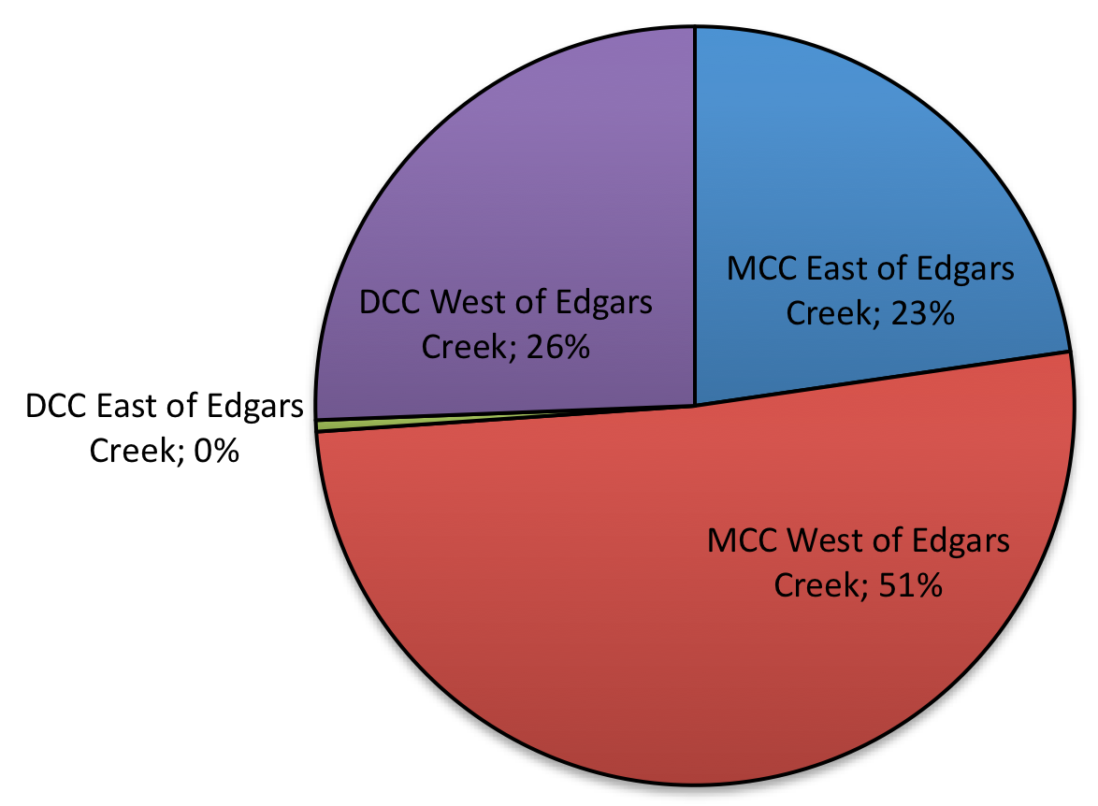

2.2 How often people visit Edgars Creek

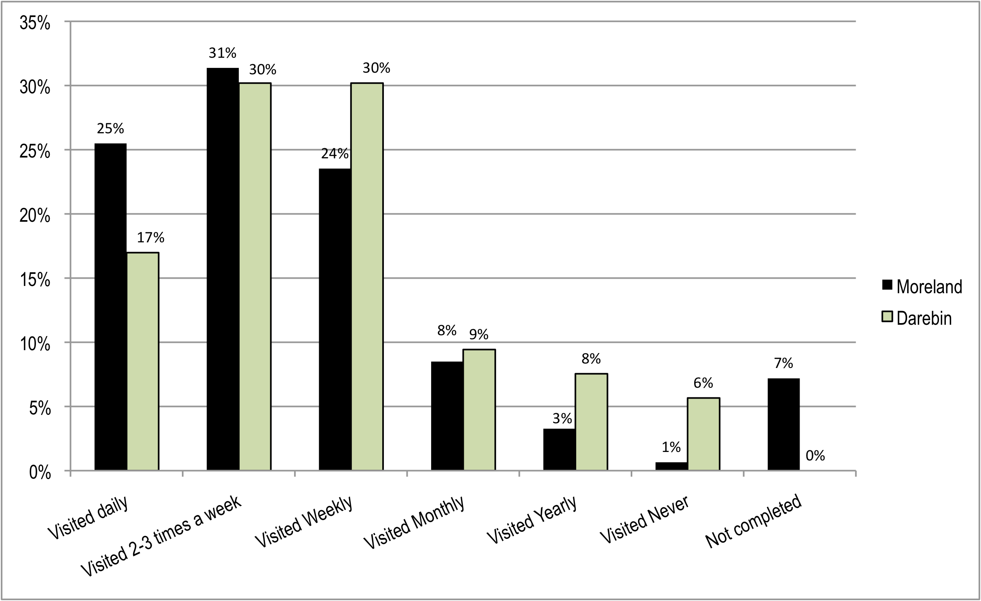

2.3 Reasons to visit Edgars Creek

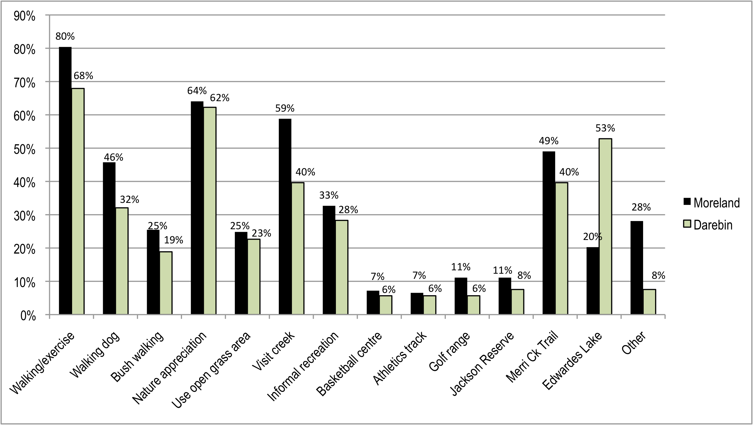

2.3.1 Other reasons to visit Edgars Creek

6 | Cycling
5 | Bike riding
2 | Commuting
2 | Dog walking upstream of Ronald St off leash
2 | Revegetation
1 | Bike ride along concrete path
1 | Bike riding, play with kids, bushcraft, survival skills
1 | Bird watching, community planting with Friends of Edgars Creek
1 | Bush setting
1 | Children experience wilderness, safe/child friendly cycling, connect with community looking after creek, reason they bought house in area
1 | Coburg lake
1 | Cross country running, loves the reveg works done and bushland/dirt tracks
1 | Cycling, running
1 | Enjoy casual walk in park overseeing the creek and open land
1 | Fitness and wellbeing
1 | Friends Of Edgars Creek, sense of community
1 | Good to have space around you, good for kids and dogs
1 | Jogging/bike riding
1 | Live next to creek and appreciate its natural habitat
1 | Meditation
1 | Meditation, paddling, revegetation
1 | Mountain bike riding
1 | Nature based play
1 | Photography
1 | Planting with Friends Of Edgars Creek
1 | Planting with Friends Of Edgars Creek, quiet contemplation
1 | Planting, waterwatch, paint pictures of creek and wildlife
1 | Play, plant trees
1 | Revegetation, playing in creek
1 | Running/fitness/adventures with kids
1 | Socialise, let dogs have a swim
1 | Tree planting, solstice, bike riding, community interaction
1 | Very elderly and can't walk around area but used to walk there daily
1  1 | Visit creek with grandchildren  Wildlife spotting

2.4 Existing open space values

2.4.1 Residents of Moreland City Council

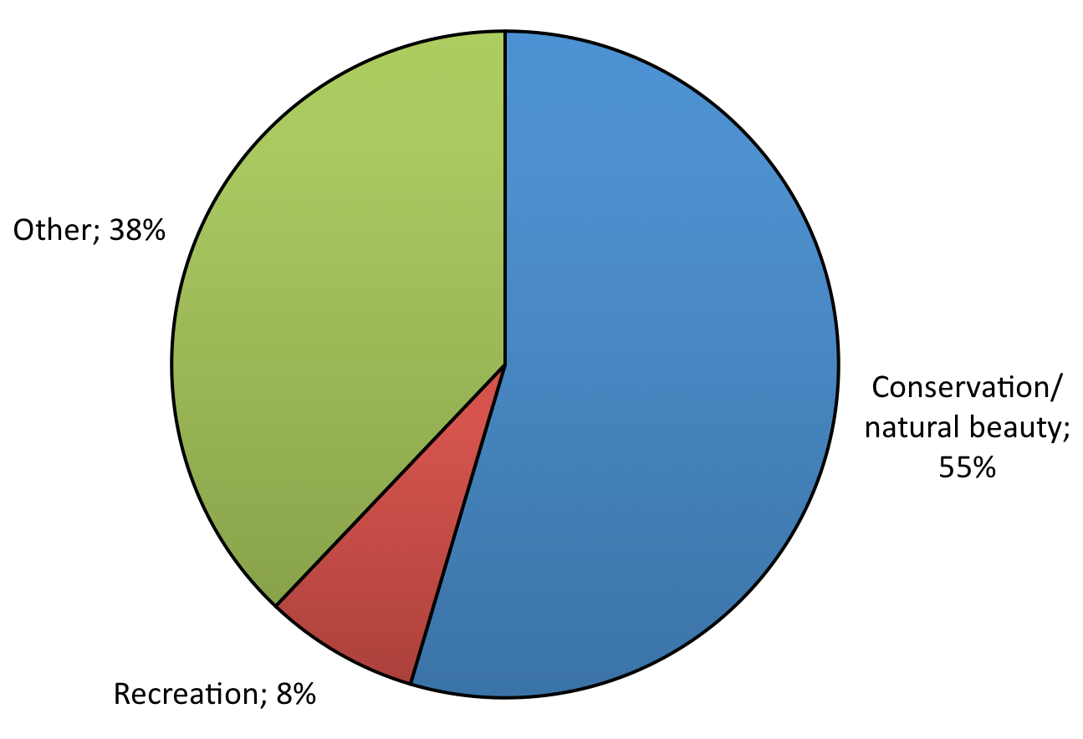

Other values of Edgars Creek

Walking/jogging/active recreation
Dirt walking track around golf range
Good walking path
Running paths/walking paths natural not paved/concreted
Running track
Somewhere to walk
The escarpment, an open place to walk, the vegetation, the Coburg Harriers Athletic Club
Access
Easy access
Easy access to a great open space, dogs off leash space, ability to be close to nature and allow children to appreciate wildlife/natural habitats
Easy access, good for dogs
Freedom to visit anytime
It goes between the lakes
Contrast to urban environment
Bushland experience in urban environment
Country feel in urban environment
Creek in the midst of suburbia
Feels like being out of the city
Isolation and insulation from neighbours
Maintained as close to natural state as is possible in 'suburbia', 'green wedge' for future generations
Natural habitat close to home
Nature amongst neighbourhoods of concrete
Oasis in urban environment
Open space in the middle of the city
Sometimes it's like being in the bush then you catch a glimpse of buildings, the city, and we live here!
Good forest structure to be enhanced. Lots of people love it.
Tranquil, resemblance to natural bush which is rare in northern suburbs
Walking in a relaxed atmosphere away from the noise and city bustle
Wildlife, even rabbits, bush feel close to city
Management of open space
Birds, good for dog walking, open grass areas
Dog off leash area, no bikes along this section
Dog off leash safely
Dog walking, no playground
Lack of man-made structure, wilderness, dogs off lead, community connection, easy pace, no lycra/bike bells, peaceful space
Love that there isn't a 3m wide bike path through the middle of it, space for off-leash dog running
Not formal areas, no bicycles
Open space to walk dog
Open space, dog walking aspect, Friends Of Edgars Creek
Safe off-lead dog walking, lack of infrastructure-hard paths
Sense of community, no lycra/high speed paths, relaxed people
Variety of activities, walking paths, dog off leash areas, golf, walk along creek
Walking the length of the creek without man-made pathways and bikes zooming by. Slow, peaceful meandering in the suburbs
Natural character
Areas of granite boulders within creek
Bike track, scenery, environment
Clean water, grassy, wildlife
Cleanliness of waterways and greenery
Combination of open space and wilder country, care by Friends Of Edgars Creek
Fish in water, playing hide and seek in trees/bushes, nests, birds, planting trees, playing in water
Green open spaces, views onto park, walking/riding/ playing golf, birdlife
I once saw an echidna that was amazing, protection of the fauna, and provision of habitat so future generations can enjoy what I had as a child
More green space for growing community, birdlife
Native habitat and wildlife, interesting space for exercise
Natural form of creek, geological features, mix of open space types
Mature trees-especially from Ronald St to caravan park
Cover of native trees, quiet, informal, natural, birds
View from hill (Conga Foods)
Natural wildlife and the sound of the water running after a rainy day
Not a concrete drain
Not very much now - used to be fantastic as children seeing blue tongue lizards, eels and plentiful birdlife
Nothing but earth, trees, creek and wildlife
Open grass areas, safe areas to walk
Open space with few people, dog can swim, birds, flora
Peace, no bikes, greenery, space, beautiful views, calming
Recreation in a bush setting
Seeing the wildlife
Semi natural environment, spatial qualities, complexity of open space, meandering intimate, simple tracks
The creek, the space, clears the mind, and planting taking place is beautiful to watch
Varied landscape
Watching its beauty and ducks going in and out of the water- a great leisure time for me living near the creek
Wildlife appreciation
Social/community values
Being able to walk and enjoy the park with family, dog and friends
Community feel-many resources, facilities, natural features not built structure, biodiversity
Community space
Encourages community to be active
Families running around enjoying the area
Great place to take son and dog, they love it
Informal meeting place for dog walkers and therefore has social value
Kids explore and play
Quiet, meeting people and their dogs, restoring natural balance
Socialising
Socialising, fauna, space to kick the footy, love the creek
Parkland for children, bike path to Coburg lake, important green space
Space for kids, lungs of city
Other values
Can't believe its at my doorstep
Consider what we have almost lost, what we have lost, and how we can protect what is left or replicate what we lost, it's a true natural treasure of diversity
Great job locals and council have done, beautiful waterfall area
Is very attractive
Love the park and thanks council for looking after it
Peaceful & quiet
Could be cleaner and bridges repaired
Playing in water
Precious open space
Replanting work and usually clean creek
There are no cars
Tranquility
Unfussy and big
Wide space opposite Golf Rd
Unmade tracks, birds
Work Friends of Edgars Creek are doing
Love the cliffs, birds, the quiet peacefulness

2.4.2 Residents of Darebin City Council
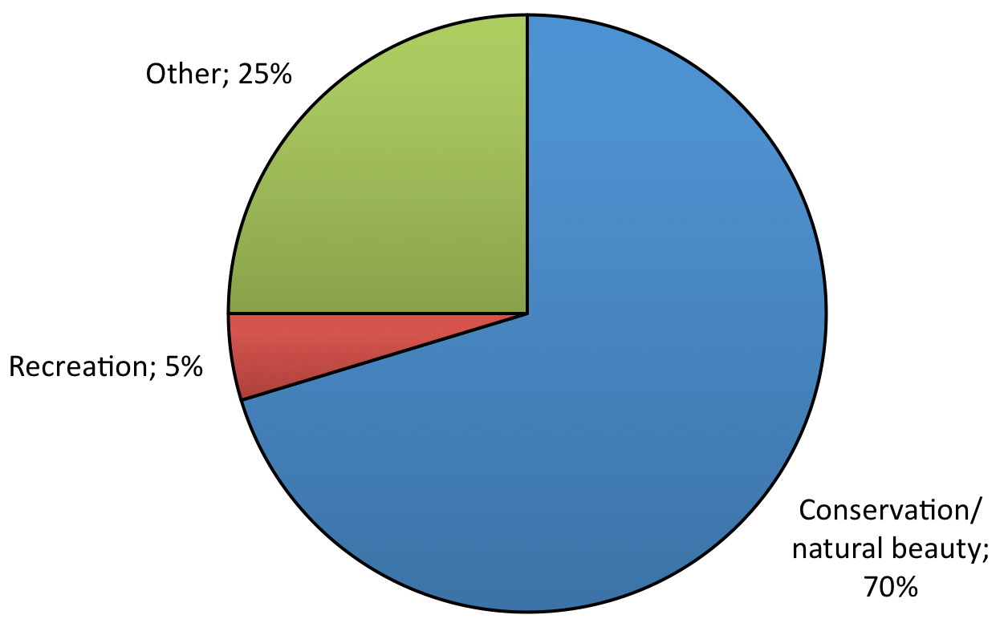

Other values of Edgars Creek

Accessibility
Accessible paths
Dog off leash
Dog off leash, social interaction
Dog off leash, walking with kids
Ease of access
Edwardes lake is great for families
Freedom for the dogs to have long runs during winter, rarely go in summer due to snakes
Kodak cliff, gooseneck
Large open grass area - bigger than local park, quiet, dog walking
Meeting other dog-walkers and other people generally - it's like being in the country in some places!
Places for kids to explore and imagine
Riding track and picnic areas
Short cut

2.5 Issues and opportunities to be considered in development of the plan

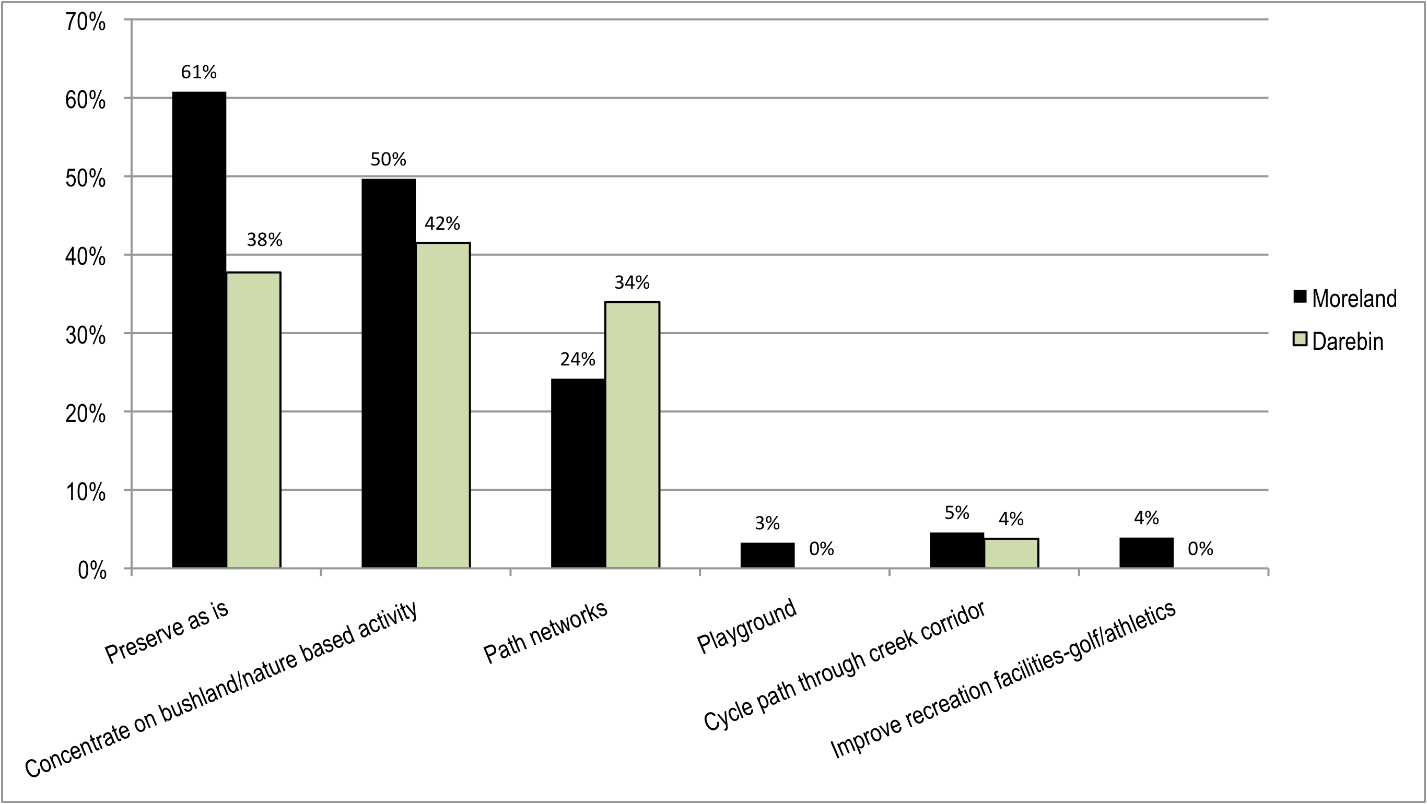

2.5.1 Residents of Moreland City Council - Other issues and opportunities

Conservation/natural character
Conserve natural environment
Rubbish dumping and accumulation
Suitable walking tracks
Encourage use without losing wilderness values
Build on community work without losing sense of community project
Ensure wildlife is protected
Ensure accessible for people in the community
Protect against any further development
Few bushland places in northern suburbs, expand planting program
Land conservation
Not cutting down trees, importance of trees for habitat, shade, carbon emission reduction, collect rainfall, purify air
Not keen on foxes, preserve biodiversity and fauna
Original flora/fauna must be kept intact
Plenty of formal/conventional parkland along Merri Ck and at Coburg Lake, preserve Edgars as a bushland type environment
Pollution/runoff
Bike or walking access to lake from junction
Conservation & management of natural vegetation
Preservation of flora/fauna, regeneration with indigenous/native plants
The danger of all human interventions in natural systems, all natural, indigenous and biological values must be carefully protected, tread softly
Trails and paths
A path for bike riding, exercise, walking
Bicycle track/shared path
Bike path connecting Edwardes Lake to Coburg lake
Bike path, exercise stations, signage-no motorbikes
Bike track away from creek, prioritise slow activities
Walking and free space for dogs and kids to play
Manage dogs as becomes more populated
Issue of potential weeds from new/existing development on creek edge development (need to be vigilant)
Doesn't want bike path in corridor, rubbish bins, lighting for safety
Don't put concrete paths everywhere, conserve flora/fauna, dog off leash area very important
Like the quietness and not the 'freeway' atmosphere of bike path, but you should be able to ride up the creek to Edwardes lake
Make it a bikeway, plant fruit trees
More trails from basketball centre to Edwardes lake
Natural without concrete paths, keep green spaces and green verges along creek
Needs to be a cycle path
No bike path
No bike path, keep peaceful
Ice cream shop
No bikes, maintain current peace and tranquility
No cement paths, no more picnic areas (enough) bins and litter traps in the creek
Potential to turn into another bike path ruining peace/beauty and nature
Issue of bike path on floodplain
Stand against selling off or building on this area, bike access and trail
Dedicated website to keep us informed of status
Stop motorised trail bikes, fenced dog park
Walking track to Edwardes lake
Widen path for bikes and people
Water quality/condition
Address the issues of pollution in the creek, revegetate to bring back native fauna - what a wonderful thought!
Remove all non-native flora
Clean creek so dogs/kids can play in it
Encourage people to walk or ride
Clean river and be accessible to the wildlife
Health of creeks and rivers
Restore creek north of the footbridge-return back to creek not drain
Protect creek for and from Coburg Hill residents
Trap rubbish that gets into creek
Up stream pollution, loss of flora/fauna
Water quality, wetlands, rocky rapids instead of concrete
Water resources & quality
Weed infestation, water quality/health, maintain 'natural setting' - no paved paths
Wetland to improve water quality, bush tracks, weed control
Facilities/amenities
Need 2/3 seats near the 'cliff'
Amenities, bog free pathway
Bins and dog-poo bag dispenser
Paths mowed short to keep snakes away
Build a solid bridge that isn't damaged by floods
Drinking fountain, rubbish bins and playground
Fix bridges to make safe in flood
Fix the Edgars creek bridge - too long
Guided tours, lookouts
Ice cream shop near waterfall on Sundays, not to have concrete path or twirly wirly slide
Ice cream shop, make it real bush
Keep it open/safe, bins for rubbish, picnic tables, signs telling community of their responsibilities
More bins, dog poo disposal bins, signs to get people pick up after dog
More pathways, places for recreation, BBQ
Highlight natural features of landscape
Proper lighting/safety issues
Overflowing bins, rubbish around basketball stadium
Protect, attract more native fauna for the enjoyment and enrichment to the lives of our grandchildren, rubbish needs to collected regularly, another bridge crossing the creek, a children's play area with swings/flying fox and skate area for teenagers
Query about park on Newlands Rd - provision of traffic lights
Replace bridge over Edgars ck at top of Jackson Pde
Organise regular rubbish removal especially after flood
Perfect as is!
Retain dirt tracks, control rabbits/box thorn, cultivation of ephemeral wetlands, public toilet near basketball stadium car park, development of existing play area beside sports fields
Seat here and there, but no obvious development
Shaded picnic areas/seats for elderly, rubbish bins, well formed paths
Signage on snakes etc, dogs on leash
Toilet near existing facilities, maintain creek as nature reserve
Waterhole for swimming, water fountain, clean waterway, more bins, bike track, small footbridges to cross creek at various location
Design
Better use of open space - family friendly, cycle friendly
Issue with extreme weather impact
Permanent walking tracks and bridge crossings
Coburg Hill interface
Creek crossings, better pathways to lake, walkway from Arthur St over Edgars creek and over Merri Ck leading to Merlynston train station
Regular mowing/rubbish removal
Doesn't want undergrowth increased due to fire hazard
Don't build on parkland, replace bridge near waterfall, preserve goose-neck meander, plant more trees
Ease of access for older walkers, minimal seating, maintain informality
Ensure development doesn't infringe on natural environment
Ensure water and environmental sustainability
Fire management, safety & security
Impact of Kodak development-no more development along creek
Improve riparian area upstream of car park, lack of access west band upstream car park, maintain secluded atmosphere along the creek Ronald St to car park
Replace Kodak bridge with swing bridge
Prefer not to have path from Ronald up stream
Protect Silurian cliff, provision of dog off leash
Keep as natural and as untouched as possible
Keep as natural as possible, don't fill it with playgrounds, BBQ plenty around
Keep natural wildlife, natural plants, tidy up rubbish
Noisy factories on other side of creek
Keep parkland open and available for all uses including dog off lead
Maintain ecosystem / native setting
Minimise commercial intrusion, adventure & exploration, limit physical changes-no concrete paths
Multi-use area and needs to set out for all opportunities, some reveg opportunities and pathways need an integrated approach
Not to overdevelop the areas with playgrounds and other man-made structures - let people appreciate it
Opportunities to enhance natural bush
Remove high tension wires-underground at least, industrial buildings an eyesore and transfer station too noisy - relocate?
Remove or at least underground transmission wires
Safety for people
Maintenance
Current stakeholder, protection/maintenance of reveg works, maintain and ensure flora/fauna in area
Ensure area is clean and not overgrown with feral vegetation
Ensure no further encroachment of current size, keep regenerating/revegetating area
Halt/slow bank erosion, eradicate chilean needle grass
Maintain and value what we have, we need parkland
Maintain bridges, picnic area, issue with impact of increasing population, pollution of creek, littering, safety, cost of plans of ratepayers
Maintain golf range
Maintain natural, unstructured feel, space for off-lead dog walking, weed control, erosion, moderating stormwater runoff
Need path from Arthur St to creek and grass mowed more often, maintain what you do otherwise waste of money
Not too much interference
Re-establish barren areas with flora/fauna, walking path, rubbish cleaned - employ someone to keep area clean and safe
Regeneration, keep natural, we can restore this! Get rid of rubbish
Reveg/maintenance, accommodate a diverse range of uses while preserving intrinsic qualities of bushland, slow pace, no concrete footpath next to creek, water quality, protect flora/fauna, improve stormwater mgt/water quality, cafe near pool
Reviving natural habitat, regular rubbish removal particularly after flooding
Rubbish weeds
Sound, effective maintenance of the area to keep it attractive and used by the public
Weed removal, rubbish removal, stop pollution
Management/open space conflict
Address anti-social behaviour - littering, driving, trail bikes, vandalism
Arrogance of some dog owners - little regard of other users, especially small kids, water quality of creek
Community education about local environmental values ie signs about flora/fauna
Illegal dirt bikes
Irresponsible dog owners not picking up doggie do - educate and provide bins
Keep dog off leash areas, 1-2 safe creek crossings
No concrete paths/formal playground/bbq, improve erosion control, fix bridge, refreshment centre Coburg hill site, maintain ban on motorbikes, more reveg money and projects
Thinks conservation works not doing anything for the creek
Other issue/opportunity
Access without interfering with existing environment
Engaging people with the area, protecting it with the new population at Coburg hill
Fitness
Shared use, protecting the creek and peoples hard work
Space for people to enjoy a slow pace, peaceful
Worried about impact of influx of people spoiling the peace and quiet necessary for health and wellbeing

2.5.2 Residents of Darebin City Council - Other issues and opportunities

Aboriginal cultural heritage
Access to creek
Accessibility poor, rubbish, chemicals spilling from factories, preserve habitat
Accessible for walking/bike riding whilst retaining as natural as possible
Better track, safety of trail in evening, reduce pollution and improve wildlife habitat, information signs, more bridges, remove weeds
Community access
Community gardens along the way, clear cycle/ped paths. A great space for interesting landscapes. Community greenhouse.
Conservation of the area, maintenance of current facilities and improved access and infrastructure
Dog off leash areas, more regular maintenance of grass, runoff from factories smells horrid
Educate people about indigenous vegetation, weed/pest control, replace non indig plants with indig plants
Edwardes Lake
Extend bike track to Edwardes Lake, ensure Kodak redevelopment doesn't adversely effect area, signage pointing out significant geological, historical or biological features
Few seats and bridge crossing in different areas, welfare of ducks/frogs
Fix the bridge
Flooding
If putting in bbq's maybe charge a booking fee as always very busy
Improve lighting and people dump meat/bones that might make dog sick
Increase size of reserve to cater for expanding population, and provide habitat links to the creek for a greater wildlife corridor, bird nesting boxes in trees, plant more trees, how to keep creek clean after storms
Issue with Coburg Hill and potential for mis-use of creek, maintain tranquil nature of the space
Maintenance - clean exit to creek at Edwardes St - snake hazard and missing link to continue past Edwardes Lake and beyond. Return cycle link
Maintenance - clean up overgrown areas, remove rubbish from water
Maintenance - control vermin, cut grass
Maintenance - litter free, grass cut, safe for public
Manage pollution
Meeting needs of public while conserving nature, subtle placement of rubbish bins and benches
No pollution
Path along the eastern side of Edgars Creek linking to Murray Rd with a port bridge near Hopetoun Crt, then path changing to west side to Edwardes Lake
Please fix bridge at Ronald St and Golf Rd, local indigenous plantings and safety considerations
Poor access from caravan park
Promote healthy community by providing outdoor space and activity
Protecting local wildlife is top priority
Remove rubbish, noxious weed control, encourage tree growth
Retain off lead areas, keep wild space, minimise human structures and continue great work of Friends of Edgars Creek
Safe walking paths, seating or resting, observation and meditation
Safety of women and children from 'seedy' men hanging around creek
Walking link from Henty St to Coburg Lake as well as bike track
Walking tracks on both sides of creek, footbridge crossing in Arthur St/Norfolk Crt area
Weed control, maintain informal status of area
Wheelchair/pram access - steps into a ramp, more support for Friends of Edgars Ck, rabbit elimination

APPENDIX A

Letter to residents and questionnaire

APPENDIX B

Evening Community Meeting Notes 2/5/2012

APPENDIX C2
Edgars Creek Conservation & Development Plan
Edwardes Lake to Merri Creek

SUMMARY REPORT
COMMUNITY CONSULTATION OUTCOMES
Undertaken during the Draft Plan phase

Prepared by

Thompson Berrill Landscape Design Pty Ltd

for

Moreland City Council and Darebin City Council

May 2013
TABLE OF CONTENTS

PAGE #

1. INTRODUCTION 3

2. INFORMATION LEAFLET QUESTIONNAIRE #2 RESPONSES TO
DRAFT KEY RECOMMENDATIONS 1 TO 11 4

3. SUMMARY OF GENERAL COMMENTS 13

4. SUMMARY KEY ISSUES RAISED DURING THE CONSULTATION 14
PROCESS AND PROPOSED DRAFT PLAN AMENDMENTS

ATTACHMENT #1
Information leaflet #2 and questionnaire

1. INTRODUCTION

1.1 Information leaflet and questionnaire #2

A second information leaflet and questionnaire was prepared to seek feedback from the local community regarding the key recommendations of the Draft Edgars Creek Conservation and Development Plan. The information leaflet summarised the key values, issues and opportunities raised by respondents from the first phase of consultation which were considered in preparation of the draft plan. The information leaflet also invited residents to attend a community information sessions held on site Sunday 17/3/2013. Refer Attachment 1.

1473 information leaflet #2 questionnaires were letter box dropped to residents in the local Moreland area during February/March 2013 and copies were also available on site at the community information session. A further 94 copies were e-mailed to respondents Moreland residents who provided their address in the first phase of consultation as well as 25 Darebin residents.

A total of 85 questionnaires were completed and returned by closing date of 29/3/2013.

1.2 Informal community information session

A community information session was held on Sunday 17/3/2013 from 10am-12pm near the Ronald Street footbridge. Approximately 20-25 people come through. Generally the people attending were very supportive of the draft plan. There was some concern about regarding the potential future establishment of sporting fields on existing open grass areas near Newlands Road. There were also differing opinions from some cyclists and pedestrians regarding formalization of the path network. The discussion and feedback on the day regarding these issues is accurately reflected in the questionnaire responses to Q9 and Q10.

1.3 Location of questionnaire respondents

The distribution of respondents to Information leaflet questionnaire #2 was very similar to those responding to questionnaire #1. There was however no direct mail out/letter box drop in Darebin aside from those 25 people who left their details in responding to the first questionnaire. This naturally resulted in lower numbers from residents in these areas compared to information leaflet #1.
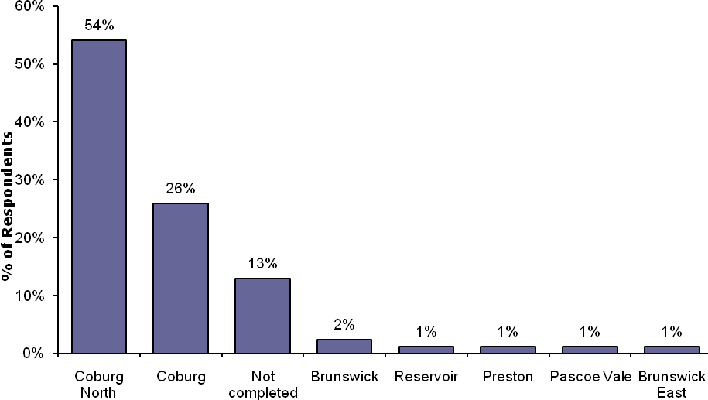

2. INFORMATION LEAFLET QUESTIONNAIRE #2 RESPONSES TO DRAFT KEY RECOMMENDATIONS

The following table is a summary of the overall community response to key draft recommendations. For the overall summary in the table below ‘strongly agree’ and ‘agree’ responses have been added together as have the ‘disagree’ and ‘strongly disagree’ responses. ‘N/C’ is not completed.

For further detail and community comments refer to Sections 2.1 to 2.14.

COMMUNITY RESPONSE

No. | DRAFT PLAN RECOMMENDATION | AGREE | DISAGREE | N/C
1 | Protect areas of existing remnant vegetation and continue indigenous revegetation works in collaboration with local community groups to increase biodiversity and to link fragmented habitat areas. | 99% | 1% | 0%
2 | Prioritise weed control efforts focusing on weeds of national significance and protection of areas with high value remnant indigenous vegetation. | 95% | 2% | 3%
3 | Retain natural processes associated with Edgars Creek and protect landscape values associated with significant geological landforms. | 98% | 1% | 1%
4 | Minimise the impact of existing urban areas on the ‘secluded bushland character’ of the creek reserve though appropriate buffer planting to existing open space boundaries. | 99% | 1% | 0%
5 | Implement best practise planning and design guidelines for new development areas to ensure appropriate set back and buffer planting to retain and improve the ‘secluded bushland character’. | 97% | 1% | 2%
6 | Protect and improve understanding of indigenous cultural heritage values. | 87% | 3% | 10%
7 | Improve water quality in Edgars Creek targeting at source litter control and improvements to existing stormwater connections to the creek where possible. | 98% | 0% | 2%
8 | Establish a new water quality treatment wetland on the existing golf range area to treat urban stormwater runoff prior to discharge to Edgars/Merri Creek and improve floodplain habitat values. | 81% | 15% | 4%
9a | Establish a new 2.5 wide sealed walking/cycling path from new development areas at Coburg Hill to the existing Merri Creek trail and Coburg Lake along to the west bank of Edgars Creek. | 79% | 17% | 4%
9b | Establish a new 1.5m wide unsealed all weather walking only path in stages north from Coburg Hill to Jenkin Street on the east side of the creek. | 83% | 13% | 4%
9c | Improve on road cycling links between Coburg Hill and Edwards Lake via Elizabeth Street, where cycle paths cannot safely be established or are inconsistent with environmental objectives along the creek. | 87% | 9% | 4%
10 | Retain flat grass open space areas away towards Newlands Rd to meet the recreational needs of existing and future communities including establishment of a playground longer term sports fields if required. | 74% | 20% | 6%
11 | Provide additional seats overlooking the creek and key views while ensuring design is consistent with the bushland character of the open space corridor. | 87% | 10% | 3%

The questionnaire respondents were asked to indicate their views on each of the draft key recommendations of the Draft Conservation and Development Plan. Respondents were invited to tick a box indicating whether they ‘strongly agree’, ‘agree, 'disagree' or ‘strongly disagree’.

The survey also allowed respondents the opportunity to detail the reasons for their responses, or other thoughts, in a general comments area summarised in Section 2.2.3 of this report. Comments relating to the particular draft recommendations have been added within each section, with any comment receiving multiple responses noted in brackets.

There were three more detailed written submissions received. The comments and feedback from these has been included in response to each draft key recommendation where relevant and/or in the general comments section.

2.1 Key Recommendation 1:
Protect areas of existing remnant vegetation and continue indigenous revegetation works in collaboration with local community groups to increase biodiversity and to link fragmented habitat areas.

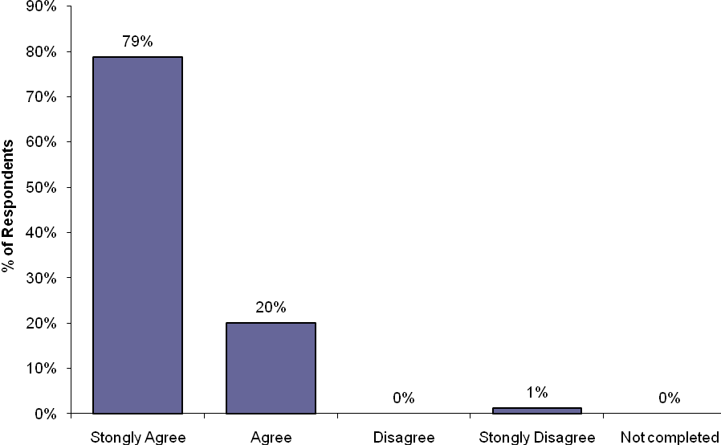

Q1 related comments:
- Protection of existing remnant vegetation should be the number one priority (7)
- Maintain and restore indigenous bushlands (3)
- Mass replanting to reduce stream flow erosion of banks.
- Protect existing vegetation e.g.; older gum trees.
- Retain and enhance natural landscape and increase native vegetation
- We need to protect our environment and native fauna, to be worthy custodians for our future generations.

2.2 Key Recommendation 2:
Prioritise weed control efforts focusing on weeds of national significance and protection of areas with high value remnant indigenous vegetation.
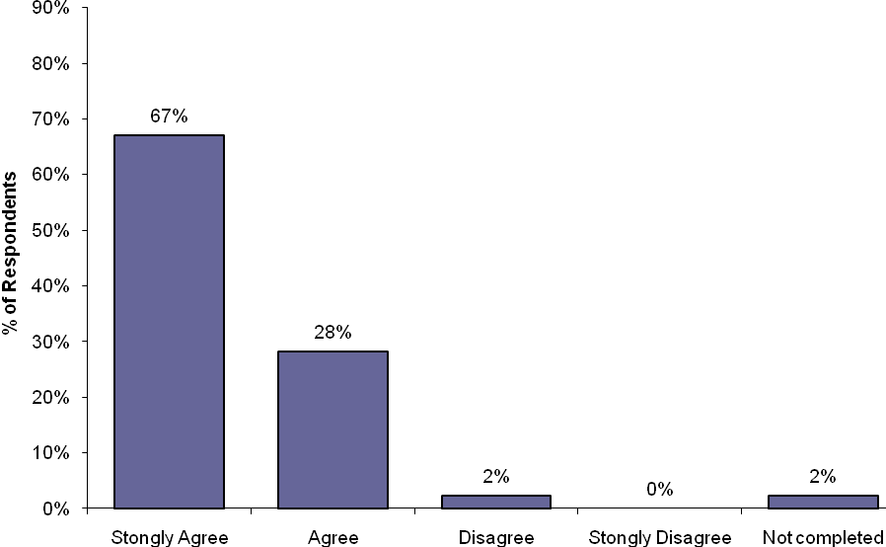

Q2 related comments:
- Prioritising weed control efforts should be the number one priority (4)
- Weed control efforts should be broader especially to prevent downstream spread of riparian weeds (2)
- Alternative weed control should be used instead of 'round up' which ends up in the creek and water table
- Eradicate exotic grass weeds in and adjacent to creek area
- Decrease use of herbicides
- Tidy up the spaces by removing weeds and litter

2.3 Key Recommendation 3:
Retain natural processes associated with Edgars Creek and protect landscape values associated with significant geological landforms.
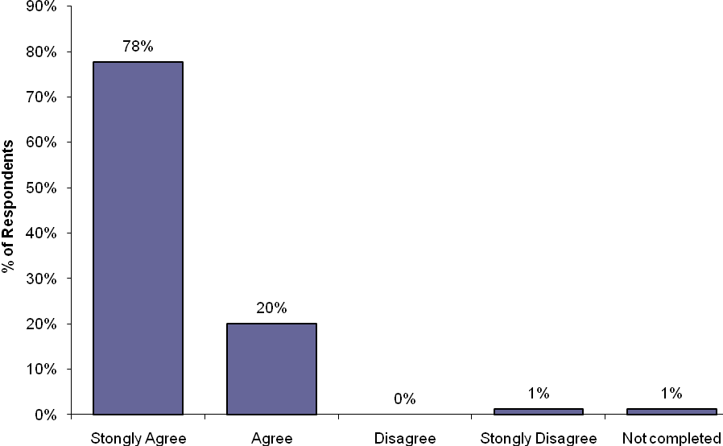

Q3 related comments:
- Retaining natural processes is a key priority (2)
- Priority of working with geological environment then progress with upgrade of aesthetics and functionality.

2.4 Key Recommendation 4:
Minimise the impact of existing urban areas on the ‘secluded bushland character’ of the creek reserve though appropriate buffer planting to existing open space boundaries.
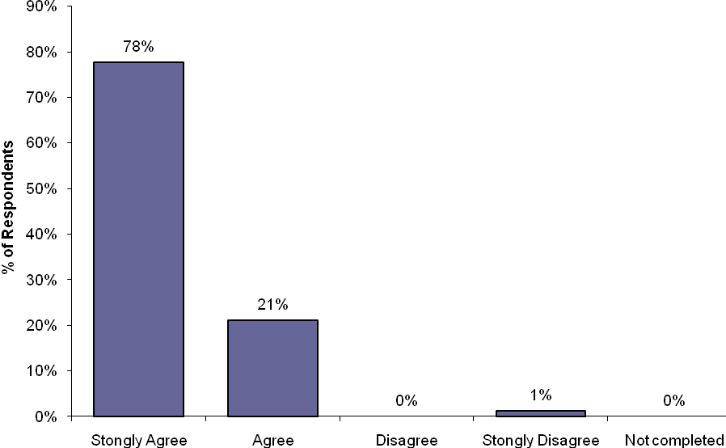
Q4 related comments:
- Minimising impact of existing urban areas should be a number one priority (3)
- Establish effective buffer planting along with Coburg Hill development
- Plant more trees in Coburg Hill development
- Minimise impact of urban development
- Limit impact of human traffic as much as possible but still allowing access for recreation, nature appreciation, fitness, dog walking and family activities.

2.5 Key Recommendation 5:
Implement best practise planning and design guidelines for new development areas to ensure appropriate set back and buffer planting to retain and improve the ‘secluded bushland character’.
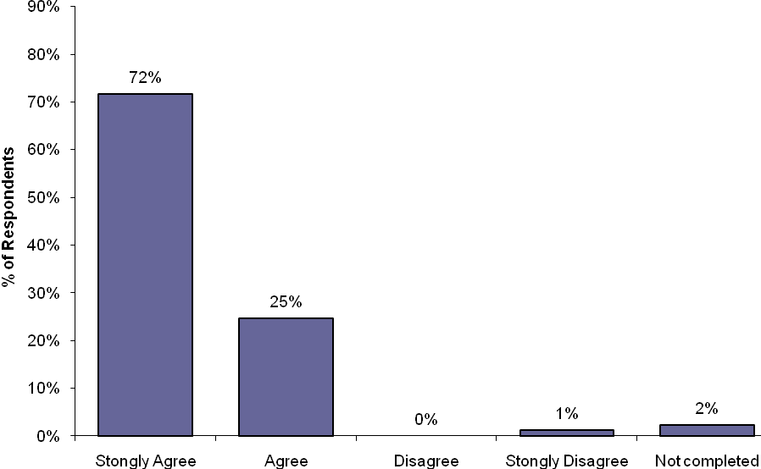

Q5 related comments:
- Anything that retains and encases that "in the bush" experience so hard to get in Melbourne. There are zillions of developed play areas
- Ensure Coburg Hill does not encroach on the plan
- Improve and preserve the bushland character
- Improving 'secluded bushland character' should be a high priority
- Maintain secluded bushland character.
- Protecting habitat and NOT overdeveloping the area
- Residents enjoy the area as it is, don't try and commercialise it
- Area near Golf Road has housing lots shown on it. Any suggestion that more green space could be lost to housing should be dismissed outright by Council.

2.6 Key Recommendation 6:
Protect and improve understanding of indigenous cultural heritage values.

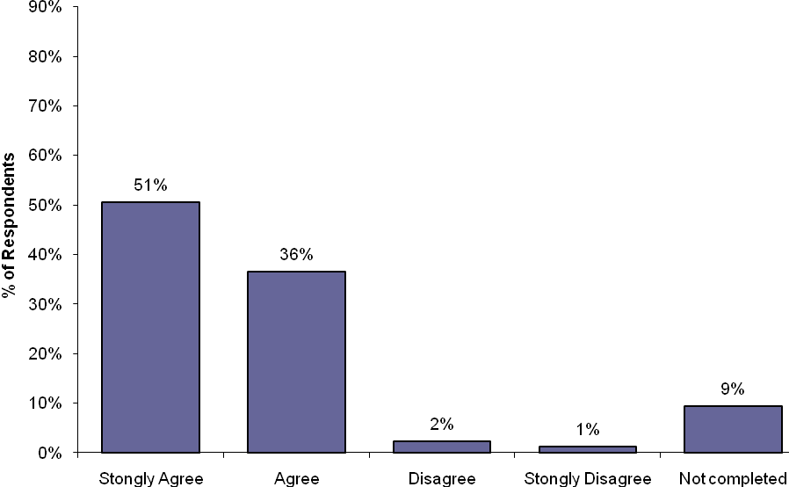

Q6 related comments:
- Protection of cultural heritage values is a key priority

2.7 Key Recommendation 7:
Improve water quality in Edgars Creek targeting at source litter control and improvements to existing stormwater connections to the creek where possible

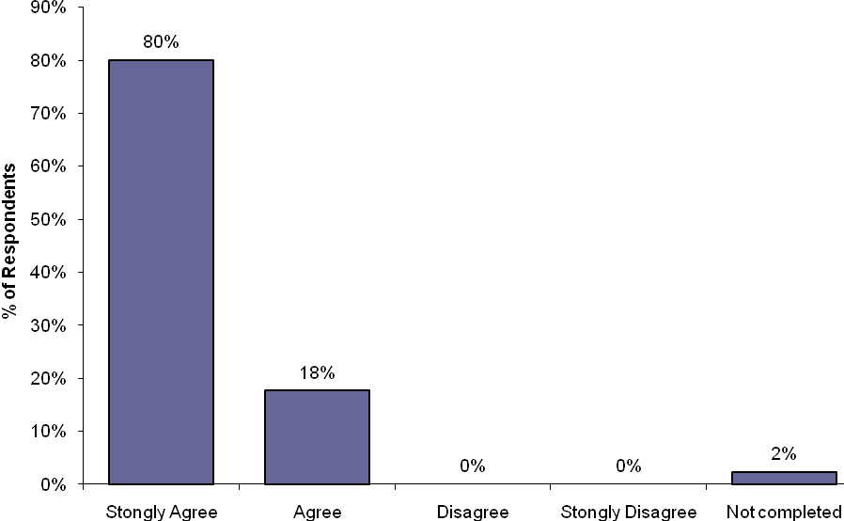

Q7 related comments:
- Improving water quality is a high priority (6)
- Conserving water needs to be given the highest priority (2)
- An idea is to place a wetland area near the new footbridge to Coburg Hill on the west side as it is low-lying there
- Highest priority is improving water quality and litter control.
- More "Clean up Days" arranged to help improve the water quality as often the water stinks
- Storm water needs to re-divert into the landscape, into suitably planted wetlands.

2.8 Key Recommendation 8:
Establish a new water quality treatment wetland on the existing golf range area to treat urban stormwater runoff prior to discharge to Edgars/Merri Creek and improve floodplain habitat values.

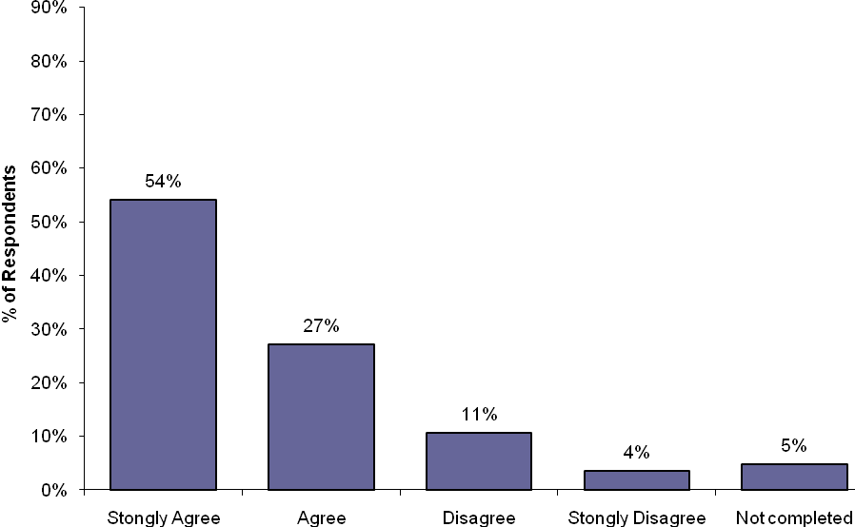

Q8 related comments:
- Establish a wetlands area with boardwalk for bird watching and studying.
- I welcome the golf driving range being better made use of for better things. So much land for so few people! A remnant of another era when golf was unaffordable for most, an elitist sport.
- Retain the golf driving range, as it is so good to have a free facility to practice and enjoy
- In 50 years, area has only been seen to flood 3 times, otherwise remains very dry.
- Keep it natural, get rid of the golf range.
- Wetland needs to be treated as a high priority
- The regeneration and re-establishing of wetlands is a high priority.
- I remain unconvinced that this will significantly improve water quality as there are many drains that release water into Edgars Creek. Seems like a bit of a ‘greenwash’ to me and removes space currently used as a walking area.
- Concerns about water flow through the area, where will the water come from during the warmer months.
- Would love to see all the frogs there
- Are you aware of the flood prone land behind the houses on Golf Road, near the Merri CK park?

2.9 Key Recommendation 9:
Improve walking and cycling access between Edwardes Lake and Merri Creek Trail including 9a, 9b and 9c:

The improvement of walking and cycling access between Edwardes Lake and Merri Creek Trail has been identified in the Open Space and Cycling Strategies of both Moreland and Darebin City Councils. Assessment completed as part of this Draft Plan confirmed that it was not possible to achieve an off road shared cycle trail along the entire length Edgars Creek in accordance with current trail flood safety standards and environmental impact minimisation requirements. This question was therefore broken up into three sections, relating to the proposed path type/level of access proposed in each section of the creek.

2.9a Key Recommendation 9a:
Establish a new 2.5 wide sealed walking/cycling path from new development areas at Coburg Hill to the existing Merri Creek trail and Coburg Lake along to the west bank of Edgars Creek.

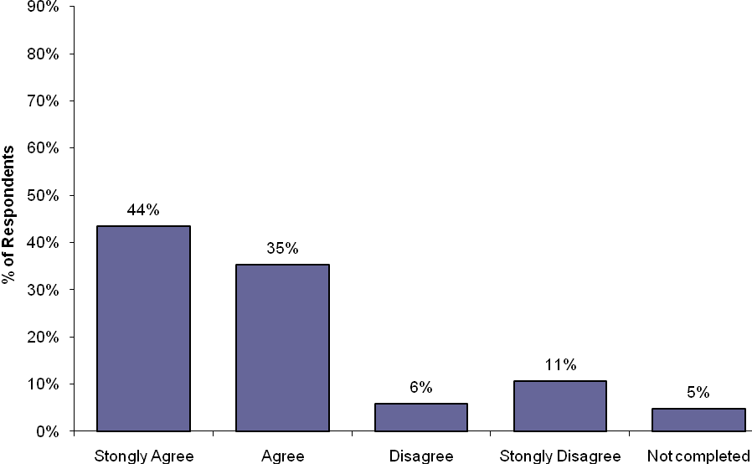

Q9a related comments:
- Path should be a high priority (2)
- Create more paths
- Improvement of cycling and walking tracks is a high priority
- No way should there be a sealed walking/cycling path along the west bank of Edgars Creek
- This would be fantastic as we currently walk/scoot/ride from McMahons Road to Newlands Primary - perfect!
- Development and safety on cycling and walking tracks is important
- Extension of the cycling and walking park will encourage healthy exercise
- The proposed path will completely dissect the golf practice area reducing the utility of this area as open space.
- Golf Road could be designated as a safe cycling route, this would only add a few minutes to the trip and would remove the need for establishment of the path and loss of open space.

2.9b Key Recommendation 9b:
Establish a new 1.5m wide unsealed all weather walking only path in stages north from Coburg Hill to Jenkin Street on the east side of the creek.
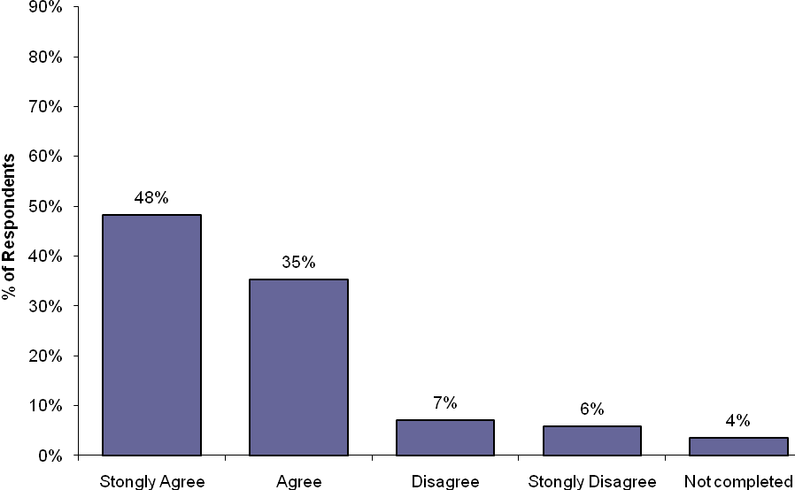

Q9b related comments:
- A safe and environmentally friendly bike path needs to be built between Coburg Hill and Jenkin Street.
- All the future/potential trails need to be 'shared'.
- Establishing a sealed walking only path should be a high priority.
- If you only put in a dirt track to Edwardes Lake people with cycle it anyway, I know I will.
- Love it all! Would hate to see a concrete path all the way, so loving the dirt path.
- The people who use this area the most (every day!) are cyclists and people walking their dogs and jogging.
- There are two sides to this creek, and it needs to meet both the desires of bush walking and recreation cycling. Please prioritise connecting the Edgars Creek trail to Edwards lake
- Please provide more than one new footbridge to allow trail users to better explore the parklands
- The addition of a raised boardwalk would not only protect the environment but enhance it
- We like it how it is now, the only thing required are new stairs. We are against adding paths as they are altering the existing environment
- Why waste money on walking tracks that already exist in the area?
- Why wasn’t Bicycle Victoria invited to be part of the consultation paper? Why just two planting groups with strong interests in not making cycling part of this proposal and with a strong history of trying to plant out industry standard path widths?
- Lighting around Hopetoun Crescent is required to improve public safety.
- Increased use of the existing informal path has led to a rise in theft from cars in Hopetoun Crescent, improved lighting is required NOW not later when the boardwalk and path are built.

2.9c Key Recommendation 9c:
Improve on road cycling links between Coburg Hill and Edwards Lake via Elizabeth Street, where cycle paths cannot safely be established or are inconsistent with environmental objectives along the creek.

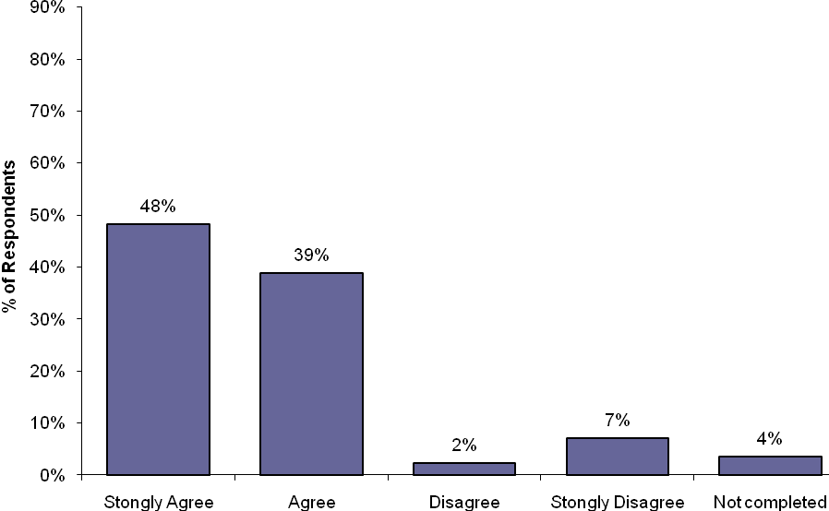

9c related comments:
- Highest priority is cycle infrastructure. Elizabeth street needs bike lanes and traffic calming measures.
- Cycling access needs to more highly prioritised. On road cycling links are not an acceptable alternative.
- A sealed cycle path should be put all the way through to Edwardes Lake
- Please prioritise connecting the Edgars Creek trail to Edwardes Lake.

2.10 Key Recommendation 10:
Retain flat grass open space areas away towards Newlands Rd to meet the recreational needs of existing and future communities including establishment of a playground longer term sports fields if required.

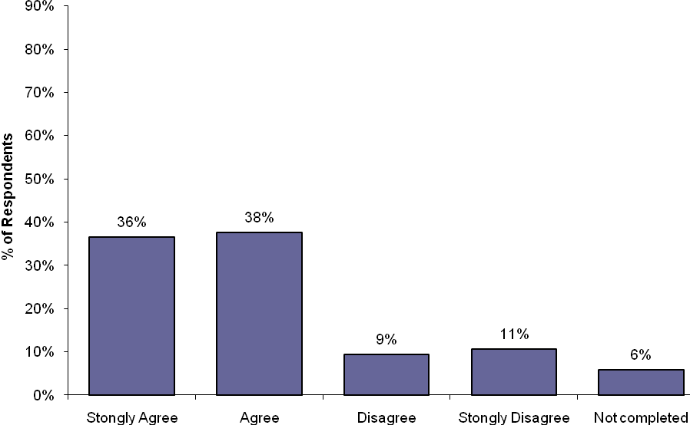

Q10 related comments:
- Areas of Vic Roads land should be enhanced by plantings, particularly of CBD view on top of hill where natural vegetation is creating a wonderful bush retreat with the best views of the Melbourne city skyline ever seen
- Didn't Moreland have difficulty supplying water to existing sports fields in time of drought?
- Ensure that the transfer of former Vic Roads land is complete and the council signs off on maintaining the land
- Keep the parks open feel; don't fill it with paths like other parks. It is very particular especially if you live on Newlands Road which is a very busy truck road all the time
- No sports fields, leave it open space
- Protecting all green space should include no road near the golf course
- Provide a children's play area e.g.; swings, maybe a roller skating area for older children
- There is a need for space for kids that are not play equipment. There should be space and bush so they have a different experience to readymade play facilities
- We already have an abundance of sports facilities nearby!
- Please consider something other than a sports oval, we are a diverse community!
- If designed in such a way not to impinge on open space and its current use as one of the very few large dog off lead walking areas in Moreland.
- In principle a playground is a good idea.
- Why can’t open space be left as green open space. My concern is that sports fields by definition reduce public access to open space once sports clubs ultimately gain control over use.
- Ping pong tables are perfect low maintenance, multi generational activities for public spaces
- Trees need to be planted and recreational facilities designed for the area next to Conga foods.
- Recreational needs seem to be very well met here already, a lot more could be done in this space
- Leave as much open area as is possible for kids to walk, play, run and enjoy.
- Ban playground and sports grounds which need protective fences, toilets, club rooms and car parks, which would all destroy the essential open parkland setting
- No establishment of formal sports fields west of Edgars Creek, which will detract from the bush setting and create the whole area into a sports precinct

2.11 Key Recommendation 11:
Provide additional seats overlooking the creek and key views while ensuring design is consistent with the bushland character of the open space corridor.

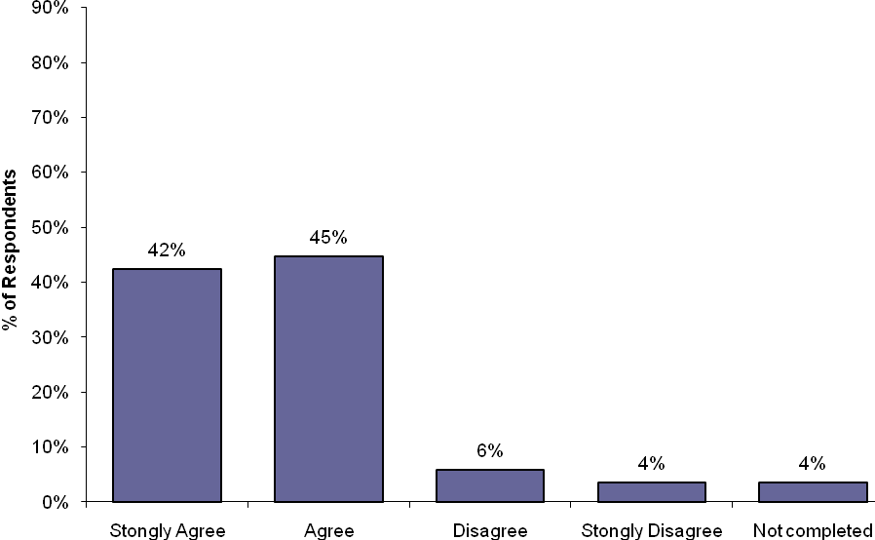

3.0 SUMMARY OF GENERAL COMMENTS

Below is a summary of additional general comments included in the survey for the Edgars Creek Conservation and Development Plan in which did not relate directly to the draft recommendations 1 – 11.

Dogs
- Please provide bins for dog walkers to deposit their dog's waste
- Installation of dog faeces litter bins to reduce rubbish on creek.
- A few doggy poo bag dispensers are required.
- Off-lead parks are valued for exercise and important socialising of dogs, and people come with dogs from all over Melbourne.
- Owners congregate at the footbridge all throughout the day to use the off-lead field.
- It’s really important that the area remains OFF LEASH for dogs
- A fenced dog park is needed
Rubbish/Litter
- Please place extra rubbish bins on tracks
- Please provide more rubbish bins

General
- Please think about what Moreland is missing to support the community. What about our arts community? Music stage for festivals and community gatherings? A skate park?
- Some questions are a bit verbose. A simple summary translated into Arabic/Greek/Italian would be good.
- All recommendations are worthwhile. However time for implementation should be 2-3 years, not 10-15 years.
- I appreciate the councils awareness of the importance of the development of the Edgars Creek area.
- I have lived here 40 years and have seen that any intervention is usually to the earths detriment
- Would like to see a public toilet somewhere near Edgars Creek, perhaps near car park beside basketball stadium.

4.0 SUMMARY RESPONSE TO THE KEY ISSUES RAISED DURING THE CONSULTATION PROCESS

The following tables summarise the comments or key issues raised in the questionnaire responses. The tables include a response to the comment and in italics at the end of the response a draft recommendation as to whether a change will be made to the draft conservation and development plan as a result of the comment.

ITEM | REC No. | SUMMARY OF COMMENT | DRAFT RESPONSE
4.1 | Weed Control
4.1.1 | 2 | Decrease use of herbicides.  Alternative weed control should be used instead of 'round up' which ends up in the creek and water table. | Ongoing weed control is critical to protection of areas of remnant vegetation and revegetation. Council also appoints specially qualified bushland management contractors who are skilled in selecting and implementing alternative techniques such as ecological burning, scorching and flame weeding and incorporate regimes of brushcutting/slashing and handweeding where appropriate to limit weed seed set. These methods are selected for both improved ecological results and a reduced dependency on herbicides. Unfortunately many weeds found along Edgars Creek can only be controlled using herbicides. Weed control using herbicides is only undertaken by skilled staff and contractors from Council, Melbourne Water and Friends of Edgars Creek. Herbicides used are specifically designed to minimise impacts on waterway environments and are only used in strict accordance with Council and Melbourne Water Guidelines and material data sheets.  Recommendations:  Add note regarding operator skills and appropriate herbicide usage to weed management recommendations in the report in Section 2.4.  Add note to promote broader education program about weed/pest control. (High priority.) in recommendation table 2.4.2.
4.2 | Water quality and proposed wetland establishment
4.2.1 | 8 | Retain the golf driving range, as it is so good to have a free facility to practice and enjoy. | Refer R4/1 pg 51 The existing golf practice range is unregulated and presents a significant risk to other users of open space including walkers.  The draft plans recommends closure of the golf practice range removing existing signs and distance markers and installation of signage indicating use of the area for golf is now prohibited. Users will be instead directed to the nearest dedicated public golf facilities at Northcote, Essendon/Riverside and Bundoora Park. If high levels of informal use of the area for golf persist Council may investigate establishment of a dedicated practice net near Outlook Road car park.  Closure of the informal golf practice facility will also enable establishment of the water quality treatment wetland and the new sealed shared trail link from Ronald Street Bridge (Coburg Hill) to Merri Creek trail and Coburg Lake.  Recommendation: No change to plan.
4.2.2 |  | Remain unconvinced that the proposed wetland will significantly improve water quality as there are many drains that release water into Edgars Creek. Seems like a bit of a ‘greenwash’ to me and removes space currently used as a walking area. | Merri Creek Constructed Urban Wetlands Feasibility Study 2009 completed for Council and Melbourne Water indicated there is sufficient room on the proposed site to treat the contributing 21ha catchment to best practice water quality treatment standards. Establishment of a wetland at the confluence of Merri Creek and Edgars Creek will also provide a significant habitat node providing a refuge for birds and other fauna migrating along both creek corridors through the built up urban environment. Closure of the golf range and establishment of the wetland will improve both public safety and landscape amenity for walkers in the area and the large open grassed area to the north will be retaining for passive open space use.  Recommendation: No change to plan
4.2.3 | 8 | In 50 years, area has only been seen to flood 3 times, otherwise remains very dry.  Concerns about water flow through the area, where will the water come from during the warmer months. | The proposed ephemeral wetland to be constructed on the informal golf practice area will be fed by urban stormwater and has a catchment of approximately 21ha. The detailed design and size of wetland will be hydraulically modelled to ensure sustainability with this catchment. Natural drying out of the wetland and reduction in water levels through the warmer months is expected and forms an important part of both water quality treatment and maintenance of wetland plant diversity and habitats for many bird species and frogs expected to colonise the wetland when established.  Recommendation: No change to plan
4.2.4 | 8 | An idea is to place the wetland area near the new footbridge to Coburg Hill, as the west side of the creek is low-lying there.  Are you aware of the flood prone land behind the houses on Golf Road, near the Merri Creek park? | This area was assessed as part of the Merri Creek Constructed Urban Wetlands Feasibility Study 2009 completed for Council and Melbourne Water. The report concluded that the level of the existing stormwater drains connecting to the site were too high and required too much excavation for cost effective establishment of a constructed wetland in this location and the selected area at the informal golf range was preferred.  However naturally low lying flood prone areas including both these sites, provide an excellent opportunity for reestablishment of indigenous riparian vegetation originally found in many areas along Edgars Creek and Merri Creek floodplains.  Melbourne Water Guidelines Constructed wetland systems: Design Guide for Developers 2005, indicates that wetlands should not be constructed where the waters edge is within 25m of an allotment boundary and this would preclude use of floodprone areas near the houses for this purpose. However staged revegetation of these areas to improve habitat links will continue in close consultation with Melbourne Water, Merri Creek Management Committee and Friends of Edgars Creek.  Recommendation: No change to plan
4.3 | Improvement of walking/cycling access between Merri Creek Trail and Edwardes Lake
4.3.1 | 9 | A sealed cycle track should be put all the way through to Edwardes Lake. | Refer 2.5.1 pg 29 There is no existing walking/cycling trail link along Edgars between Edwardes Lake and Merri Creek. Investigation of this link is a high priority in Darebin and Moreland Cycling and Open Space Strategies. Development of shared trail access must ensure compliance with Austroads Design Standards and Melbourne Water Guidelines in relation to flood safety and waterway impacts. The trail link must also consider the significant environmental and cultural heritage values found along the creek and open space corridor. Investigation completed as part of the draft plan concluded that provision of continuous off road cycling access between Edwardes Lake and Merri Creek is not achievable within existing public land ownership and funding constraints. The landscape and environmental impacts, including vegetation removal and habitat fragmentation, associated with establishment of the required infrastructure, bridges and boardwalks to overcome flood constraints in sections of narrow and confined open space are considered too great.  The summary of overall draft recommendations include:  - New sealed shared trail between the existing Ronald Street footbridge shared trail and the Merri Creek Trail/Coburg Lake along the west bank, requiring closure of the golf practice range.  - New shared trail link from Ronald Street to Kodak Bridge to be established away from the creek along the new Coburg Hill development frontage.  - New shared trail link from Kodak Bridge to Elizabeth St to be established in new open space link through Coburg Hill.  - Improve on road cycling access along Elizabeth Street.  Potential improved pedestrian cycle links through Darebin managed land (subject to detailed design) may include:  - Potential future shared trail link between Kia Ora Road and Henty Street on the east bank.  - Potential future shared trail link between Henty Street and Edwardes Lake (subject to future development and acquisition of open space along the west bank).  - As an interim measure until the links between Kia Ora Road and Edwardes Lake can be achieved consider improved on road cycling access via Carrington Road, Glenvale Road and Gilbert Road.  Recommendation: Update recommendation in 2.5.1 about improvement to shared trail links in Darebin managed land to note trails as potential future shared trail links, subject to feasibility and funding. Update Figure 8 (page 23) to show potential future shared trail links.
4.3.2 | 9a | No way should there be a 2.5m sealed walking/cycling path along the west bank of Edgars Creek.  The proposed path will completely dissect the golf practice range area.  Golf Road could be designated as a safe cycling route, this would only add a few minutes to the trip and would remove the need for establishment of the path and loss of open space. | Council acknowledges a significant increase in population in the area as a result of the Coburg Hill residential development. Council must consider supporting alternative means of transport to reduce pressures on road networks, encourage active lifestyles and reduce environmental pollution from cars.  Refer R5/1 pg. 52 There is currently no off road sealed shared trail link between new development areas at Coburg Hill and the Merri Creek Trail. The proposed establishment of an off road cycling link through Coburg Hill will also improve links over to existing residents west of Elizabeth Street. Unlike upstream sections of Edgars Creek there is plenty of room to establish the proposed sealed shared trail through this area in accordance with required safety standards without impacting on environmental values.  The proposed shared path will be aligned from the west bank of the existing Ronald Street footbridge through to the Merri Creek trail near the existing bridge over the creek to Coburg Swimming Pool. The path alignment is to be on the west side of the proposed new water quality treatment wetland that will be established closer to Edgars Creek to maximise habitat values. The existing informal golf range is to be closed. Refer 4.2.1 from this report.  Recommendation: No change to plan
4.3.3 | 9b | If you only put in a dirt track to Edwardes Lake people will cycle it anyway, I know I will.  All the future/potential trails need to be ‘shared’ by pedestrians and cyclists.  Cycling needs to be more highly prioritied, on road cycling links are not and acceptable alternative. | Refer R1/2, R2/2 pg 61 and 4.3.1 from this report. There is informal off road walking access between Jenkin Street (Elizabeth Street north) and Livingstone Street . The draft plan recommends establishment of a min 1.5m wide (2.0m where possible) unsealed walking track between Jenkin Street and Livingstone Street on the east bank.  The section north of Hopetoun Crescent adjacent to the caravan park is steep and highly constrained and even 1.5m wide access may not be possible around the steep escarpment. The draft plan recommends use of boardwalk and/or retaining wall and handrail to achieve a min 1.2m wide all ability walking only access clearance. These works will be subject to specialist geotechnical investigation.  Recommendation: No change to plan
4.3.4 | 9b | Lighting around Hopetoun Crescent is required to improve public safety. | There are existing street lights along Hopetoun Crescent. Review of existing street lighting was outside the scope of this project however investigation to improve the lighting arrangement at Hopetoun Crescent could be considered to improve public safety at this entry point to the Edgars Creek corridor.  Recommendation: Add issue and recommendation at LU8/2 for Council to liaise with the engineering department to investigate potential improvements to street lighting at Hopetoun Crescent.
4.3.5 | 9b | We like it as it is now, the only thing required is new stairs. We are against adding paths as they are altering the existing environment.  Why waste money on walking paths that already exist in the area? | The Edgars Creek open space corridor is a popular area for walking all year round. The high levels of use in some sections have cause significant wear, especially in wet weather and the existing tracks in some areas limit access by persons with limited mobility. The increase in population from the Coburg Hill development is anticipated to increase usage of the parkland and place additional pressures on these path networks causing increased wear.  The aim of the plan is to improve all weather and ability access on the east bank adjoining existing and future residential areas on this side. The dirt tracks on the west bank upstream of Ronald Street footbridge are less well used and will continue to provide informal access only.  Recommendation: No change to plan
4.3.6 | 9c | Elizabeth Street needs bike lanes and traffic calming measures.  Cycling access needs to be more highly prioritised. On road cycling links are not acceptable. | Establishment of bike lanes along Elizabeth Street and improved provision of on road traffic calming to assist cyclists is a high priority recommendation in this plan (refer 4.3.2 pg 67) and the Moreland and Darebin Cycling Strategies.  Refer also 4.3.1 from this report.  Recommendation: No change to plan
4.3.7 | N/A | Please provide more than one new footbridge to allow trail users to better explore the parklands | Refer 2.5.3 pg 30 The narrow public open space corridor steep and confined topography in upper sections of Edgars Creek result in high velocity flood events. New paths and bridges will require appropriate flood protection and safety measures in accordance with Melbourne Water Guidelines. In many areas these requirements limit opportunities for establishment of new bridges. Refer also 4.3.5 from this report.  Recommendation: No change to plan
4.4 | Existing large grass open space near Newlands Road
4.4.1 | 10 | Ensure that the transfer of former Vic Roads land is complete and the council signs off on maintaining the land.  Area near Golf Road has housing lots shown on it. Any suggestion that more green space could be lost to housing should be dismissed outright by Council. | Refer LU4/1 pg 54 Former VicRoads Freeway Reservation is zoned Public use (PUZ1) but managed by Council as public open space. The draft plan recommends formalising Council management of former VicRoads land between Edgars Creek and Newlands Road and rezoning as public open space (PPRZ) as a high priority.  Recommendation: No change to plan
4.4.2 | 10 | Areas of Vic Roads land should be enhanced by plantings.  Trees need to be planted and recreational facilities designed for the area next to Conga foods. | Refer E8/1 pg 54 There is limited indigenous vegetation on the west bank across to Newlands Road (former VicRoads Land). This areas has also been filled and is currently managed as open mown grass for informal recreation.  The draft plan recommends revegetation using scattered indigenous overstorey trees along the existing and future paths to improve landscape amenities on the west bank across to Newlands Road. Open mown grass areas will be retained for informal recreation allowing sufficient space to upgrade these areas to formal playing fields if required in the future.  Recommendation: Remove reference to future formal playing fields as these are not required in the short – medium term. If required in the longer term they would only be considered following a formal recreational needs assessment. Refer also 4.4.4 from this report.
4.4.3 | 1 | No sports fields, leave it open space.  Ban playground and sports grounds which need protective fences, toilets, club rooms and car parks, which would all destroy the essential open parkland setting  Why can’t open space be left as green open space. My concern is that sports fields by definition reduce public access to open space once sports clubs ultimately gain control over use.  Recreational needs seem to be very well met here already, a lot more could be done in this space.  Please consider something other than a sports oval, we are a diverse community! | Refer R9/1 pg 52 Additional recreation facilities including playing fields, may be required at some point in the future and existing filled flat open grass areas between Newlands Road and Edgars Creek are currently of low environmental value and are located far enough from the Edgars Creek primary conservation zone to enable use for this purpose. This includes sufficient space for ancillary facilities such as off street parking, pavilion, public toilets and picnic/play facilities which could be established in this area while still maintaining adequate future revegetation buffer zones to the creek and adjoining houses.  The draft plan recommends retaining flat open grass areas between Newlands Road and Edgars Creek on the west bank as informal active recreation areas. Longer term and subject to funding and increasing development on the west bank (not currently planned) the grass surface may be upgraded to provide multipurpose sporting fields. This would only occur if need was clearly identified through further detailed recreational needs assessment s.  Recommendation: Remove reference to potential future sporting use of this area as outlined in R9/1 pg 5 and E8/1 pg 54. Retain reference to an ongoing requirement for retention of a large area of informal open grass open space free from planting for informal active recreation and potentially larger community events. Remove the rectangle indicative sports fields shapes while retaining a similar area free from future new tree planting.
4.4.4 | 10 | Provide a children’s play area e.g.; swings, maybe a roller skating area for older children.  There is a need for space for kids that are not play equipment. There should be space and bush so they have a different experience to readymade play facilities. | There is an existing junior play facility located on the eastern side of the Coburg Basketball Stadium and recently upgraded sub regional play facilities at Coburg Lake. There are existing sub regional playground facilities at Edwardes Lake. The draft plan recommends new play facilities could be considered in the future on the west bank between Newlands Road and Edgars Creek to complement the environmental and passive open space values of the Edgars Creek corridor.  Recommendation: Add reference for new playground design requirements at R9/1 to reflect the need for establishment of a playground with a character reflective of the natural open space character of Edgars Creek corridor, and complement existing play facilities leaving Lake and proposed play facilities at Coburg Hill. This will include reference to use of natural materials and a design theme which encourages creative play and interaction with the surrounding natural environment rather than standard off shelf play equipment. Action to remain a low priority given proposed play facilities at Coburg Hill and recent upgrade to playground at Coburg Lake.
4.5 | Other general comments
4.5.1 | N/A | Some questions are a bit verbose. A simple summary translated in Arabic/Greek/Italian would be good. | Moreland is a diverse community. The information leaflet and questionnaire contained reference for the Moreland language link which provides a translation service for the Information Leaflet over the phone into 9 different languages including Arabic/Greek/Italian.  Recommendation: No change to plan
4.5.2 | N/A | What about our arts community? Music stage for festivals and community gatherings? | Retention of open grass areas between Newlands Road and Edgars Creek on the west bank would allow for future staging of larger community events and festivals if required. Refer draft recommendation 10 and 4.4.1, 4.4.2and 4.4.3 from this report.  Recommendation: No change to plan
4.5.3 | N/A | Installation of dog feaces litter bins to reduce rubbish on creek  Please place extra rubbish bins on tracks | There are few existing rubbish bins in the Edgars Creek open space reserve. While provision of additional rubbish bins within the reserve is not recommended as they are difficult to service and can contribute to an increase in litter the provision of some additional bins at key entries and popular dog walking areas should be considered.  Recommendation: Add new issue at 2.5.7 and liaise with Council waste management services to investigate provision of additional bins near park entries at Golf Road, Ronald Street and Livingston Street as a high priority.
4.5.4 | N/A | A fenced dog park is needed.  It is really important the area remains off leash for dogs | Cash Reserve off Livingstone Street and areas off Golf Road are designated dog off leash areas. Initial consultation and recommendations from the draft plan do not recommend any changes to existing dog off lead areas along Edgars Creek.  Fenced dog parks are typically used in smaller park areas to separate conflicting user groups. The large area of open space between Newlands Road/Golf Road and Cash Reserve on Edgars Creek is suited to existing dog off lead use and provision of a fenced dog park is not required or recommended.  Recommendation: No change to plan
4.5.5 | N/A | Would like to see a public toilet somewhere near Edgars Creek, perhaps near the car park beside the basketball stadium. | There are no public toilets within the Edgars Creek open space reserve. The nearest facilities are located at either end of the study area at: Coburg Lake Reserve (600m west along the Merri Creek Trail) and in the north there are also toilets at Edwardes Lake Reserve. The existing Coburg Basketball Stadium and pavilion at Jackson Reserve provides restricted public access to toilets during sporting events.  The majority of the car park area near the Basketball Stadium is subject to flooding and is therefore not suitable location for a public toilet facility.  In accordance with Councils Public Toilets Strategy 2012 Public toilets are also typically only provided where there is a designated community gathering point such as a picnic/barbeque, major playground area or multi use sports field. i.e. ‘Public destinations with high activity and extended periods of visits require public toilet facilities during times of activity’. Currently there are is no need or desire to establish new facilities of this type along Edgars Creek however longer term if additional facilities were established in passive open space areas provision of public toilets may also be considered.  Recommendation: No change to plan.
4.5.6 | N/A | All recommendations are worthwhile however time for implementation should be 2-3 years not 10-15 years. | Council currently manages 576 ha of public open space. While implementation of recommendations arising from the Edgars Creek Conservation and Development Plan across 2-3 years would be desirable currently Council resourcing and access to external funding is not available to achieve this. The initial expenditure outlay and timing must also consider the ongoing maintenance costs required which can sometimes be greater than the capital outlay overtime. 10-15 years is a realistic and achievable timeframe for implementation of many draft conservation and development plan actions however even then some actions will be subject to Council obtaining external State and/or Federal funding.  Recommendation: No change to plan
4.6 | Additional Comments/Information
4.6.1 | E9/1 | Newlands Road remnant escarpment area – the Moreland Indigenous Vegetation Assessment identified the remnant area to the west of Conga Foods as being of significant value, particularly as a result of the number of remnant and rare species or escarpment shrubland. E9/1 picks up on this but the draft plan in figure 15 does not show this area as a conservation/vegetated zone. It would be good to show this as currently the proposed path cuts directly through the zone. | This is a mapping error and will need to be rectified. There is no intent or need to remove significant vegetation from the escarpment and detailed investigation of future path alignments will reflect this.  Recommendation: Amend Figure 15 to illustrate significant escarpment vegetation and update path alignment as shown to avoid this area.
4.6.2 | N/A | Naming of parkland – some of the open space areas have a dedicated name and other areas are referred to by local features eg Golf Road. It is unclear where some areas start and finish (eg Cash Reserve). Would it be possible to create some definitions or land management units that could potentially be the zones for renaming. Or should it all be referred to as Edgars Creek Linear Parkland? | The naming of individual open space areas will assist inland management, providing a clearer understanding of the specific area under management and acknowledging the diversity of values, uses and management requirements.  Naming of individual sections of open space can also provide an opportunity to reflect cultural heritage/local history and features in a manner more consistent with current patterns of community use.  Recommendation: Add issue and recommendation for investigation of provision of additional open space place names in accordance with Council policy Naming Places in Moreland. .  Opportunity to formally name open space along Edgars Creek Reserve from Edwardes Lake to confluence with Merri Creek including recognition of culturally significant areas/values.
4.6.3 | N/A | An organised Cycle-cross event was held on Sunday 17 July 2011 at Edgars Creek (north of the current Golf Practice range) and the mountain biking event resulted in damage to the grassed areas and sections of remnant vegetation. | Cycle-cross and other formal 'mountain bike activities/events' are not appropriate or supported along the Edgars Creek corridor due to the proximity of the creek and natural vegetation values of the area. These formal high impact events can severely impact on the surface of informal walking tracks, especially in wet weather, and reduce safety and amenity for local walkers using the area on a daily basis.  Recommendation: Add issue and recommendation as noted above to Final Report.
4.6.4 | N/A | A couple of months ago Council received a request for a trail link from the Merri Creek shared trail, south across the existing footbridge to link with the Coburg Pool and road crossing to Pentridge Village. | This path is outside the current study area but was discussed at the Reference Group as to inclusion on the Final Plan. This area was not reviewed in detail as part of the project however the proposed alignment as shown in the diagram below as a red line provides a possible route skirting the overflow parking area for the pool.  Recommendation: New path proposal and alignment is supported in providing link from the Pentridge Village to the Merri Creek trail and proposed path network up along the Edgars Creek corridor.
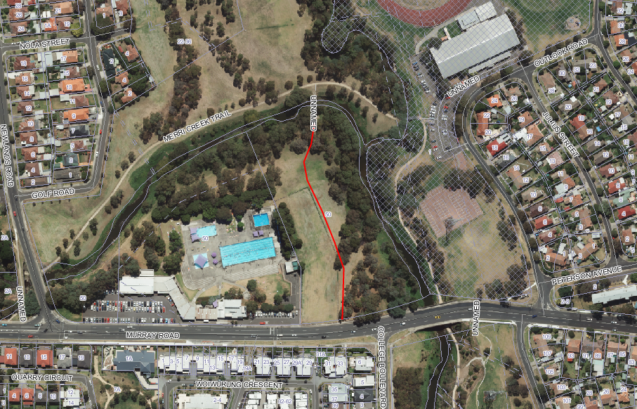

Attachment 1
Information Leaflet Questionnaire#2

