Moreland

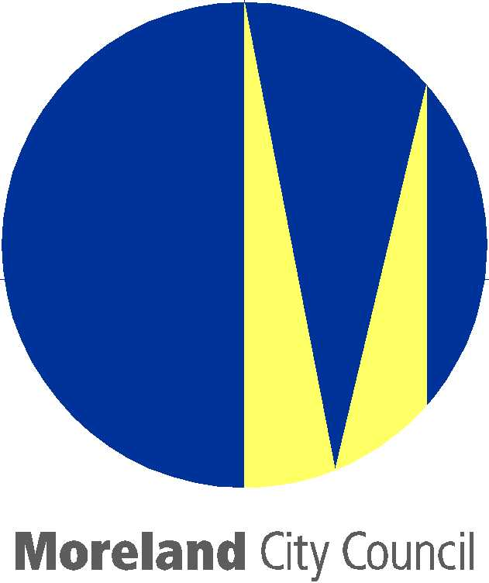
Draft Drainage Asset Management Strategy

NOVEMBER 2005
November 2005

Version Control

This Document is a live Council document and is subject to periodic review. The validity and currency of the document is critical in applying its content as it contains significant asset management and performance data that is “real-time” based.

If you are reading this document please check the version date and the endorsement date below to make sure that the document is current.

Version | Version Month | Year | Endorsed Date | Status
1.0.0 | October | 2005 | 20/10/2005 | Draft – Internal Consultation
1.0.1 | November | 2005 | 14/11/2005 | Draft – Public Consultation

Foreword
The storm water drainage network in Moreland represents a significant investment by Council and its ongoing development, management and maintenance is an important commitment.

Council’s aim to “keep the drains clear, keep the drains working and bring them up to the current standard” demonstrates its commitment to protect, maintain and enhance the public safety and to care for the general welfare of the community by safeguarding against damage from storms and floods within the context of Council’s affordable financial resources.

In recent years, there have been increasing concerns about the adequacy of Council’s drainage network to meet current standards, cater for current and future development and to minimize pollutants entering the waterways. In addition, in 2002 Council carried out a drainage capacity study, which assessed the capacity of Council’s existing drainage network and identified all areas in Council’s drainage system that could be subject to flooding.

Implementing the solutions to address the drainage issues experienced in Moreland will not be an easy or quick task. However, Council is confident that by implementing the key actions identified in this document, Moreland will be in a better long-term position to provide drainage assets that are sustainable, appropriate, accessible and responsive to the community.

The DAMS is a dynamic document as there will be regular updates to reflect the changing needs of the organization the community and the environment. Council welcomes constructive comments and suggestions for future editions. Comments should be made in writing and addressed to the Director City Infrastructure, Moreland City Council, Locked Bag 10, MORELAND VIC 3058 or info@moreland.vic.gov.au

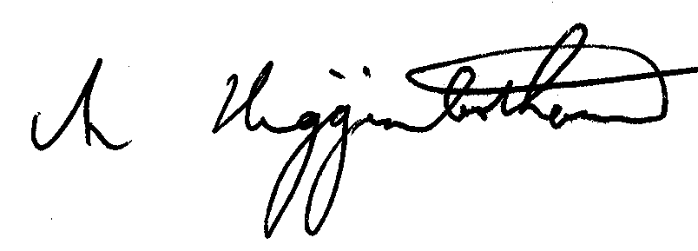

Cr Mark Higginbotham

Mayor

Table of Contents

Foreword 3
Table of Contents 4
1. Executive Summary 5
1.1 Introduction 5
1.2 Council Vision and Strategies and Actions 6
Maintenance Actions 6
Network Condition Actions 6
Flood Mitigation Actions 6
Design Standard Actions 6
Water Quality and Environmental Protection Actions 6
Sustainability Actions 6
Land Use Planning and Development Actions 6
Education and Awareness Actions 6
2. Purpose of the Strategy 7
2.1 Strategy Approach 8
2.2 Council’s Asset Management Vision 8
2.3 Key Benefits of the Strategy Implementation 8
2.4 Relationship with Other Council Strategies 9
3. Background 10
3.1 Defining Drainage 10
3.1.1 Drainage in Moreland 10
3.1.2 Major & Minor Drainage Systems 10
3.1.3 Council’s Role 11
3.1.4 Melbourne Water’s Role 11
3.2 Drainage Standards 11
3.2.1 Storm Duration 11
3.2.2 Impact of Drainage Design on our Daily Life 11
4. Current Position 13
4.1 Underground Drainage Asset Stock 13
4.2 Age of Council’s Drainage Assets 13
4.3 Drainage Information Management 13
4.4 Present Condition of Council’s Underground Drainage Assets 14
4.5 Drainage Issues in Moreland 15
4.6 Land Subject to Flooding - Overlays in Moreland 16
4.7 Managing the Provision of Service Delivery 18
4.8 New Underground Drainage Assets -Initial Design and Construction 18
4.9 Routine Maintenance 18
4.10 Periodic Maintenance 18
4.11 Renewal and Upgrade Works 19
4.12 Inspecting Drainage Assets 19
4.13 Prioritisation of the Drainage Improvement Program 19
4.14 Management of Stormwater Quality 19
5. Future Vision & Goals 20
5.1 Drainage Vision 20
5.2 Five-Year Goals 20
5.3 Twenty Year Goals 20
6. Gap Analysis 21
6.1 Are We Doing Enough? - Asset Consumption Vs. Asset Replacement 21
6.2 Projected Drainage Renewal Gap 22
6.3 Projected Upgrade Gap 23
7. Strategies and Actions 24
7.1 Maintenance Actions 24
7.2 Network Condition Actions 24
7.3 Flood Mitigation Actions 24
7.4 Design Standard Actions 24
7.5 Water Quality and Environmental Protection Actions 24
7.6 Sustainability Actions 25
7.7 Land Use Planning and Development Actions 25
7.8 Education and Awareness Actions 25
8. Adopted Financial Strategy 26
8.1 10-Year Drainage Financial Strategy 26
8.2 10-Year Financial Drainage Distribution Profile 27
8.3 10-Year Financial Drainage Distribution Profile – Assumptions 28
9. How Will We Monitor and Assess Performance of this Strategy 29
9.1 Cost Performance Measures 29
9.2 Condition Performance Measures 29
9.3 User Satisfaction Performance Measures 29
9.4 Maintenance Performance Measures 29
10. Strategy Review 30
11. Glossary of Terms 31

Executive Summary

Introduction
In recent years, numerous reports have been released analysing local government’s performance in asset management. The main two reports relating to the management of drainage assets have been:

- Victorian Auditor-General's report, "Managing Stormwater Flooding Risks in Melbourne" (July 2005)
- National Office of Local Government "Report on the Operation of Local Government" (2001)

These reports have identified that the environment in which local government operates is constantly changing and as assets continue to age, Councils will need to demonstrate an accepted level of skill/expertise and duty of care in relation to Council's management practices and maintenance of assets.

The Victorian Auditor-General's report also identified that “metropolitan Melbourne continues to be exposed to the risk of significant flood related damage from significant storm events. Reducing this exposure will require a range of responses from improving community education, upgrading drainage systems, introducing better planning controls and addressing legislative gaps. It will also require a ‘joined up’ government response. The Department of Sustainability, Melbourne Water Corporation and local government need to work collaboratively to raise stormwater flood protection levels for metropolitan Melbourne”.

In light of the above reports and as a result of recent flood events experienced within the municipality, resident feedback, adoption of the Moreland Asset Management Policy and involvement in the MAV Step Asset Management Improvement Program, Council has developed this Drainage Asset Management Strategy (DAMS) that outlines better resource allocation and utilisation with the objective of better decision-making based on quality data and well defined objectives.

Moreland City Council, like most councils faces a wide range of demands to improve the services its community wants. Funds are limited, and choices have to be made about which services / assets have the higher priority. The 2005 Mayor’s Speech states that “Council will renew and enhance Moreland's infrastructure, and will consider borrowing options for targeted infrastructure improvements, particularly those with an intergenerational benefit”.
The current written down value of Council’s Drainage infrastructure is of the order of $43.1 million and its replacement value is $121.6 million.

At present, the long-term annual asset consumption is in the order of $1.2 million. On current estimates, Council’s Drainage assets need upgrades and renewal works of up to $1.4 million each year, in the short-term (five year period) to ensure that the pipes, pits and culverts continue to function and maintain their service levels. This is a significant change, when compared to past levels of expenditure in the vicinities of $500,000 per annum.

Given that future asset renewal backlogs can be un-sustainable and given that the services provided in the future run the risk of falling below reasonably acceptable levels, Moreland City Council has decided that it is important to set its priorities in a systematic and coherent way. To do this, detailed strategies have now been developed in relevant operational, maintenance and funding areas. These strategies form the basis of the DAMS and set overall goals to ensure that Council’s funds and programs are working towards those goals. In addition, and equally importantly, the strategies give the community a clearer understanding of those goals, of what Council aims to achieve with the community’s money.

The 2005-2009 Council Plan makes reference to the above in the following statement:
“Council will responsibly manage the City’s infrastructure and plan for its renewal acknowledging the important impact this has on the community’s quality of life”.

The past level of funding on drainage assets has been around $500,000 per year, a figure that reflects the historical under-investment in infrastructure renewal across all categories of assets. The relatively lower level of spending compared with the recognised requirements, has occurred over a number of years, so that we are now faced with substantial ‘catch up’ spending as well as striving to meet current demands. For example:

- The majority of drainage pipes within the municipality have not been physically inspected and/or cleaned in more than 40 years, well beyond a desired level of at-least once every five years.

- In the southern and middle parts of the municipality, the drainage system was built in the 1890s – 1940s with the standards of drainage construction that were applicable to meet the requirements of the day, but not the growth of population and the expansion of residential and industrial developments we see today. The majority of Council’s pipes and pits are not up to a standard or size where routine cleaning or repair is practically achievable; leaving significant risk of blocked pits and pipes.

- The lack of drainage modelling techniques in the past and rate of growth within the municipality has led to poorly designed networks of pipes and pits. There are parts of the network that will need significant upgrades to meet current design standards.

- Lack of co-ordination with developers and lack of supervision and guidance has led to new assets that are faulty or sub-optimally performing.

Council Vision and Strategies and Actions
Council’s vision can be summarised as to “Keep the drains clear, keep the drains working and bring them up to standard”.

The DAMS recognises that the future planning is not exclusively about allocating more funds, but equally about improving the processes of maintenance and renewals, including aspects of design and supervision.

The key recommendation of the DAMS is to implement the strategies and actions identified in Section 7.

The following is a list of some of the key actions identified:

Maintenance Actions
- Continue with the proactive inspection and cleaning program for all pits within the municipality, once annually.
- Implement the purchase of a ‘Combination Unit’ to undertake proactive cleansing of all Council pipes. Utilise this combination unit to determine pipe condition.

Network Condition Actions
- Proactively CCTV inspect a random sample of the underground drainage system network on a two yearly cyclic basis, to identify the condition of these assets.

Flood Mitigation Actions
- Develop a plan to upgrade 30% of under-capacity pipes within the municipality to adopted standards with a prioritised program of works and begin implementation. This plan will be included in Council’s DAMP.

Design Standard Actions
- Develop a footpath paving policy to reduce the width of impervious surfaces where opportunities exist, in conjunction with the footpath renewal program.
- Council encourage the installation and use of rainwater tanks and water sensitive urban design.

Water Quality and Environmental Protection Actions
- Review Council’s Local Laws to ensure the local legal system fosters the reduction of pipe blockages caused by building sites that discharge debris into the system.
- Explore possible options with Melbourne Water of joint projects such as wetlands and retarding basins.

Sustainability Actions
- Increase funding to the required identified levels for capital renewal and maintenance to ensure that the drains are kept working.
- Put in place alternative mechanisms for raising funds for the provision of new drainage, by implementing special charge schemes.
- Lobby for additional funds from Melbourne Water to address issues of undercapacity drainage in the worst affected areas of Moreland.
- Apply for grants from the Urban Stormwater Conservation Fund to upgrade the drainage system to improve quality of water in the waterways.

Land Use Planning and Development Actions
- Explore the option of introducing an Infrastructure Contributions Plan (Development Contributions Plan). Funds collected from developers would be used to fund drainage upgrades and water sensitive urban design within the local area.

Education and Awareness Actions
- Implement an education campaign to inform the residents in the flood affected areas of Moreland as to the various drainage issues that Council faces and what actions they can take to alleviate the risk and/or consequence of potential flooding events.

Purpose of the Strategy
In recent years, numerous reports have been released analysing local government’s performance in asset management.

The main two reports relating to the management of drainage assets have been the Victorian Auditor-General's report, "Managing Stormwater Flooding Risks in Melbourne" (July 2005) and National Office of Local Government "Report on the Operation of Local Government" (2001).

These reports have identified that the environment in which local government operates is constantly changing and as assets continue to age, Councils will need to demonstrate an accepted level of skill/expertise and duty of care in relation to Council's management practices and maintenance of assets.

The Victorian Auditor-General's report also identified that “metropolitan Melbourne continues to be exposed to the risk of significant flood related damage from significant storm events. Reducing this exposure will require a range of responses from improving community education, upgrading drainage systems, introducing better planning controls and addressing legislative gaps. It will also require a ‘joined up’ government response. The Department of Sustainability, Melbourne Water Corporation and local government need to work collaboratively to raise stormwater flood protection levels for metropolitan Melbourne”.

In light of the above reports and as a result of recent flood events experienced within the municipality, resident feedback, adoption of the Moreland Asset Management Policy and involvement in the MAV Step Asset Management Improvement Program, Council has developed this Drainage Asset Management Strategy (DAMS) that outlines better resource allocation and utilisation with the objective of better decision-making based on quality data and well defined objectives.

- Linking and integrating Council’s Asset Management vision and resources;
- Transparent setting of priorities for funding used on drainage assets.
- Forecasting future service delivery needs and the capacity of the drainage assets to meet those needs, on short, medium and long-term basis; and
- Establishing systems for performance measurement of Council’s drainage assets.

For many years, Moreland and other Councils have had to manage their extensive Drainage networks in an environment of limited funding. This has had the positive consequence of encouraging better efficiencies in managing and rehabilitating pipes and pits. However, the extent of the shortfall has been such that there has been a gradual decline in the integrity of the infrastructure. This has been exacerbated by increases in the levels of growth in residential and industrial areas, particularly new developments in the municipality and a growing trend towards increasing the number of properties on existing land, hence increasing the risk of flooding.

A central issue for the DAMS is the allocation of funding to remedy these problems by taking a long-term view of infrastructure performance and cost, and considering options in a comprehensive, pro-active and informed manner. The DAMS is driven by policy goals and objectives as detailed in subsequent sections and relies on systematic assessments of asset performance and costs. It:

- Provides a framework for responsible and strategic management of the drainage network. It sets out the overall goals for the maintenance and renewal of drainage assets, and assists to set clear priorities for the funds used each year. The DAMS in effect takes a futuristic view and outlines the principles, platforms and directions upon which Moreland City Council’s Drainage Asset Management Plan (DAMP) is based.

- Provides the basis for the development of forward works plan and expenditure targets. It will aid Council to manage its assets in a sustainable manner that enables them to last their full-expected life and provide the intended levels of service.

- Sets out a desired level of expenditure to meet the demands of the drainage assets and to help achieve other strategic Council goals. The DAMS also sets out the optimal way to spend available limited funds to achieve best outcomes, i.e. maximise the service potential of the assets. Efficiencies are being gained through improvements in drainage maintenance technology, and better pits and pipes (designed for both serviceability and maintainability). The DAMS also leads to a dynamic adaptation of future design standards to ensure that new assets in the drainage portfolio are built in such a manner that they lend themselves to easy and cost-effective maintenance practices.

With the range of demands on Council’s budget, it will clearly take some time before we reach the target of the desired $1.4 million per year in capital renewal expenditure. The DAMS is therefore a long-term document. While setting Council’s directions, the DAMS will change and develop with new technology, funding availability, and changing emphasis in Council priorities.

Council has steadily expanded its use of information systems and performance measures in the management of drainage and associated assets over recent years.

It is important that the DAMS be accepted as a dynamic document that will change with shifting priorities and as a result of the development of more expert recording and analysis of data. The successful implementation of the DAMS will require strong leadership, ‘buy-in’ by all Asset Responsible Managers and staff, multi-disciplinary perspective and a sustained, consistent commitment.

Strategy Approach
Council’s approach to the DAMS is driven by what it takes to provide an ‘acceptable, functioning drainage network on the ground’. Therefore, the DAMS has been built from the ground up as follows:

- Council has defined and articulated the key services desired. These services form the basis of the DAMP and funding objectives. This document describes both the current state of assets and services and Council’s vision for future services and assets.

- Council has established ‘acceptable levels’ at which these services may be provided. These levels form the basis for future resource levels and tactics.

- The agreed levels of service have been used to determine the:
  - Standard of new drainage assets and their functional features.
  - Upgrade requirements for existing assets.
  - Minimum maintenance requirements existing assets, so that service levels are met.

- Strategies have been documented and recommended for:
  - Financial resources required for the short-term and the long-term to meet the target service levels.
  - Condition monitoring of drainage assets to manage the physical state of the asset.
  - Capacity monitoring of drainage pipes and pits to monitor the serviceability potential of the asset.
  - Criticality monitoring drainage pipes and pits to develop prioritisation mechanisms that will enable Council to target funds more appropriately.
  - Resource allocation to meet service level targets.

The monitoring and review process is intended to continuously improve the quality of information, strategies and associated tactics and plans. Key performance indicators, documented in Section 9 will be used to monitor the strategy. These KPIs essentially provide the base-line for future decision-making.

Council’s Asset Management Vision
The vision stated in Council’s Asset Management Policy 2005, is as follows:

Vision: Ensure that Council’s assets support services that are sustainable, appropriate, accessible and responsive to the community.

Goal: Meet the required level of service in the most cost-effective way through the creation, acquisition, maintenance, operation, rehabilitation and disposal of assets to provide for the community in the present and future.

Moreland City Council acknowledges that the fundamental aspect of this vision is to provide a good, acceptable level of service that will enable a good, acceptable quality of life. This is the basis of our DAMS.

Key Benefits of the Strategy Implementation
Through the implementation of the DAMS, Moreland City Council seeks to achieve the following benefits:

- Lowering its long-term costs of drainage asset preservation.

- Reducing the backlog of maintenance progressively over time through improved decisions, enhanced technology and increased funding that is optimally targeted.

- Improved Drainage network performance, lower disruptions and inconveniences to users and lower risks of accidents and damage resulting from drainage failures.

- Improved and effective use of available resources through optimised decision-making.

Relationship with Other Council Strategies
The DAMS sets the future direction to enable Council to be in a better position to manage its drainage assets and achieve the Asset Management Policy vision, goals and targets. In order to do this effectively, other Council strategies and plans must be considered and they include the:

- Council Plan 2005-2009;
- Strategic Resource Plan 2005-2009;
- Stormwater Management Plan;
- Watershed Action Plan 2001-2021;
- Road Asset Management Strategy;
- Road Asset Management Plan;
- Integrated Transport Strategy;
- Moreland Open Space Strategy;
- Economic Strategy; and
- Street Landscape Strategy.

Background

Defining Drainage
Any rain that falls on roofs or is collected via paved areas like drive ways, roads or footpaths is called stormwater. The drainage network within the City of Moreland is a combination of pits, pipes, open channels, natural waterways and road reserves, which carry the stormwater and dispose it in creeks, rivers and/or other catchments. The stormwater eventually ends up in the ocean.
The figure below shows a typical drainage concept for urban catchments.

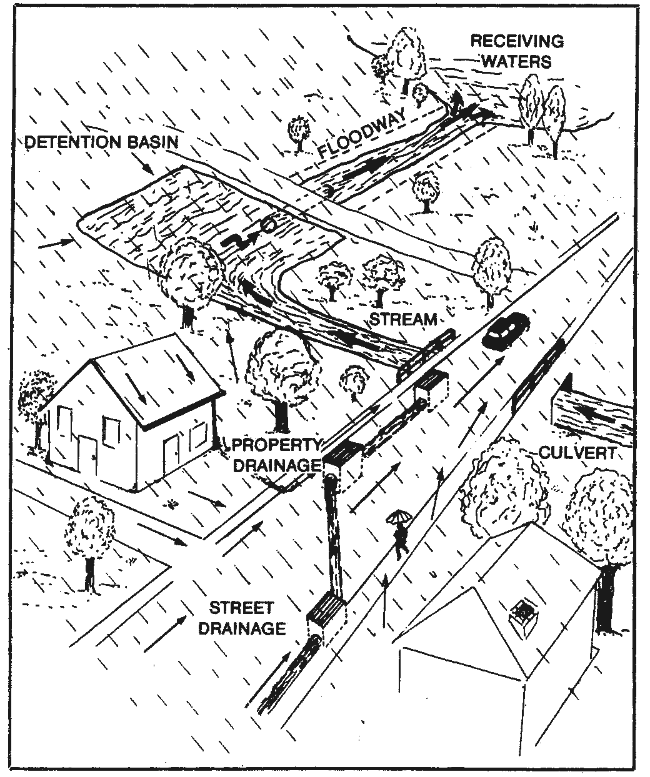
Diagram 1 – Typical drainage concept for urban catchments

Drainage in Moreland
Moreland, as a result of its period of development, has not evolved in a manner that has all roads or properties serviced by constructed drainage systems. Generally, communities have grown without many of the services considered normal in modern subdivisions, including drainage. Council constructed those that now exist at a later date as problems were identified. This has not resulted in all roads or properties gaining good drainage, as the retrofitting was often difficult to achieve, particularly where the allotments are small, the roads narrow or where property owners had intensely developed their land. This is particularly the case in the older areas of the municipality.

Moreland also suffers from other drainage difficulties. Some areas have developed in a manner that resulted in the filling of minor waterways, occasionally without a replacement pipe system. This creates concerns ranging from poor property access to drainage systems through to pipe systems that have to serve a large area that are often more susceptible to failure. Whilst drainage lines can be sized to cater for a large area, over time it is common for small-unintended pockets of land to be connected to the system, generally because the Planning Scheme does not restrict it. This, coupled with changes in land use and site densities, often results in a gradual decline in the level of service, particularly in the larger catchments.

Another aspect of drainage in Moreland is the use of rights of way for above ground drainage. This is often effective, particularly where the slopes are adequate and the rights of way constructed. Where, however, the rights of way are unmade or the general surface slopes are inadequate, problems occur with water remaining for days after the rain has ceased and creating potential amenity problems to the surrounding area.

Stormwater drainage systems ultimately connect to creeks and rivers that come under the care and management of Melbourne Water. Where the creeks or small watercourse have been filled in and replaced by drainage systems, the controls still remains with that authority and are called main drains. In Moreland, Melbourne Water controls over 32 km of main drains.

Major & Minor Drainage Systems
Drainage systems are usually designed as two separate elements. The underground piped network transports stormwater flows for minor storm events (generally flows of up to 1 in 5 ARI). The piped network has sufficient capacity to contain nuisance flows and reduces the frequency and quantity of surface flows.
The major drainage system caters for flows in excess of the piped network and usually consists of floodways, road reserves or natural waterways. The major drainage system prevents stormwater damage to properties and transports the stormwater to the receiving waterways. The frequency at which the overland drainage system operates is determined by the design criteria of the piped network.

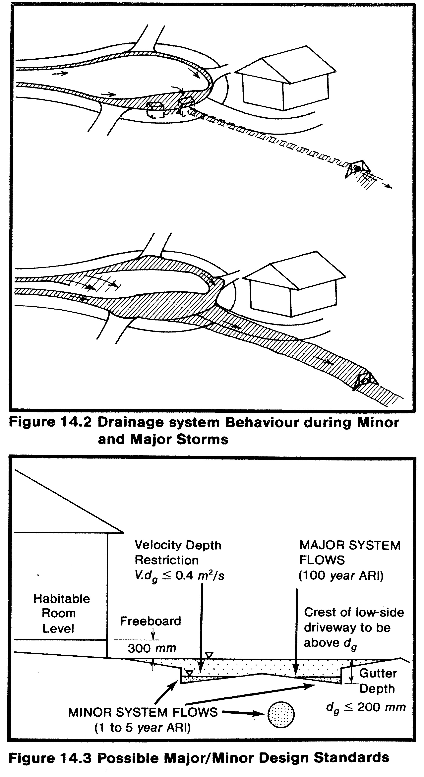
Minor
Major
Diagram 2 – Drainage system behaviour during minor & major storm events

Diagram 3 – Possible major & minor design standards

Council’s Role
Council primarily controls the stormwater drainage system, (supporting catchments up to 60 hectares in area) with the exception of the larger pipes and creeks.

In its role as the local drainage authority, Council is responsible for maintenance and renewal of the existing drainage system.

Council is also responsible for undertaking forward planning and administering development control through planning permit assessment, building permit assessment and local laws.

Melbourne Water’s Role
Melbourne Water is the regional drainage and floodplain management authority for the Melbourne area. It is responsible for managing regional drainage and flood mitigation (generally supporting catchments greater than 60 hectares) and operating and maintaining 32kms of main trunk drains within Moreland.

Melbourne Water is also responsible for the management of the Merri, Moonee Ponds, Edgars, Westbreen and Merlynston Creeks that pass through Moreland.

Drainage Standards
Rainstorms vary in intensity and duration and therefore the quantity of water runoff also varies from one occasion to another. Accordingly, drainage systems are designed to be able to cope with the runoff from storms up to a predetermined designed rainstorm. This design rainstorm is discussed in terms of the frequency with which it occurs, for example, a 1 in 5 year ARI (Average Recurrence Interval) storm event, which is a generally accepted standard for minor drainage systems in metropolitan Melbourne, has a chance of occurring once every 5 years or in other words, this storm event has a 20% chance of occurring every year.

The greater the frequency interval, the greater the intensity of the expected storm, and the larger the drainage pipe sizes required and corresponding cost.

New drainage infrastructure within Moreland is provided in accordance with the design criteria in Table 1. These criteria are based on the Australian Rainfall and Runoff Guidelines and the VicRoads Road Design Guidelines, Part 7 Drainage.

Area | Storm Frequency | Probability of Storm Occurring in Any Given Year
Residential Areas | 1 in 5 year ARI | 20%
Central Business Districts | 1 in 10 year ARI | 10%
Commercial / Industrial | 1 in 10 year ARI | 10%
Overland Flow Paths | 1 in 100 year ARI | 1%
Road Reserves | 1 in 100 year ARI | 1%
Table 1– Drainage design standards

Storm Duration
This recognises that a 1 in 5 year storm that lasts for 1 hour will produce a different runoff outcome than a 1 in 5 year storm that lasts for 24 hours. Either may, in fact, cause flooding problems depending on the size of the catchment and the nature of the existing drainage downstream. The former is likely to cause localised flooding of a few houses, whereas the latter may cause a local creek to rise and have broader scale flooding problems.

The design process must use judgment to assess the typical storm duration and frequency that will occur for any particular location.

Impact of Drainage Design on our Daily Life
All drainage systems are designed for a defined frequency. Therefore, all systems have a finite flow capacity and once that capacity is exceeded, the stormwater runoff will seek other flow paths. If not planned correctly, that route may well be through private property, and occasionally, the buildings as well. Unfortunately, this is more common in older developed areas of the municipality as most existing systems have not been designed with an ‘escape route’ in mind.

In addition, the urban consolidation involving multi-unit development is also having an impact of increasing the impermeability and thus the amount of stormwater runoff. This further reduces the service level provided by the existing drainage system. In general, there is little that can be done to increase the overall capacity of the system to cater for the increased flows as it would be prohibitively expensive to consider replacing existing pipes including the larger main drains that run to the creeks.

One common method of trying to minimise the impact of the higher densities is by requesting developers to provide on site water detention systems at the time of development.

The final impact of the provision of drainage services lies in the definition of ‘flood prone’ as accepted by Local Government and the insurance industry. In general, property affected by storm events of 1 in 100 year ARI (ie. Has a 1% chance of occurring in any given year) may be considered as flood prone.

As the underground drainage system in Moreland does not cover this level of service, greater emphasis is therefore placed on establishing that the consequences of storm events of 1 in 100 year ARI is managed by the major flow paths.

The major flow path is built into the roads through both the layout and the capacity of the kerb and channel. Most importantly it consists of a sympathetic layout of roads that is capable of carrying all flows that the underground drainage system cannot.

Where stormwater flows are considerable and the shape of the road inappropriate to act as a major flow path, generally the only satisfactory solution is for the reconstruction of the road.

That, however, is expensive and often has the additional complication of utility services, which are buried in the road pavement that are close to the surface.

Current Position

Underground Drainage Asset Stock
Council owns and maintains approximately 509kms of underground drainage pipes and 17,700 drainage pits worth approximately $122 million.

Asset Type | Quantity | Length (m) | Replacement Cost
Drainage Pipes |  | 509,689 | $95,056,032
Drainage Pits | 17,704 |  | $25,151,051
Gross Pollutant Traps | 25 |  | $866,228
Box Culverts |  | 1,864 | $538,318
Retarding Basins | 0 |  | $0
Total |  |  | $121,612,078
Table 2– Drainage asset stock values as at 30 June 2005

Diagram 4 – Distribution of pit types in drainage network
SEP – Side Entry Pit
GP – Grated Pit
JP – Junction Pit
CP – Concealed Pit
GPT – Gross Pollutant Trap
Diagram 5 – Distribution of pipe sizes in drainage network
Many of these assets were first constructed at the same time as the original suburbs were built. They are now in varying condition, depending on a range of factors:
- When they were originally built (much of Brunswick in the 1880s, Coburg and Pascoe Vale in the 1920s and 1940s, to Glenroy and Fawkner in the 1950s).
- The standards applicable at the time of construction.
- How well the assets have been maintained (some have seen major cleaning, clearing, rehabilitation, even reconstruction work, others little work since being built).
- The environment surrounding the drainage assets (eg: in the vicinity of large trees).

Age of Council’s Drainage Assets
Diagram 6 – Average age of drainage assets stock compared to expected useful life

Drainage Information Management
All information pertaining to location, type, sizes, materials, known constructed dates and condition of the drainage assets specified in Table 2 is recorded and stored in Council’s Drainage Asset Register. It is estimated that Council’s Drainage Asset Register is about 90% up to date.

In 1996, Council undertook an extensive desktop exercise where all data from available construction plans/drawings was entered into a central data register, which was spatially linked, to a Corporate Geographical Information System (GIS).

Following on from this exercise, consultants were engaged to verify all drainage pits and pipes on site. This exercise involved walking the entire municipality to visually identify all drainage assets and where appropriate, changes were made to Council Drainage Asset Register to reflect the drainage network as constructed.
Council acknowledges that its Drainage Asset Register is not 100% complete and that discrepancies exist. These discrepancies exist because of past practices of constructing assets without drawings, incomplete drawings as a result of lost records during Council amalgamations, poor past record keeping practices, poor past construction practices (what was specified on the plans was not built out in the field) and because not all pit locations and types could be verified as over time, they have been buried under the road pavement.

It is envisaged that over the next five years as additional detailed inspections are undertaken and processes documented that the Drainage Asset Register, which is linked to the GIS, will be 99.9% accurate.

Present Condition of Council’s Underground Drainage Assets
By understanding the condition of Council’s drainage assets and the various types of distresses that affect Council’s assets, Council can utilise this data to endeavour to maintain the level of service the community wants, in the context of affordability and also minimise the risk of asset failure. The consequences of drainage failures can include legal liability and downstream impacts on Council and Melbourne Water drains and waterways.

There are many reasons why existing drainage assets fail/deteriorate and therefore do not meet current performance standards and community expectations. Among the most common reasons for failure are the following:

- Damage by service authorities when installing / constructing their infrastructure within Council’s road reservation.

Many Closed Circuit Television (CCTV) audits have revealed service authority conduits running through the underground drainage pipes. These conduits generally obstruct debris in the pipe system causing it to block.

When cases such as these are detected, Council writes to the relevant service authorities and requests that they carry out rectification works to remove the pipe conduits.

The CCTV camera inspection is carried out by sending a small remote controlled car, fitted with a camera inside the drainage pipe.
The camera on the remote controlled car allows an inspector to record the images onto video that can be kept as a permanent record. As the camera moves up the pipe internally, the inspector who is views the images on a TV unit, usually sitting inside a mobile unit undertakes a visual inspection while viewing the images and incorporates a written report that covers defects and provides photographs.
- The predominant soils within the municipality are basaltic clays, which are highly reactive and expand and contract with changes in moisture content. The movement of the sub soil can generally cause the underground drainage pipes to move from their original constructed alignment, becoming disjointed.
- Tree roots searching for water entering cracked pipes or at the pipe joint, causing permanent structural damage or blockage in many instances.

- Cracking due to traffic loads. The growth in the transportation industry has led to an increasing number of B-doubles, Twin-Axle Trucks and heavy load carrying garbage trucks. This has an invariable structural impact on the surface drainage assets like pit lids and grates as well as the underlying pit structure and shallow pipes.
- Blockage of the pipes and pits from some building sites; allow soil, concrete and rubble to enter the underground drainage system. Also house-hold and street debris over time can contribute to blockage of the pipes and pits.

Based on condition audits and inspections carried out on a sample of Council’s drainage network in 2004, drainage assets were estimated to be in average condition as shown in diagram 7 in the condition barometer chart. On a network basis, as shown below, on average our pipes and pits have consumed 60% of their useful life.

Diagram 7 – Average useful life consumed of drainage asset stock

Council acknowledges that the method used to ascertain the network condition of its drainage assets has been based on a statistical calculation that was based on a percentage of audited data and determined by an experienced consultant in this area, to represent Council’s entire network.
This statistical sampling is a recognised and widely used method, due to the fact that the drainage pipes are buried below the ground, and a visual assessment of the drainage pipe network is difficult to determine without the assistance of CCTV technology. Due to the extensive network of Council owned drainage pipes the exercise of undertaking CCTV inspections is a costly one and Council does not have the available financial resources required to undertake extensive CCTV visual condition assessments for the entire drainage network.
Council has however, commenced a program in 2004, to undertake visual condition audits of a percentage of its underground drainage pipe network on a two yearly basis.
As information from these CCTV condition audits becomes available, the condition data in the Drainage Asset Register will be continually updated to ensure a clearer understanding of the condition and performance of the drainage pipe network.
In addition, Council has undertaken additional CCTV condition audits over time in response to problems reported by residents or observed with the drainage performance. Where this has occurred, the condition data pertaining to these assets has been updated in Council’s Drainage Asset Register.
The general observation as identified by the CCTV audits is typically one of blockage in the pipe affecting the pipe’s performance or poor structural condition as a result of pipe displacement and tree roots entering the pipes through cracks or butt joints, which also affects the pipes performance.

Drainage Issues in Moreland
Many of the catchments within the City of Moreland are heavily developed and parts of the drainage networks are considerably old, with some drains dating back to the 1850s. This presents particular drainage issues that are not encountered in newer suburbs.
The specific drainage issues within the City of Moreland are:
- Undercapacity drainage - some of the earlier drainage was designed to cater for just a 1 in 1 year storm event.
- Dated drainage network – some components of the drainage network have reached the end of their expected life and will need replacing over the next 25 years.
- Limited space – the high density of development in many areas of Moreland makes it is difficult to establish retarding basins or overland flowpaths.
- High level of development - the high level of development within many parts of the city increases the demand on many sections of the already undercapacity drainage network.
- Some overland flowpaths pass through private property - As a result of development, some properties have been constructed in overland flowpaths.
- Not all properties discharge to a drainage system – this leads to a higher level of nuisance flows.
- Limited capacity of downstream Melbourne Water Corporation drains – hence limiting the capacity of Council’s drainage system.
- Inconsistent drainage standards throughout the city – became even more evident following the merging of Coburg, Brunswick and Broadmeadows to create Moreland City Council.

Land Subject to Flooding - Overlays in Moreland
In 2002, Council commissioned the services of an engineering consultant to undertake a capacity analysis of the drainage network within the municipality.
The objectives of the study were to:
- Identify deficiencies in Council’s drainage system.
- Identify all areas in Council’s drainage system that may be subjected to overland flows.
Diagram 8 on the following page provides an illustration of the areas that have been identified as subject to possible flooding as part of the capacity analysis and named Land Subject to Flooding (Council) and Special Building Overlay and Land Subject to Inundation Overlay, as identified by Melbourne Water.
The dark blue shaded areas on the diagram represent Melbourne Water’s Special Building Overlay. The Special Building Overlay identifies urban areas that have been acknowledged by Melbourne Water as subject to possible flood inundation by overland flows during storm events of 1 in 100 year capacity, due to undercapacity drainage infrastructure owned and maintained by Melbourne Water.
The medium blue shaded areas on the diagram represent Melbourne Water’s Land Subject to Inundation Overlay. The Land Subject to Inundation Overlay identifies areas that have been acknowledged by Melbourne Water as land located in flood storage or flood fringe areas and affected by 1 in 100 year storm events. These areas are typically land adjacent to the natural waterways being the creeks and will typically flood when stormwater entering the creek rises above the level of the creeks banks and overflows to the adjacent land.
These Melbourne Water overlays have been included in the State Planning Scheme Map and assist local authorities to implement the State Planning Policy Framework and the Local Planning Policy Framework, including the Municipal Strategic Statement and local planning policies.
Melbourne Water being the flood plain management authority for the greater Melbourne area, therefore plays an important role in the planning system as the referral authority. This means that Moreland City Council must consult with Melbourne Water when assessing planning applications to construct within these designated areas.
The light blue shaded areas reflect Council’s Land Subject to Flooding overlay, which represent probable overland flow paths, i.e. paths along the Council drainage system where floodwaters could flow during major storm events (1 in 100 year ARI), due to undercapacity of the drainage infrastructure owned and maintained by Council. This overlay has been identified and mapped by the engineering consultant who undertook the capacity analysis and is based on the consultant visiting each street in the municipality, studying maps and undertaking calculations to identify drainage problem locations.
These light blue shaded areas shown in diagram 8 could also be incorporated into Council’s Planning Scheme as a Special Building Overlay to ensure that they are available to private building surveyors to ensure compliance with the Building Regulations Act 1994 when assessing planning applications to construct within these designated areas.
By incorporating Council’s Land Subject to Flooding overlay into Council’s Planning Scheme this would require that any future building development prior to being granted approval, would need to comply with the requirement that the finished floor level will be at least 300 mm above the 100 year ARI flood level.

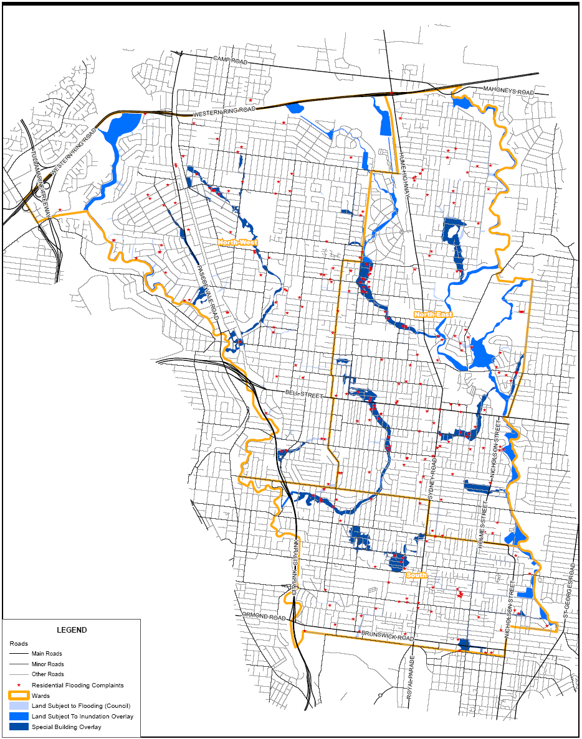
N
Diagram 8 – Map of probable areas in Moreland subject to flooding

Managing the Provision of Service Delivery
The DAMS is based on providing assets that are adequate for defined service levels. Therefore, Council in providing its drainage levels of service will address the provision of service at three tiers.

- Initial design and construction for new assets
- What are the key features of a new drainage asset that will be included in our new designs?
- If we provide a new drainage infrastructure, what is the level of functional adequacy, level of capacity and condition as a minimum?
- Ongoing routine maintenance for built assets
- Once the drainage asset is constructed, what is the minimum level of maintenance we will provide to keep the asset safe and serviceable?
- Periodic maintenance for built assets
- What periodic activities will we undertake on a pro-active basis to extend the life of our drainage assets?
- Renewals or Upgrades for assets beyond their service potential
- When and why will we renew drainage infrastructure?
- What is the physical shape and feature of an upgraded asset to ensure that it meets required standards?

New Underground Drainage Assets -Initial Design and Construction
The creation of a new drainage involves two distinct processes - first design and then the construction. With inner city re-development, Council currently has more new roads and drains being constructed than we have seen for some time. These are occurring with new medium density projects such as Victoria Terrace (Victoria Street) in Brunswick, the development of former school sites such as Oak Park High School, and more extensive new developments such as the Gowanbrae estate and Pentridge Estate.

Council sets design standards for drainage in these developments, so that the proposed pavement and surfaces take into account site features and the level of use of the drainage. Council then considers the drainage design, and other features such as drainage capacity, in the planning approval process.

Council will apply its specifications, called Technotes, for design and construction of new drainage pipes and pits.

All new drainage infrastructure such as pipes, pits, culverts and other ancillary assets required for new developments are built by the developers and their contractors and approved by Council. Council staff supervises the works to ensure compliance to Council’s specifications.

When the works are completed and after a 12-month maintenance period, the developer hands these assets over to Council for ownership and maintenance for the remainder of their useful life.

Council also uses the Technotes when it undertakes capital improvement works of the underground drainage system or implementing drainage special charge schemes.

Routine Maintenance
Over time, minor faults can occur with the drainage assets. Council addresses the repairs and maintenance of these faults on the basis of defined intervention levels and response times.

The intervention level defines the condition, state or risk level associated with an asset component, i.e. the point in time at which the asset is considered to be below an acceptable level of service. Maintenance is scheduled as soon as the drainage asset reaches this point.

Response time defines a reasonable time frame within which the residents can expect Council to remedy the defect.

The intervention levels and response times are contained in Council’s DAMP.

Periodic Maintenance
This is more extensive than routine maintenance, but does not involve the full rebuilding of the drainage infrastructure. Typically, periodic maintenance involves programmed pit inspection, programmed clearing, programmed pipe enhancements and programmed pit upgrades.

Occasionally, short sections of pipes may require replacement. However, this is only appropriate if the repair of a small section solves immediate problems, rather than simply transferring the drainage problems to another part of the street.

The intervention levels and response times are contained in Council’s DAMP.

Renewal and Upgrade Works
This is the most extensive form of drainage works. Typically, it involves the replacement of old or malfunctioning pipes and pits. It is also part of Council’s upgrades during street rehabilitation works. Where possible, some of the drainage assets may be retained, which lowers costs. In addition, to enhance maintainability, Council will ensure the use of a minimum pit size of 900x600mm and the use of fibre glass pit lids.

Generally, reconstruction results in a drainage asset that is “as good as new” - and will have a life expectancy equivalent to a new drainage.

The intervention levels and response times are contained in Council’s DAMP.

Inspecting Drainage Assets
The DAMP will describe the future scope and programmes of such audits and assessments. The methodology of assessment is contained in Council’s ‘Drainage Data Collection Guidelines’. The typical items that will be assessed are:
- Structural condition of the pipe
- Capacity rating of the pipe
- Structural condition of the pit

Prioritisation of the Drainage Improvement Program
The framework with which Council will prioritise its drainage renewal program will be further developed and fine-tuned in the DAMP.

It is envisaged that Council’s prioritisation index for drainage assets will take into account the following formula:

Condition + Serviceability + Sustainability = Priority Index

Condition = Deteriorated/failed drainage asset that requires preventative or remedial action to bring it back to its original state.

Serviceability = Provision of fit for purpose drainage infrastructure that has the capacity and adequacy to manage the flow requirements, based on defined levels of service.

Sustainable = Meeting the needs of the present without compromising the ability of future generations to meet their own needs. Working towards reducing pollutants entering the stormwater system and ending up in receiving waterways.

Management of Stormwater Quality
Moreland City Council adopted a Stormwater Management Plan in 2001, to provide a strategic framework to protect stormwater quality through the municipality, thereby protecting local and downstream waterways that receive stormwater run-off.

Since the implementation of Council’s Stormwater Management Plan, Moreland City Council has undertaken significant initiatives to reduce pollutants entering the stormwater system and ending up in receiving waterways.

One of the main actions identified by the Stormwater Management Plan and directly linked to the DAMS is the installation of Gross Pollutant Traps. Council has established priorities through the Stormwater Management Plan to install Gross Pollutant Traps at various strategic locations. Since 2001, Council has been progressively installing these Gross Pollutant Traps.

Future Vision & Goals

Drainage Vision

Ensure that Council’s drainage assets are sustainable, appropriate, accessible and responsive to the community.

The key outcomes of this vision are to keep the drains clear, keep the drains working and bring them up to the current standard.

Sustainable – Meeting the needs of the present without compromising the ability of future generations to meet their own needs. Working towards reducing pollutants entering the stormwater system and ending up in receiving waterways. This includes the assets bring environmentally sustainable.

Appropriate – Provision of fit for purpose drainage infrastructure that has the capacity and adequacy to manage the flow requirements, based on defined levels of service as contained and monitored in our Drainage Asset Management Plan.

Accessible – Provision of drainage infrastructure that can be accessed by all residents as per Council’s service standards.

Responsive – Provision of fit for use drainage infrastructure that is maintained and repaired based on reasonable standards and response times.

Five-Year Goals
To attain this vision in the following 5 years, Council aims to:
- Develop an on-going proactive program to flush all drainage pipes over a two to three year period to keep the drains clear.
- Continue with proactive pit cleansing program, once annually.
- Review all overland flow paths and develop a targeted program to keep these paths clear of obstructions.
- Progressively increase funding for capital renewal and maintenance to ensure that the drains are fit for use.
- Develop a plan to upgrade the drainage system to adopted standards with a prioritised program of works.
- Put in place alternative mechanisms for raising funds for the upgrade of the drainage system.
- Upgrade at least 50% of pits that are un-maintainable and in areas of high-risk of damage.
- Upgrade pit lids with fibreglass material type that are located in areas of high-risk of damage.
- Prepare a Planning Scheme Amendment to incorporate the Sustainable Tools for Environmental Performance Strategy (STEPS) into the Moreland Planning Scheme.
- Continue to encourage the use/installation of rainwater tanks in the municipality by offering residents discounts and information.

Twenty Year Goals
In the next 20 years, Council aims to:
- Upgrade at least 30% of under-capacity pipes within the municipality.

- Have all new development meet 100% on-site treatment for stormwater management under the STEPS program (currently requires 75% on-site treatment).

- Reduce where appropriate impermeable surface areas.

These goals are the fundamental basis of determining the actions plans and funding needs for the DAMS.

Gap Analysis

No asset lasts forever. Even with good maintenance, drainage assets will generally last between 60-100 years.

The Moreland situation is critical – The area saw bursts of urban development in the 1880s (Brunswick), 1920s (Coburg) and 1945-60 (Pascoe Vale, Glenroy, Fawkner) - which results in significant demands for reconstruction in the 1980s, 2020s and around 2050.

Are We Doing Enough? - Asset Consumption Vs. Asset Replacement

In accordance with Australian Accounting Standards, applicable to local government infrastructure, Council now reports on the annual depreciation of its assets. The fundamental purpose of this depreciation is to determine the long-term consumption rates of the asset infrastructure. In accordance with the new International Financial Reporting Standards, Council acknowledges that long-term consumption profiles may not be an indicator of short-term funding needs. However, Council utilises the consumption characteristics to develop average funding scenarios.

An analysis of the data relating to the drainage network size and the information reported to Council provides an opportunity to test if Moreland may be doing enough from a long-term asset provision perspective and also to assess objectively where the gaps are.

The following table lists Council’s key drainage assets, annual depreciation values as at 30 June 2005. The table also lists the amount currently spent each year on new or renewal capital works including grants available to Council.

Component | Depreciation per Annum | Average Actual Capital Funding | % of Asset Depreciation Funded Through Capital Renewal
Drainage Pipes (Renewal) | $950,560 | $240,000 | 25%
Drainage Pipes (Upgrade) | - | $66,107 | N/A
Drainage Pits (Renewal) | $251,515 | $156,500 | 62%
Litter Traps (New) | $8,662 | $77,328 | -
Culverts (New) | $8,972 | $2,007 | -
Totals | $1,219,710 | $541,942 | -
Table 3 – Drainage asset depreciation as at 30 June 2005 versus average actual capital works expenditure
Taking into consideration the range of services Council delivers and limited funds that are available, table 3 demonstrates that Council not been funding its annual drainage depreciation.

Moreland is not alone in facing a shortfall between asset replacement demands and the funds to pay for them. A report for the Office of Local Government in 1998 studied the infrastructure requirements and funding of all Councils in Victoria. This report found that in the near future, many councils will face a big shortfall between the demands for drainage renewal, and the funding available.

The condition assessment of our underground drainage system coupled with the observed poor performance of drainage in numerous areas, confirm that the levels of funding similar to those calculated through the depreciation method are indeed required to bring the underground drainage system in Moreland to a level that is commensurate with the community’s expectations.

Projected Drainage Renewal Gap

Council’s drainage infrastructure gap is defined, as the estimated immediate capital injection required renewing those assets that are in poor or very poor condition states. This is based on a service need that assets in such conditions are not able to provide appropriate services in accordance with Council’s Vision statement.
Condition Score at which Council will Replace Pit or Pipe

% of drainage asset

Condition Score

Diagram 9 – Condition distribution of drainage assets in various condition states
On a condition scale of 0 to 10 with 10 being the worst, the above graph indicates that 45.67% of Council’s pit and pipe assets are at a condition 5 or worse.
Diagram 10 – 20 year annual predicted capital renewal drainage expenditure
2006-2011
2011-2016
2016-2021
2021-2026
Diagram 10 indicates that Council will require funds in the order of $19 million dollars over the next 20 years to renew all pipe and pit assets that will reach a condition score of 10. $845,000 will be required per year from 2006 to 2011.

2006-2011
2011-2016
2016-2021
2021-2026
Diagram 11 – 20 year prediction of condition of drainage pipes based on current capital funding levels
Diagram 11 indicates that based on current and historical capital funding renewal patterns ($240,000 per annum) for the pipe network, at the end of twenty years, 11% of the pipe network will be in condition state 10.

With 509.7km of underground drainage pipes, that equates to 56km of pipes that will be in condition score 10.

2006-2011
2011-2016
2016-2021
2021-2026
Diagram 12 – 20 year prediction of condition of drainage pits based on current capital funding levels
Diagram 12 indicates that based on current and historical funding patterns ($156,000 per annum) for the pit network, at the end of twenty years, 3% of the pit network will be in condition state 10.

With 17,704 drainage pits, that equates to 531 pits that will be in condition state 10.

Diagram 13 – 20 year predicted capital funding gaps
2006-2011
2011-2016
2016-2021
2021-2026

Diagram 13 indicates that based on current and historical funding patterns for the renewal of the pipe and pit network, at the end of twenty years, Council will have an asset backlog in the order of $11,125,00. Between 2006 and 2011, Council will have an annual drainage asset gap of $475,000 per year.

Projected Upgrade Gap

In 2002, Council commissioned the services of an engineering consultant to undertake a capacity analysis of the drainage network within the municipality.
The objectives of the study were to:
- Identify deficiencies in the Council drainage system based on existing conditions and future land use development identified in the planning scheme.
- Identify all areas in Council’s drainage system that may be subject to overland flow and provide guidelines on controls on development in these areas.
It should be noted that the drainage system and subdivisional layout in Moreland were developed over a long period in which community expectations and the design of urban areas varied from current industry standards. Consideration of flooding in major storms (eg. 100 year ARI floods) and planning subdivisions to match the topography of the area were not practices that were adopted during the majority of this time.
Increases in density of urban development and recorded rainfall intensities have also contributed to a need to review and upgrade drainage standards. Economic conditions at the time of urban development also affected the standards of urban infrastructure. For example prior to the 1960s the Melbourne Metropolitan Board of Works (MMBW) drains were typically designed for two thirds of the ten year ARI flow (approximately a 3 year ARI flow). During the Depression and World War 2 many of the MMBW drains were designed for one third of the 10 year ARI flow. As a result of these changed conditions and design standards, drainage networks throughout Melbourne no longer reflect the growing needs and expectations of local residents.
All of the catchments in Moreland City Council were studied using a Risk Assessment methodology that identified locations on the Council drainage system where the drainage performance objectives may not be met. The study identified that the need to upgrade drains within Moreland City Council is therefore related to changing standards, development densities and community expectations.
The study has identified likely drainage capacity problems in Moreland City Council and has identified $38.6 million of drainage improvement works on the Council drainage system based on future land use or $28 million based on existing conditions (ie. upgrade works based on current industry standard rates of runoff, 1 in 5 ARI).

Strategies and Actions
As previously outlined in Section 5, Council’s vision is to ‘Ensure that Council’s drainage assets are sustainable, appropriate, accessible and responsive to the community’.

The key outcomes of this vision is to keep the drains clear, keep the drains working and bring them up to standard.

To ensure that Council will achieve its vision, Council will prepare and adopt a DAMP that will deliver the following actions identified in the DAMS.

Maintenance Actions
- Continue with the proactive inspection and cleaning program for all pits within the municipality, once annually.
- Implement the purchase of a ‘Combination Unit’ to undertake proactive cleansing of all Council pipes. Utilise this combination unit to determine pipe condition.
- Develop an on-going proactive program to flush all drainage pipes over a two-year period to keep the drains clear.
- Upgrade pit lids with Fibreglass type on all key locations of risk and high maintenance.

Network Condition Actions
- Proactively CCTV inspect a random sample of the underground drainage system network on a two yearly cyclic basis, to identify the condition of these assets.
- Document processes to ensure that Council’s Drainage Asset Register and Corporate GIS is regularly updated with condition data from the CCTV inspections, pit inspections and pipe flushing work.
- Progressively fine-tune and update Council’s Drainage Asset Register to bring the database up to 100% within the next 5 years.

Flood Mitigation Actions
- Upgrade at least 50% of pits within the next ten years that are un-maintainable and in high-risk areas.
- Review all overland flow paths and develop a targeted program to keep these paths clear of obstructions.
- Develop a criticality rating for locations that are most likely to be affected by storms and implement a pro-active capacity upgrade program.
- Identify all areas not serviced by drainage systems and prioritise these areas to proactively approach property owners to participate in a special charge scheme to construct drainage.
- Develop a plan to upgrade 30% of under-capacity pipes within the municipality to adopted standards with a prioritised program of works and begin implementation. This plan will be included in Council’s DAMP.
- Review road design standards to ensure that all roads when reconstructed meet the current criteria to be able to act as overland flow paths during storm events of 1 in 100 years ARI.
- Advocate to VicRoads to ensure that all roads owned and maintained by them, meet the current criteria to be able to act as overland flow paths during storm events of 1 in 100 years ARI.

Design Standard Actions
- Design of new drainage assets and upgrades of existing drainage assets will be undertaken with a comprehensive inclusion of maintainability factors. Council recognises that pits and pipes will have to be maintained thorough their useful lives and therefore need to be designed in such a manner that maintenance staff can effectively clean and maintain them. This requires well-designed access points, wider pits and pit lids that will be permanent in nature. The location of pits is also a product of ‘maintainability’, particularly with parked cars in urban areas.
- All future drains and pits, where practicable, shall be located out of the roadway.
- Council’s standard drawings regarding drainage assets will be reviewed and if required, revised to ensure that they are in-line with the provisions of Drainage Systems, Section 56.09 of the ResCode 2001.
- Develop a footpath paving policy to reduce the width of impervious surfaces where opportunities exist, in conjunction with the footpath renewal program.
- When undertaking road reconstruction works, ensure that the reconstructed roadway profile, where practical will cater for 1 in 100 year ARI storm events.
- When undertaking road reconstruction works, explore options of increasing permeable surfaces.
- Council encourage the use and/or implementation of rainwater tanks and water sensitive urban design.

Water Quality and Environmental Protection Actions
- Review Council’s Local Laws to ensure the local legal system fosters the reduction of pipe blockages caused by building sites that discharge debris into the system.
- Continue with the installation of Gross Pollutant Traps, where known locations of gross pollutants entering the creeks are identified.
- Explore possible options with Melbourne Water of joint projects such as wetlands and retarding basins.
- Develop guidelines to address stormwater management on private building and construction sites.

Sustainability Actions
- Reduce short-term failures by effective contractor supervision during the construction of new drainage assets.
- Increase funding to the required identified levels for capital renewal and maintenance to ensure that the drains are kept working.
- Develop the criteria required to calculate the priority of projects in the DAMP.
- Put in place alternative mechanisms for raising funds for the provision of new drainage, by implementing special charge schemes.
- A policy will be prepared for the implementation of drainage special charge schemes, where property owners pay for the provision of new drainage infrastructure where required.
- Explore borrowing options for the renewal of the high-risk areas of the drainage network that will provide an intergenerational benefit to the community.
- Lobby for additional funds from Melbourne Water to address issues of undercapacity drainage in the worst affected areas of Moreland.
- Apply for grants from the Urban Stormwater Conservation Fund to upgrade the drainage system to improve quality of water in the waterways.
- Introduce more proactive supervision and Local Law enforcement during construction of new drainage assets.

Land Use Planning and Development Actions
- Explore the option of introducing an Infrastructure Contributions Plan (Development Contributions Plan). Funds collected from developers would be used to fund drainage upgrades and water sensitive urban design within the local area.
- Funds collected from developers would be used to fund drainage upgrades in local area. Council intends to develop a nexus between the development and the proposed works.
- The development of a contribution plan will take approximately 12 months to produce to do the calculations required to get a plan ready for exhibition.
- Update Council’s GIS System with areas identified as posing critical risk/subjected to inundation for viewing and use by relevant Council officers.

Education and Awareness Actions
- Implement an education campaign to inform the residents in the flood affected areas of Moreland as to the various drainage issues that Council faces and what actions they can take to alleviate the risk and/or consequence of potential flooding events. For example:
- Residents should ensure that at all times their stormwater discharges to an identified Council Legal Point of Discharge;
- Residents living in areas identified by Melbourne Water as subjected to inundation should be encouraged to approach Melbourne Water to discuss their options;
- Benefits of Council implementing Special Charge Schemes to fund the resolution of drainage issues;
- What steps residents can take to minimise the amount of litter and pollutants entering the drainage network and the waterways.

Adopted Financial Strategy

10-Year Drainage Financial Strategy

Council’s Asset Management Policy (adopted on the 23 May 2005) includes the following policy statements:

- “Will work towards at least 80% of expenditure on capital works to be allocated to the renewal of existing assets. This allocation may include projects to consolidate assets”.
- “Distribution of the renewal allocation for capital works is to reflect the level of service that each asset category provides to the community. Initially this distribution is to be based on the % of accumulated depreciation across each asset category”.

Based on the above Policy statements and taking into consideration Council’s projected capital expenditure as outlined in the Strategic Resource Plan (May 2004), the following capital works expenditure for the Drainage Improvement and road reconstruction related drainage works, has been identified as affordable over the following ten years:

2006/07 ($,000) | 2007/08 ($,000) | 2008/09 ($,000) | 2009/10 ($,000) | 2010/11 ($,000) | 2011/12 ($,000) | 2012/13 ($,000) | 2013/14 ($,000) | 2014/15 ($,000) | 2015/16 ($,000)
$1,079 | $1,252 | $1,437 | $1,642 | $1,861 | $1,861 | $1,861 | $1,861 | $1,861 | $1,861
Table 4 – Proposed Drainage Renewal and Upgrade Capital Expenditure
The following table has been identified as the affordable funding strategy for new drainage asset works. This figure has been derived from the 20% allocated to new works as specified in the Asset Management Policy. The expenditure identified below will be allocated as required for works such as gross pollutant traps, Council’s contribution to special charge schemes for new drainage, retarding basins and wetlands.

2006/07 ($,000) | 2007/08 ($,000) | 2008/09 ($,000) | 2009/10 ($,000) | 2010/11 ($,000) | 2011/12 ($,000) | 2012/13 ($,000) | 2013/14 ($,000) | 2014/15 ($,000) | 2015/16 ($,000)
$300 | $300 | $300 | $300 | $300 | $300 | $300 | $300 | $300 | $300
Table 5 – Proposed Drainage New and Expansion Capital Expenditure

NB: Beyond the 2008/09 financial year, there is a level of uncertainty as to the expenditure that will be allocated to the capital works program as Council only has a 4-Year Strategic Resource Plan. The 4-year forward figures will need to be reviewed once the revised Strategic Resource Plan is developed for these financial years.

Council’s long term financial model as documented in the Strategic Resource Plan (May 2004) takes into consideration a CPI increase of 3% per annum till 2008/09.

10-Year Financial Drainage Distribution Profile

Taking into consideration the 10-Year Drainage Financial Strategy, the proposed expenditure distribution is as follows with respect to the capital works program. The expenditure identified for the maintenance of the drainage assets has been derived from current funding profiles allocated to Council’s Maintenance Units.

 | 2005/06 ($,000) | 2006/07 ($,000) | 2007/08 ($,000) | 2008/09 ($,000) | 2009/10 ($,000) | 2010/11 ($,000) | 2011/12 ($,000) | 2012/13 ($,000) | 2013/14 ($,000) | 2014/15 ($,000) | 2015/16 ($,000)

Maintenance

Cleansing Unit
Pit Lid Replacement | $44 | $55 | $58 | $60 | $63 | $65 | $65 | $65 | $65 | $65 | $65
GPT Cleansing | $10 | $20 | $22 | $23 | $24 | $25 | $25 | $25 | $25 | $25 | $25
Pit Cleansing | $209 | $115 | $120 | $126 | $131 | $136 | $136 | $136 | $136 | $136 | $136
Pipe Cleansing - Contractors | $51 | - | - | - | - | - | - | - | - | - | -
Pipe Cleansing – Combo Unit | - | $145 | $152 | $158 | $165 | $172 | $172 | $172 | $172 | $172 | $172
Street / ROW / Shopping Centres Cleansing | $1,562 | $1,562 | $1,634 | $1,706 | $1,778 | $1,849 | $1,849 | $1,849 | $1,849 | $1,849 | $1,849

Road Maintenance Unit
Pipe & Pit Maintenance | $40 | $40 | $42 | $44 | $46 | $47 | $47 | $47 | $47 | $47 | $47
Lintel & Frame Replacement | $24 | $25 | $26 | $27 | $28 | $30 | $30 | $30 | $30 | $30 | $30

Asset Strategy and Planning Unit
Proactive CCTV Inspections | - | $75 | - | $82 | - | $87 | - | $87 | - | $87 | -
Totals | $1,940 | $2,037 | $2,052 | $2,225 | $2,233 | $2,402 | $2,315 | $2,402 | $2,315 | $2,402 | $2,315

Capital

Road Reconstruction Related Works
Renewal | - | $135 | $156 | $180 | $205 | $233 | $233 | $233 | $233 | $233 | $233
New | $250 | $135 | $156 | $180 | $205 | $232 | $232 | $232 | $232 | $232 | $232

Drainage Improvement Works
Renewal | $193 | $405 | $470 | $540 | $616 | $698 | $698 | $698 | $698 | $698 | $698
Upgrade | - | $404 | $470 | $537 | $616 | $698 | $698 | $698 | $698 | $698 | $698
New | - | $300 | $300 | $300 | $300 | $300 | $300 | $300 | $300 | $300 | $300
Totals | $443 | $1,379 | $1,552 | $1,737 | $1,942 | $2,161 | $2,161 | $2,161 | $2,161 | $2,161 | $2,161
Table 6 – Proposed 10 Year Drainage Expenditure Profile
NB: The expenditure identified for the maintenance of the drainage assets has been derived from current funding profiles and the strategic resource plan as documented for Council’s Maintenance Unit as part of the Best Value Process. There is a level of uncertainty with respect to the expenditure post 2010/2011 and this will need to be reviewed once these figures are revised.

10-Year Financial Drainage Distribution Profile – Assumptions
The basis for the above Financial Strategy is as follows:
- Approx 300 pit-lids require replacement per annum. On an average 250 lid inserts are replaced and 50 lids and frames are replaced with fibreglass lids. The annual needs based budget for this item is therefore 50 @ $600 (fibreglass) plus 250 @ $100 (concrete lid insert).

- Budget for lintels and frames are based on current allocation in the Roads Unit base budget.

- Current activity for cleaning pits has been based on current structure - two crews of two people plus a tipper and a utility vehicle. Budget for this activity is based on current allocation in the base budget. Pits currently cleaned twice annually under this structure.

- Budget for Combination Unit (Pipe Cleansing) has been derived as follows:
  - Contractors allocation to cover leasing costs.
  - One pit cleansing crew to be redeployed to operate.
  - The redeployed crew will also undertake some pit cleansing activities as well as pipe cleansing.
  - By redeploying one pit crew, pits within the municipality will be cleaned once annually.

- Street / ROW / Shopping Centres Cleansing and pipe & pit maintenance undertaken by the Street Cleansing and Road Maintenance Units are based on current allocations in the base operating budgets.

- CCTV budget is based contract rates on previously undertaken surveys. Will cover the survey of 15km of the underground pipe network.

- Road reconstruction related works budget has been based on past allocations in the Road Renewal Program budget and derived as follows:
  - 25% of the total allocation in the Proposed Drainage Renewal and Upgrade Capital Expenditure.
  - This allocation has been split equally between renewal and new works as recognition that replacement and new drainage assets will be required in the reconfiguration of the road that takes places as part of these projects.
- Drainage Improvement Works budget has been derived as follows:
  - 75% of the total allocation in the Proposed Drainage Renewal and Upgrade Capital Expenditure.
  - This allocation has been split equally between renewal and upgrade works.
  - Allocation for upgrade works will ensure that the issues identified in the Drainage Capacity Analysis are addressed. This report identified that $6.1million is required to address the high risk areas subject to flooding that may cause building damage.
  - Allocation for renewal works as specified does not meet the required renewal expenditure as outlined in Section 8. However it is expected that renewal of drainage assets will occur as part of upgrade works projects. Recognising this aspect, it can be assumed that the gap as outlined in Section 8 will be accommodated.
  - 100% Proposed Drainage New and Expansion Capital Expenditure.

How We Will Monitor and Assess Performance of this Strategy

Cost Performance Measures
- Total maintenance funding spent per annum.
- Total renewal funding required in 5 year blocks.
- Benchmarking of maintenance and capital budgets –externally and internally from year to year.
- Unit rates for each maintenance activity, renewal and upgrade activities.

Condition Performance Measures
- Network level asset condition state.
- Asset consumption measures – network level transition of assets into poor condition per annum.
- Quantity of assets classified as being ‘under-capacity’.
- Quantity of assets classified as being below acceptable service level.
- Damages from storms and floods.

User Satisfaction Performance Measures
- Based on comparative surveys from year to year.

Maintenance Performance Measures
- Inspection quality standard based on audits as per Drainage Asset Management Plan.
- Repair quality standard based on internal audits and external benchmarking with industry standards.

Strategy Review

Any Strategy must be a dynamic document, reflecting and responding to changes over time. A full review of the Drainage Assets Management Strategy should take place every three to five years to document progress and set out proposals for the next five years. It is expected that Council’s Drainage Management Plan will be reviewed five years as a minimum.

Glossary of Terms
Accrual Accounting: Recognition of revenues as they are earned and expenses as they are incurred.
Administration: Council staff.
Asset: Is an item with service potential or future economic benefits controlled by Council as a result of past transactions or other past events.
Asset Accounting: Is financial accounting as it relates to assets.
Asset Management: The combination of management, financial, economic, engineering and other practices applied to physical assets with the objective of providing the required level of service in the most cost effective manner.
Asset Register: A record of asset information considered worthy of separate identification including inventory, historical, financial, condition, construction, and technical information about each.
Asset Renewal: The process of improving the service potential an asset delivers through such methods as upgrade, refurbishment or replacement.
Asset Values: A determination of the value of the asset, which depends on the purpose for which it is required.
Average Recurrence Interval (ARI): A term used to describe how likely a flood will occur in a given year. For example, a 1 in 20 year flood is a flood of a certain magnitude that will generally occur or be exceeded, once in 20 years (ie.5% probability of occurring in any given year).
Capital Expenditure: Expenditure used to create new assets or to increase the capacity of existing assets beyond their original design capacity or service potential. Capital expenditure increases the value of the asset.
Components: Specific parts of an asset having independent physical or functional identity and having specific attributes such as different life expectancy, maintenance regimes, risk or criticality.
Condition Monitoring: Continuous or periodic inspection, assessment, measurement and interpretation of the resultant data, to indicate the condition of a specific component so as to determine the need for some preventative or remedial action.
CP: Concealed Pit
Current Replacement Cost: The cost of replacing the service potential of an existing asset, by reference to some measure of capacity, with an appropriate modern equivalent asset.
Data Management The management of data that is held within the Corporate computer system to ensure its structure complies with the requirements and specifications of the system.
Depreciated Replacement Value: The replacement cost of an existing asset less an allowance for wear or consumption having regard for the remaining economic life of the existing asset.
Depreciation : The wearing out, consumption or other loss of value of an asset wether arising from use, passing of time or obsolescence through technological and market changes. It is accounted for by the allocation of the cost (or revalued amount) of the asset less its residual value over its useful life.
GIS: Geographic Information System. GIS is a system of computer software, hardware and data and personnel to help manipulate, analyse and present information that is tied to a spatial location.
Gross Pollutant Trap (GPT): Is a structure that is utilised to capture litter within the drainage system.
GP: Grated Inlet Pit
JP: Junction Pit
Level of Service: The defined service quality for a particular activity (ie pit repair) against which service performance may be measured. Service levels usually relate to quality, quantity, reliability, responsiveness, environmental acceptability and cost.
Maintenance: All actions necessary for retaining an asset as near as practical to its original condition, but excluding rehabilitation.
The work needed to maintain an asset in a condition that enables it to reach its service potential and may expand the assets service life.
Note maintenance does not include modification of an asset from its original design.
Maintenance Program: A specific plan of identified maintenance activities to be undertaken & recorded for an asset or aggregation of assets.
Nuisance Flows: Stormwater run-off generated from storm events with an ARI of up to 1 in 5 years.
Performance Monitoring: Continuous or periodic quantitative assessments of the actual performance compared with specific objectives, targets or standards.
Planned Maintenance: Planned maintenance activities fall into three categories:
- Periodic - necessary to ensure the reliability or to sustain the design life of an asset.
- Predictive - condition-monitoring activities used to predict failure.
- Preventive - maintenance that can be initiated without routine or continuous checking (eg using information contained in maintenance manuals or manufactures' recommendations) and is not condition based.
Rehabilitation: Works to rebuild or replace parts or components of an asset, to restore it to a required functional condition and extend its life, which may incorporate some modification. Generally involves repairing the asset to deliver its original level of service (ie heavy patching of roads etc.) without resorting to significant upgrading or renewal, using available techniques and standards.
Renewal: Works to upgrade, refurbish or replace existing facilities with facilities of equivalent capacity or performance quality.
Repair: Action to restore an item to its previous condition after failure or damage.
Replacement: The complete replacement of an asset that has reached the end of its life, so as to provide a similar, or agreed alternative, level of service.
Replacement Cost: The cost of replacing an existing asset with a substantially identical new asset, in today’s dollar terms.
Residual Value: The net market or recoverable value, which would be realised from disposal of an asset or facility at the end of its life.
Risk Assessment: The process used to determine risk measurement priorities by evaluating and comparing the level of risk against predetermined standards, target risk levels and other criteria.
Risk Management: A management technique used to identify and analyse potential risks and to implement appropriate responses.
SEP: Side Entry Pit
Strategic Plan: A plan containing the long-term goals and strategies of an organisation. Strategic plans have a strong external focus, cover major portions of the organisation and identify major targets, actions and resource allocations relating to the long term survival, value and growth of the organisation.
Useful life: The period over which a depreciable asset is expected to be used. The period over which a depreciable asset is expected to be used.
Valuation: Assessed asset value which may depend on the purpose for which the valuation is required, ie replacement value for determining maintenance levels, market value for lifecycle costing and optimised deprival value for tariff setting.
Written Down Value: Is the appropriate value of an asset in current dollar terms minus its accumulated depreciation.

Financial revenues, human resource, equipment, materials, corporate information and data systems.
Inspections using camera equipment to detect pipe failures, blockages and major faults.
Financial revenues, human resource, equipment, materials, corporate information and data systems.
Moreland City Council’s Asset Management Philosophy is based on optimising its available budgets in such a way, that the distribution of that budget across available drainage treatment types will achieve the best condition outcome over the next decade.
These values are based on Council’s Asset Valuations as at 30 June 2005.
The Moreland Technotes is a set of specifications that detail how new assets are to be constructed to comply with Council standards.
P. Burns et al Facing the Renewal Challenge (July 1998) Report for the Office of Local Government

