

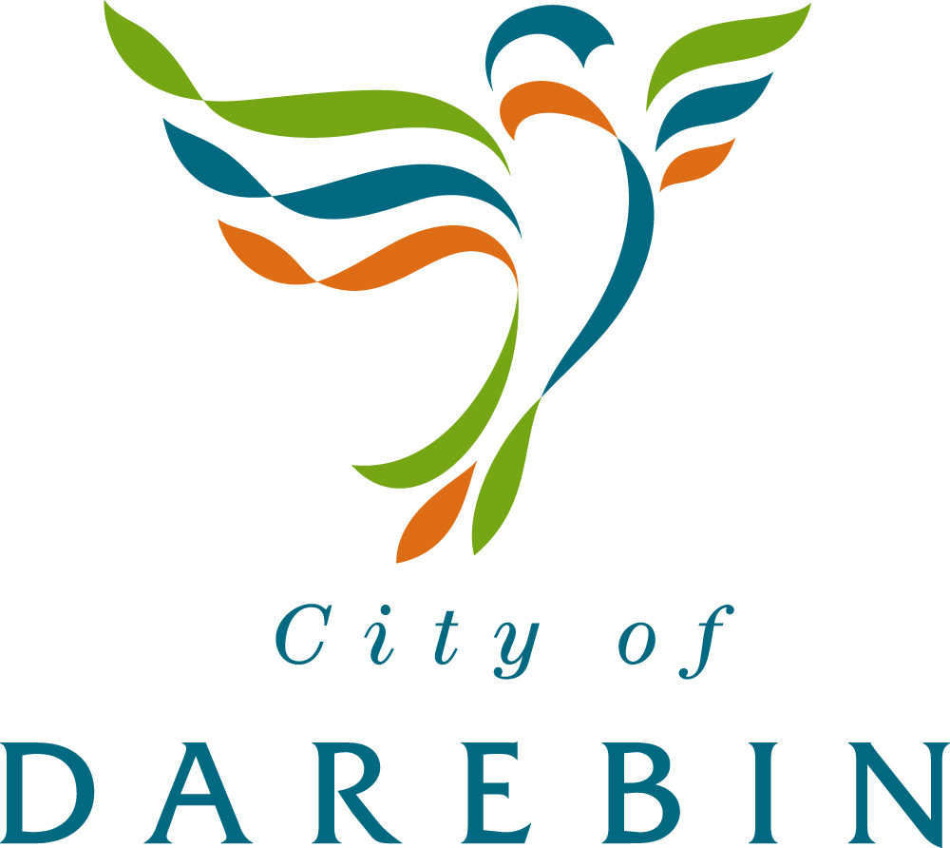

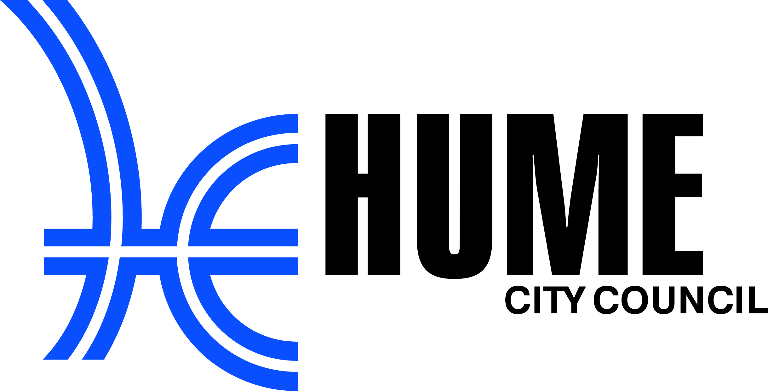



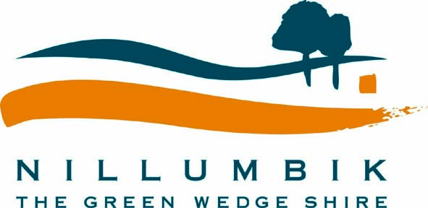

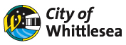

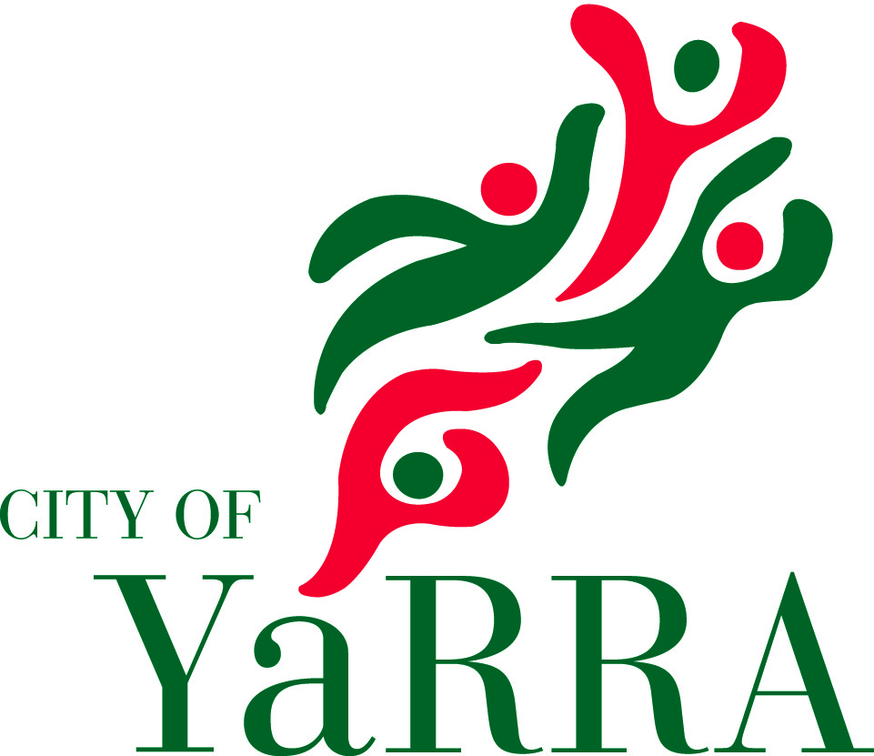

Supported by

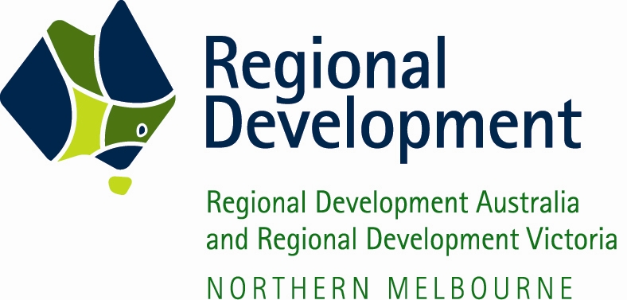
Melbourne North’s

Regional Digital Economy Strategy 2012-2014

Table of Contents

Executive Summary 3
Background 4
The Digital Economy 4
The National Broadband Network 5
The Role of Local Government 6
Opportunities for the Region 7
Digital Economy Vision and Goals 8
Goal 1 - Regional Charter 8
Goal 2 - Strengthening the Region 8
Goal 3 - Digital innovation with Council Services 11
Building Sustainable Business Models 11
Action Plan 13
Goal 1 - The First 6 Months 13
Goal 2 - 6 to 24 Months 14
Goal 3: 24 Months Onwards 14
APPENDICES 15
A. Methodology 15
B. Australian Government definition of the Digital Economy: 15
C. The National Broadband Network The 3 Year Rollout of NBN 16

Executive Summary

Melbourne’s North is a region notable for its diversity – a diverse population from all over the world, home to a diverse range of business and industry, and covering a diverse area that stretches from inner-city suburbs to the semi-rural outer suburban fringe.
The seven municipalities of Banyule, Darebin, Hume, Moreland, Nillumbik, Whittlesea and Yarra, together with regional organisations NORTH Link and Northern Melbourne RDA, that comprise Melbourne’s North Region recognise that the Digital Economy is a catalyst for innovation within the region to drive better outcomes for public services, the economy and the community.
Each of the Councils has existing plans and strategies for serving the needs of their community. But the Councils also recognise that Regional cooperation provides the most efficient way to deliver value and productivity gains from the Digital Economy and create employment opportunities.
In the recent announcement of the 3 year rollout plan by NBNCo, Melbourne’s North will be the beneficiary of one of the largest metropolitan deployments of the National Broadband Network in the nation. NBN is one of the key enablers of the Digital Economy, and the early deployment of NBN offers significant economic advantage provided the region acts quickly and efficiently.
The economic benefit can be delivered because the share of skilled residents per capita of working age population in the LGA’s catchment (its knowledge intensity) is the most powerful driver of growth for household productivity and employment.
This Digital Economy Strategy is based around three horizons covering the establishment phase of the eco-system for digital innovation, the evolution from pilot projects to sustainable deployments, leading to a sustainable culture of digital innovation, networking and inclusion.
The Councils will be an exemplar by making greater use of ICT infrastructure in the delivery of their services. However, the Councils are not the natural lead for all initiatives possible through the digital economy. But the Councils will facilitate the establishment of the eco-system through which innovation can flourish, and will engage with regional stakeholders who can lead the implementation of new initiatives.
Councils will work in collaboration with NORTH Link and the Northern Melbourne RDA to achieve the Regional Digital Economy Strategy objectives and continue to provide advocacy and promotion of key initiatives within the Region
Through a process of interviews and consultation, four key areas have been identified as the initial focus areas of the Digital Economy: Arts & Tourism, Education, Health and Aged Care (including Community Care), Industry & Small Business.

Background

The Digital Economy
The Australian Government defines the Digital Economy as the global network of economic and social activities that are enabled by platforms such as the internet, mobile and sensor networks.
The Digital Economy encompasses all sectors of our economy (Figure 1). It integrates and engages public and private stakeholders to define a scalable and elastic single architecture, as a result of collaboration between all layers.

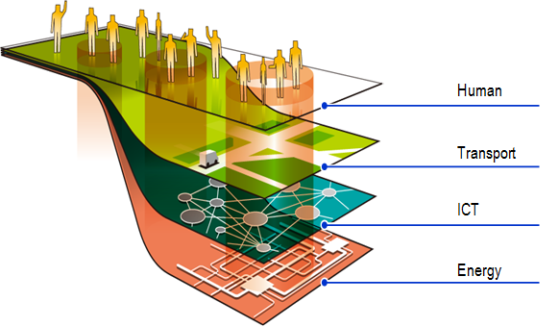
Figure 1: The Smart Region/City
Key trends in the evolution towards the digital economy include a proliferation of devices (“bring your own device”), personalisation (“I want to control what I receive and how I look”), evolution to the cloud (“the internet model enhanced and expanded”), an explosion of machine to machine sensor based communications for energy management, home automation, aged care monitoring, environmental monitoring and so on.
A key aspect of new service delivery models is a trend to providing cloud services and greater use of video communication, both of which drive the need for greater bandwidth.
The scale of the digital economy has the potential to impact every part of business and the community as illustrated in Figure 2.
In each of these areas there are further considerations to be addressed case by case in respect of policy, regulation, competition, infrastructure, innovation & education.
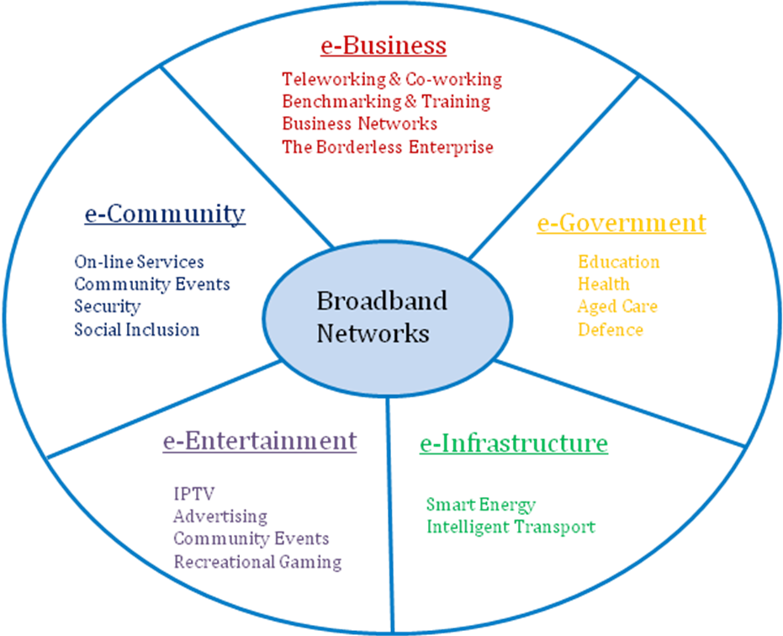

Figure 2: The Digital Economy
There is no single point of expertise that covers the full potential of the Digital Economy. The creation of an eco-system of Digital Innovation in Melbourne’s North must draw on creative talents in all parts of the community, and a key part of success is the networking of people to enable innovation to flourish.
The LGAs will lead some initiatives, but more importantly can facilitate the means for the natural leaders of new innovative projects to emerge.
The creation of new services and applications will evolve more quickly where the demand is the greatest, and there is a commitment to advocate and promote the adoption of these services & applications. By aggregating demand as a Region, Melbourne’s North can deliver value and productivity gains faster.

The National Broadband Network
The high speed fixed broadband networks, wireless networks and mobile networks are the new “essential utilities” which provide the infrastructure to support the Digital Economy.
The National Broadband Network is a key part of this infrastructure and will provide high speed fixed broadband services to all Australian household and businesses using a combination of fibre optic, fixed wireless and satellite communications. However the construction of the NBN will take 8-10 years to complete. For this reason the evolution to the Digital Economy should not be tightly coupled to the rollout of the NBN. Many of the new service delivery models under the NBN can be delivered on the broadband infrastructure deployed today, and the business models improved further as NBN is deployed in an area.
The true value for the Community is through the creation of services and applications that deliver value and productivity gain, and this work must start now.
The NBN is an enabler of the Digital Economy and should be invisible to users.

The Role of Local Government
The seven municipalities of Banyule, Darebin, Hume, Moreland, Nillumbik, Whittlesea and Yarra that comprise Melbourne’s North Region recognise that the Digital Economy is a catalyst for innovation within the region to drive better outcomes for public services, the economy and the community.
As a Region, the Councils also represent significant buying power through demand aggregation and they can leverage this buying power to secure better outcomes across the Region. The Councils can also demonstrate a long history of Regional Cooperation and collaboration that is frequently expressed as joint projects undertaken in partnership with the Melbourne North RDA and NORTH Link.
Across the Region there are a number of digital economy projects underway or in planning. But many of these projects lack a Regional focus, and the existence of the projects is not widely understood by interested parties across the Region.
To foster the creation of a sustainable world-leading eco-system of Digital Innovation in Melbourne’s North, effort needs to be invested into establishing a common language for projects across the region and an active network of business, community and government information sharing that occurs in an open way.
The Councils will therefore facilitate the following:
- Fostering a user centric view of digital economy projects.
- A register of active and planned digital economy projects to allow the sponsor of the project to connect with interested parties across the Region and strive for greater economies of scale.
- Sharing of achievements, learning and outcomes from Digital Economy pilot projects.
- Fostering a cross-sector view of digital economy projects to identify common approaches to technology and processes.
- Education of the community.
- The development of a regional database of businesses, and the creation of an Information, Problem Solving and Partnering Portal through which business across the region can interact.
- Facilitate the dissemination of work by Regional Development Australia, which is promoting a national survey of businesses and online engagement to provide local businesses with an ICT scorecard.
- A register of the ICT businesses in the area that can support the digital economy.
- The establishment of Regional innovation forums focussed on specific areas of the Digital Economy to expand on the initial ideas and develop sustainable business models to support these ideas.
- To run regular forums aimed at informing business of opportunities and technology developments.
- A Community register for the Region for recording people who have been unable to get broadband infrastructure to date.
The LGAs in collaboration with NORTH Link and the Northern Melbourne RDA, will work to foster the inclusion, participation and leadership of major industry, small business, education and health institutions, utilities, community groups and other interested parties within the region in the development and operation of regional digital economy initiatives. Through this process the aim is to:
- Aggregate demand;
- Identify the opportunity for shared resources and infrastructure to provide greater efficiency;
- Do it once with Regional support.
It will often be the case that the technology infrastructure can be used to support multiple services across the Regional economy, hence providing the opportunity for aggregating demand across multiple sectors of the Regional economy. An example of this is:
- A common Video Conference infrastructure to support Council services, in-home telehealth consultations, business incubators and so on;
- A common infrastructure to support on-line festivals, on-line exhibitions, live streaming and so on;
- Applications can be hosted once on behalf of the Region.

Opportunities for the Region
Melbourne’s North is a region notable for its diversity – a diverse population from all over the world, home to a diverse range of business and industry, and covering a diverse area that stretches from inner-city ‘gentrified’ suburbs to the semi-rural outer suburban fringe. But the region is also undergoing rapid change as its manufacturing sector comes increasingly under threat, and the shift to a knowledge community can be a key offset to this decline.
The rollout of the National Broadband Network in the region over a the 3 year period will be one of the largest rollouts in Metropolitan Australia, giving the region an economic advantage over other areas of Australia, and providing an additional catalyst to drive the creation of the Digital Economy.
The digital economy is enabled through national high speed fixed broadband networks, wireless networks and mobile networks. The ubiquitous deployment of these networks diminishes the relevance of geographic boundaries and opens the way for deploying shared infrastructure for the delivery of new services and for reaching the national and global community.
The same infrastructure also provides the ability to “Make it Local” empowering local business and community initiatives, driving awareness of what is available locally, building & sustaining local business networks, supply chains, distribution networks and so on.
The seven Councils in collaboration with NORTH Links and the Northern Melbourne RDA, strive to create a world-leading eco-system of Digital Innovation in Melbourne’s North to deliver sustainable benefits for the community. This Regional Digital Economy Strategy articulates the approach and key focus areas to achieve this outcome.

Digital Economy Vision and Goals
The seven Council’s of Melbourne’s North in collaboration with North Link and the Northern Melbourne RDA, will work together to develop a strong regional digital economy for the northern region with these goals:
- Commit to working together by signing a Regional Charter
- Primarily focus on facilitating digital innovation in the sector areas of Arts & Tourism, Industry & Small Business, Health & Aged Care and Education to strengthen them to deliver better outcomes for our local communities
- Identify sector leading ways to implement digital innovation into Local Government service delivery
The regional vision is formulated in the knowledge that it is difficult to forge a digital economy at a municipal level due to the limited size of each municipality. A digital economy requires a regional approach at minimum to create a self sustaining ecosystem of ICT digital innovation activity for both consumers and suppliers. A regional approach requires both co-operation and collaboration across the Council’s to build the necessary levels of activity and momentum at the appropriate economies of scale to effect sustainable change within the region. The value of the regional digital economy is the benefits it provides to both enhanced business competitiveness and increased social amenity for local communities. This translates to creating more local jobs and making the Melbourne’s North a better place to live which still provides more opportunities available locally.

Goal 1 - Regional Charter
The Mayors and CEO’s of the seven Councils initiated the development of a Regional Digital Economy Strategy in collaboration with NORTH Link and the Northern Melbourne RDA, because they recognised that Regional cooperation provides the most efficient way to drive Digital Innovation and deliver benefits for individual municipalities and the Region.
Each of the Councils has existing plans and strategies for serving the needs of their community. While continuing to operate based on those plans and strategies, the Councils view the Regional Digital Economy Strategy as complementary to existing Council plans and strategies.
The Regional Charter is committing the Councils, NORTH Link and the Northern Melbourne RDA to work together and focus on opportunities at a regional level.
Goal 2 - Strengthening the Region
Through a process of interviews and consultation with a wide cross section of regional stakeholders, the following four areas were identified as the priority areas for Digital Innovation:
- Arts & Tourism
- Education
- Health and Aged Care (including Community Care)
- Industry & Small Business
These focus areas are not a comprehensive list of the scope of the Digital Economy, rather they represent the starting point on a journey and they represent areas consistent with Council services, economic development and social inclusion.
Each of these areas was discussed in a Regional workshop of interested parties held on the 30th May, 2012. The aim of this workshop was to develop key directions and potential projects in each of the areas as an input to ongoing Regional Innovation forums and discussions with the Department of Broadband Communications and the Digital Economy.
Following is a summary of the key directions and potential projects that emerged from the forum:
Focus Area | Key Directions and Potential Projects
Arts & Tourism | - Create a precinct of Digital Media Business by leveraging the significant creative talent in the region  - The provision of creative incubator space supported by software hosting and storage, distribution and broadband connectivity  - Creation of on-line festival, live streaming of content, virtual exhibitions hosting and distribution  - On-line tourism, including an interactive local history library  - To foster collaboration between artists, schools, TAFEs, Universities, libraries, community and arts organisations
Education | - Education without Borders  To utilise the power of the NBN directly via video-conferencing to facilitate education that is for anyone (from the very young to the very old), symmetrical (the learner is the teacher and vice versa) and accessible (whether low income, isolated, house-bound, etc).  - Resource Hub  To utilise the power to the NBN indirectly by providing a co-ordinating, facilitating, brokerage service for resource and curriculum sharing between education and education, education and business, or business and business (subsequently delivered or available over an NBN facilitated network).  - NBN Rollout  To support job creation during the construction phase of the NBN and the ongoing service and support of the digitally enabled homes and businesses
Health & Aged Care | - In Home Care: Rehabilitation programs delivered to the home  - Reduce hospital readmissions  - Better support after discharge  - In Home Care: Sensor technology and home health monitoring services (leverage the CSIRO pilots in New England)  - In Home Care: Introduce interactive systems that enable older patients with chronic and complex care conditions to monitor their own vital signs (Blood pressure, pulse, sugar levels) so they are able to remain at home longer.  - Assist older people with household technology, advice, installation, practical use and new technology  - Preventative Health Care  - Assistive social robot enabled telehealth service model for seniors and people with dementia  - Need human like communication modalities  - Holistic care  - Integration of disparate technologies  - Improving the connectivity between health services, GP’s, community health centres, local government providers and the Northern Medicare Local to improve information flow and reduce the need for institutional admission;  - Establishing an interactive website that focuses on the primary health care and health promotion needs of those with chronic conditions such as diabetes, stress, obesity and heart disease;  - Telehealth in the acute setting

Industry & Small Business | - Information, Problem Solving and Partnering Portal  This portal would provide information to assist business to access information that may help to solve business problems or connect with new partners or other specialists. It would create a local marketplace for business to have a local presence for services, questions and discussions.  - Workshops and Think Tanks  Workshops and think tanks would be valuable to educate and inform business on how best to use new technologies associated with the NBN and to demonstrate their value to business. They would provide an opportunity to try out new applications, and encourage their uptake into business processes.  - Local and Global Networks  The digital economy is not just about global networks. It can empower local business and community initiatives, drive awareness of what is available locally, build & sustain local business networks, supply chains & distribution networks.  - tap into consumer demand for local goods and services,  - help to build community connections (including in newer residential developments) – bring people together through local portals or online directories  For councils: online welcome to our community, this is what we have to offer business and residents – opportunity to support local government’s community and business development objectives.

The Region’s Councils in collaboration with NORTH Link and the Northern Melbourne RDA, will facilitate the establishment of regular Regional Innovation forums in each of the four areas to share information and foster the development of applications and service delivery models.
For each of these focus areas to be a successful part of the Digital Economy, it is necessary to maximise participation of business and the community.
Providing a programme of education and training on the Digital Economy will be a key component to support each area. In addition to addressing the benefits of the technology, the education process must also encourage ongoing participation by fostering relevance and interest for new users. This education process can be assisted by tapping the skill base of the highly digital literate youth to assist.

Goal 3 - Digital innovation with Council Services
The Councils in collaboration with NORTH Link and the Northern Melbourne RDA, will adopt an approach of advocacy and facilitation in the introduction of digital economy.
Councils are already active participants in securing funding for projects under the Federal Government Digital Economy Strategy Programmes, specifically the Digital Communities Initiative, The Digital Local Government Programme and the Digital Enterprise Programme. These successes will be registered in a Regional database and information shared in accordance with creating a Regional eco-system.
The Councils will be an exemplar in the development of the Regional Digital Economy through adopting greater use of technology in the delivery of Council services and in creating a culture of use in business and the community. The Councils will assist in the education process by making available public access points through Council facilities such as libraries. Libraries are already learning hubs for the local community, which address the digital divide and raise the awareness of new technology. The Regional Digital Economy Strategy will focus on broadening the libraries agenda to include the range of technology being developed for the NBN.
Each Council will implement change in accordance with its strategy and budget and will aim to leverage innovation across the Region.

Building Sustainable Business Models
The internet has broken down the significance of geographic boundaries by enabled service delivery from the global village.
Similarly, new digital services in Melbourne’s North can be provided from one source and not be replicated in each LGA while maintaining the identity of each municipality through branding at the point of delivery.
A key part of evolution to the Digital Economy is to create sustainable business models that ensure continuity of service in Melbourne’s North and beyond. As new service models are defined a key consideration is the assessment of how to implement a self-sustaining business model and the identification of the organisation best equipped to deliver the services. Examples include:
- Leadership in fostering a multi-sectoral approach to service delivery e.g. identifying commonality of infrastructure and services for, say, education, health, Council Services, and energy management;
- Creating efficiencies through delivering new services from shared infrastructure;
- Exploring new business models to support the Digital Economy by aggregating demand to secure better pricing, membership, sponsorship, managing content aggregation, becoming a Service Provider;
- Explore different partnerships with business, private operators, not for profit organisations and so on.
- Consideration of the benefits of the Region operating as a content aggregator or retail service provider
Through this approach, the aim is to create efficiencies and generate funds which can be used to sustain and improve services, but also to contribute to reducing digital isolation.

Action Plan
The timeline to create a world-leading eco-system of Digital Innovation in Melbourne’s North can be linked to three distinct horizons:

Goal 1 - The First 6 Months
As a first step the Councils will sign a Regional Charter that defines their commitment to creating a world-leading eco-system of Digital Innovation and to share the benefits resulting from this work across the Region and across the Nation.
To establish the framework for digital innovation & commence the first pilot projects.
- To establish a governance structure for the Digital Economy comprising:
  - A steering committee with one representative from each of the Councils, NORTH Link and the Northern Melbourne RDA, and key representatives from the Regional economy, with a Chair appointed on a rotation basis;
  - An eminent person to promote the evolution to the Digital Economy in the Region and lead advocacy efforts to this end;
  - A secretariat, shared amongst the Councils on a rotation basis, to facilitate the establishment of innovation groups, to manage a shared knowledge base and to establish common terminology;
- To facilitate the establishment of several Regional Innovation groups to focus on specific areas of the Regional digital economy, and to host a bi-annual plenary session at which the output of the Regional Innovation groups can be shared and enhanced.
- To facilitate the assessment of the benefits of deploying existing and future Digital Economy projects as Regional initiatives.
- To lead the advocacy to all levels of Government to support Regional Digital Economy initiatives.
- To be an exemplar in the adoption of digital innovation to deliver better services to the community.
- To strive for the creation of new service delivery models with particular focus on:
  - Greater use of shared infrastructure;
  - Aggregating demand across all sectors of the Regional economy to deliver better commercial outcomes;
  - Delivering sustainable services;
  - Harnessing the creative capabilities in the community.
  - Preventing digital isolation in the community.
- To strive for digital inclusion of all people in the community though ongoing education and by demonstrating the relevance of applications and services;
- To enhance public facilities to provide equitable access for all of the community, and to create the environment for networking of people and business.

To advocate to the Government in support of specific Regional Digital Economy initiatives.

Goal 2 - 6 to 24 Months
Embedding the culture of networking and innovation
- To facilitate projects across Arts & Tourism; Education; Health & Age Care and Industry & Small Business as identified at the Regional Workshop of 30th May 2012;
- To host bi-annual plenary sessions at which the output of the Regional Innovation groups can be shared and enhanced;
- To strive for the creation of new service delivery models with particular focus on:
  - Greater use of shared resources and infrastructure;
  - Aggregating demand across all sectors of the Regional economy to deliver better commercial outcomes;
  - Delivering sustainable services;
  - Harnessing the creative capabilities in the community;
- To strive for digital inclusion of all people in the community though ongoing education and by demonstrating the relevance of applications and services;
- To enhance public facilities to provide equitable access for all of the community, and to create the environment for networking of people and business.

Goal 3: 24 Months Onwards
A sustainable culture of digital innovation, networking and inclusion.

APPENDICES

Methodology
The methodology followed in preparing this report is as follows:
- Initial briefing with the Northern Regional Local Government NBN Working Group.
- Interviews with:
  - Key staff in each of the seven LGAs
  - Key staff in health care groups, aged care groups, education groups and businesses
- Review the current status of discussion with the Federal Government.
- Present initial findings at a Regional workshop and gain feedback.
- Final review and endorsement of the seven municipalities of Banyule, Darebin, Hume, Moreland, Nillumbik, Whittlesea and Yarra that comprise Melbourne’s North Region

Australian Government definition of the Digital Economy:
On 31 May 2011, the Federal Minister for the Department of Broadband and the Digital Economy launched the National Digital Economy Strategy which provides a series of measurable targets and actions to increase national productivity to ensure Australia's continued global competitiveness and improve social wellbeing.
The eight 'Digital Economy Goals' announced by the Minister focus on the areas of:
- online participation by Australian households
- online engagement by Australian businesses and not-for-profit organisations
- smart management of our environment and infrastructure
- improved health and aged care
- expanded online education
- increased teleworking
- improved online government service delivery and engagement
- Greater digital engagement in regional Australia.
The Federal Government and NBNCo are actively promoting the evolution to the Digital Economy and are providing the following programs:
- Digital Communities Initiative ($23.8M)
- Telework
- Digital Local Government Program ($17.1M)
- Digital Enterprise Program ($12.4M)
- NBN-enabled Education and skills Services program ($27.2M)
- Indigenous Communication Program ($31M)

The National Broadband Network
The 3 Year Rollout of NBN
On 29 March 2012, the NBNCo announced its 3 year rollout plan. Mike Quigley, the CEO of NBNCo, described the following principles used in the development of the 3 year rollout plan:
- Complete the sites that had already been announced.
- Take into account the instructions the government, which was to get a balance between regional and metro areas. And also to achieve a balance across the states of Australia and to complete Tasmania by 2015.
- Build the plan on the basis of the infrastructure that was available from Telstra.
- Prioritise "growth corridors", where there would be the majority of greenfields sites so NBN Co could get those done as efficiently as possible.
- Prioritise links that were essential for the operation of the fixed-wireless network and the satellite earth stations in preparation for these networks to be in place by 2015.
- "load balance" for construction contractors and adjust the build to prevent congestion in local communities.
- Ensure that James Cook, New England, Wollongong and Melbourne universities had access to fibre as they are researching high-speed broadband applications.
The rollout of the NBN is an 8-10 year construction project.
Therefore many households and businesses will continue to run on today’s broadband infrastructure for many years, and it will be up to the Retail Service Providers (see below) to harmonise the service delivery between legacy broadband networks and NBN. The management of service delivery across several generations of technology is normal is normal in the telecommunications sector and is not an impediment to the development of the Digital Economy.
The Value Chain of NBN
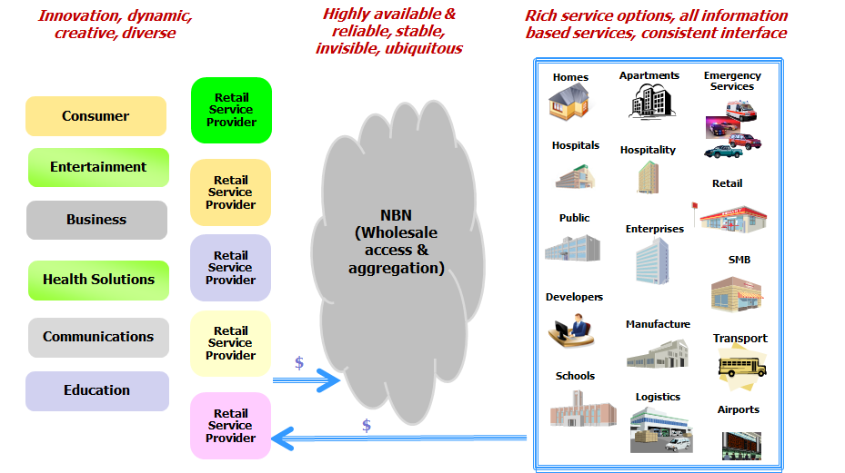

Figure 2: The Value Chain of NBN

- Overview of Melbourne’s North
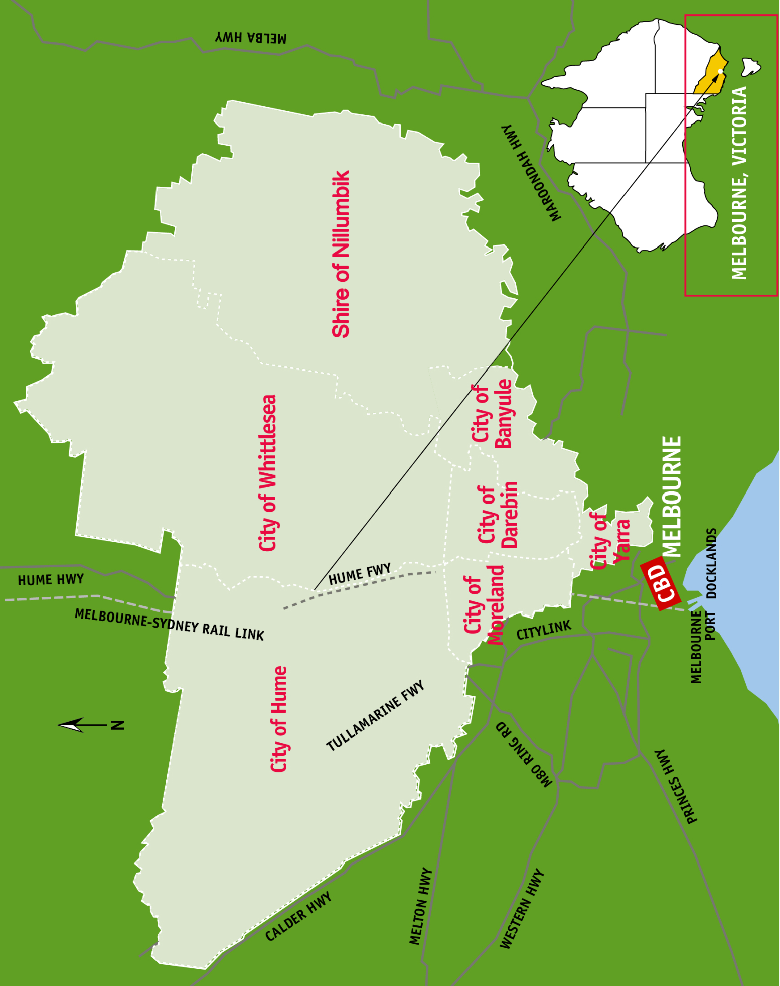

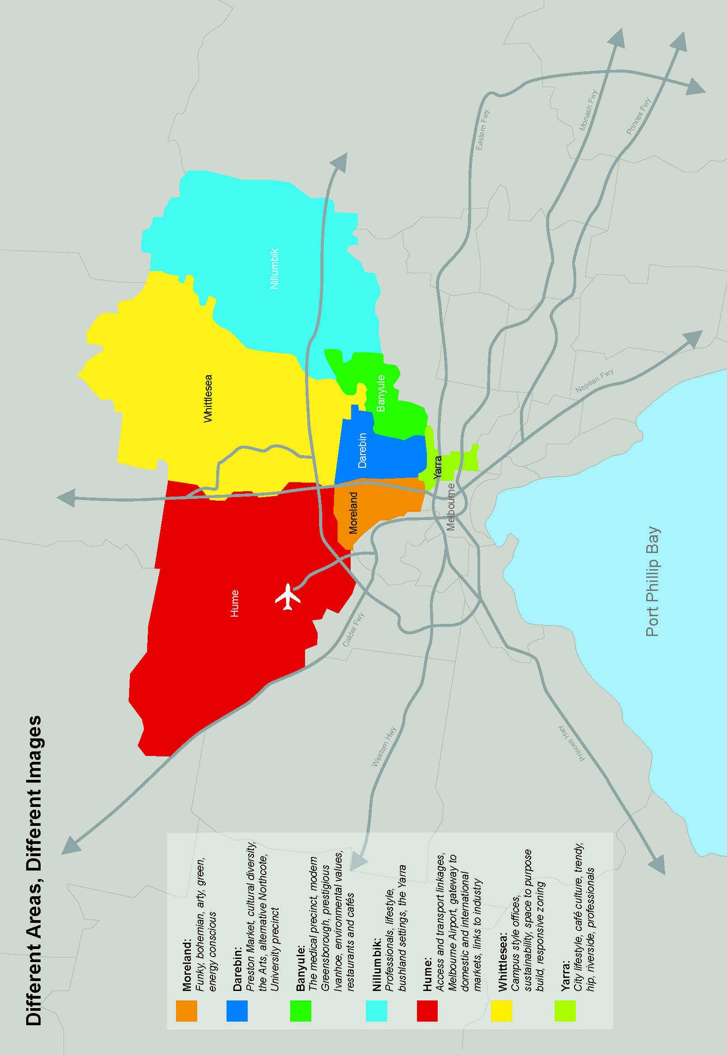

Melbourne’s North is a region that is important to both Victoria and Australia. Its population has grown 17% (around 140,000 people) over the last 10 years, with a corresponding growth in working population (13%), households (13%), GDP (28%), sales output (28%) and employment (25%) over the same period.

Series | 2001 | 2006 | 2011
Population | 766,801 | 814,947 | 903,357
Share of Melbourne’s population | 22.1% | 21.8% | 21.8%
Share of Victoria’s population | 16.0% | 15.9% | 16.1%
Share of Australia’s population | 4.0% | 3.9% | 4.0%
Working age population | 527,878 | 566,042 | 632,851
Share of Melbourne’s working age population | 22.3% | 21.9% | 22.0%
Share of Victoria’s working age population | 16.4% | 16.3% | 16.5%
Share of Australia’s working age population | 4.1% | 4.1% | 4.1%
Households | 259,476 | 274,771 | 295,639
Share of Melbourne’s households | 21.8% | 21.5% | 21.7%
Share of Victoria’s households | 15.6% | 15.5% | 15.7%
Share of Australia’s households | 3.9% | 3.9% | 4.0%
GDP (value added) $m (constant prices) | 24,442 | 27,645 | 31,306
Share of Melbourne’s GDP | 16.2% | 16.0% | 16.3%
Share of Victoria’s GDP | 12.8% | 12.6% | 12.9%
Share of Australia’s GDP | 3.0% | 2.9% | 2.9%
Sales (output) $m (constant prices) | 59,881 | 67,715 | 76,564
Share of Melbourne’s sales (output) | 16.4% | 16.2% | 16.5%
Share of Victoria’s sales (output) | 13.1% | 12.8% | 13.1%
Share of Australia’s sales (output) | 3.2% | 3.0% | 3.0%
Employment | 370,637 | 404,130 | 476,295
Share of Melbourne’s employment | 21.7% | 21.4% | 21.7%
Share of Victoria’s employment | 16.3% | 16.1% | 16.6%
Share of Australia’s employment | 4.1% | 4.0% | 4.2%

Melbourne’s North also has areas of significant disadvantage compared with Victorian and Australian averages, and this is reflected in SEIFA (Socio-Economic Indexes for Areas) data from the 2006 census (see Appendix 1: SEIFA data).

Overall, the 7 LGAs in Melbourne’s North had stronger employment growth than most other Melbourne LGAs after the global financial crisis, including above average Melbourne growth in:
- manufacturing
- construction
- accommodation
- professional
- administration
- education
- other services.
Attracting new investment into the Melbourne’s North catchment to create new employment is essential. The best complementary strategy to lift growth will be to upgrade the skills of all residents in the catchment, and to do so in conjunction with an intensive rollout of the NBN in the region. This is because the share of skilled residents per capita of working age population in an LGA’s catchment (its knowledge intensity) is the most powerful driver of growth for household productivity and employment.
Stakeholders in Melbourne’s North represent a diverse community of interests as shown in the following table:
Early childhood centres | 289
Primary schools | 152
Secondary schools | 61
Universities | 3 with 6 campuses
TAFEs | 3 with 11 campuses
Hospitals | 29
Aged care facilities | 127
Government offices | 14
Magistrates Court | 2

