

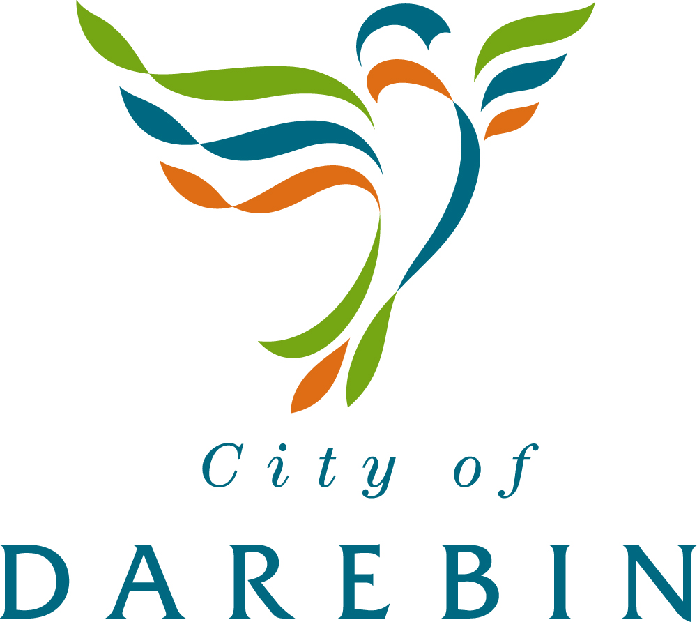

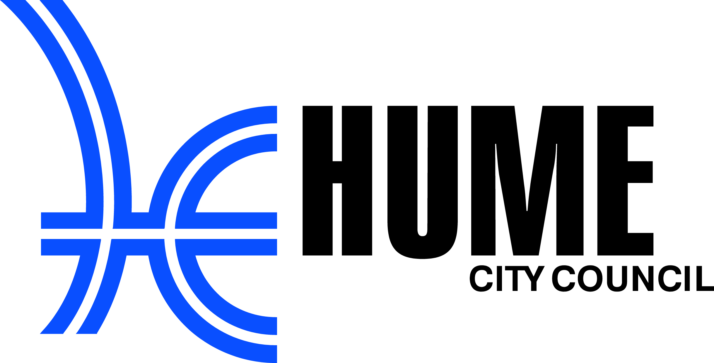



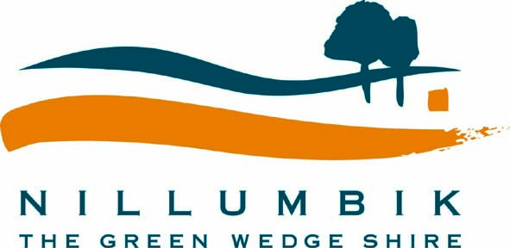

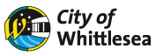

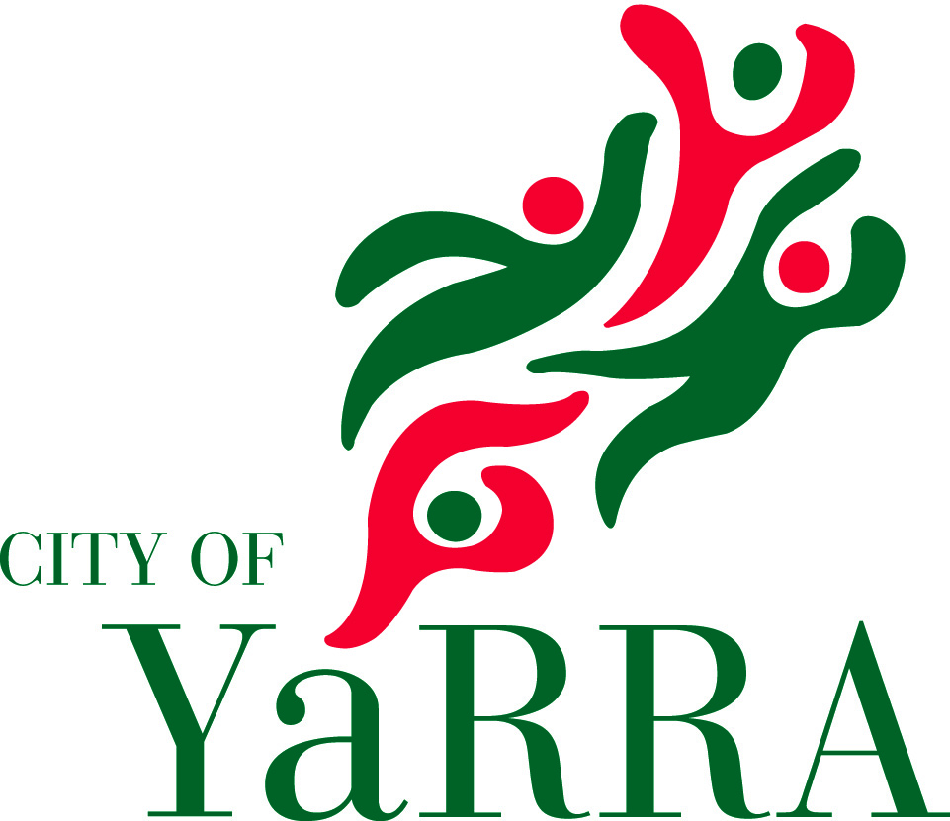

Supported by

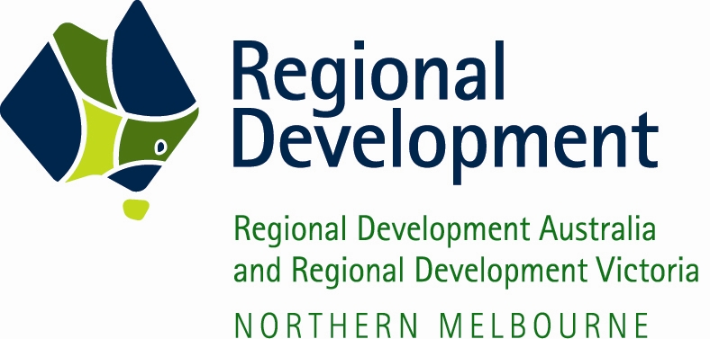

CHARTER
for
Melbourne North’s
Regional Digital Economy Strategy 2012

The Australian Government defines the Digital Economy as the global network of economic and social activities that are enabled by platforms such as the internet, mobile and sensor networks.

The seven municipalities of Melbourne’s North, Banyule, Darebin, Hume, Moreland, Nillumbik, Whittlesea and Yarra in collaboration with NORTH Link and the Northern Melbourne RDA, recognise that the Digital Economy is a catalyst for innovation within the region to drive better outcomes for public services, the economy and the community.

The seven Councils in collaboration with NORTH Link and the Northern Melbourne RDA, therefore strive to foster, create and encourage a world-leading eco-system of regional Digital Innovation to deliver sustainable benefits for the region’s community. The creation of this eco-system must draw on creative talent from all parts of the community with success arising from networking people within the region to enable innovation to flourish.

This Charter defines the commitment the seven Councils in collaboration with NORTH Link and the Northern Melbourne RDA, will provide to create a world-leading eco-system of Digital Innovation and to share the benefits resulting from this work across the Region and across the Nation.

Each of the Councils has existing plans and strategies for serving the needs of their community. This Charter is complementary to those plans and strategies, but recognises that Regional cooperation provides the most efficient way to create value and productivity gains through Digital Innovation and create employment opportunities.

The seven Councils in collaboration with NORTH Link and the Northern Melbourne RDA, agree:

- To cooperate and collaborate as a Region to deliver value and productivity gains in accordance with a Regional Digital Economy Strategy.

- To establish a governance structure for fostering the Digital Economy comprising:

  - A steering committee with one representative from each of the Councils, NORTH Link and the Northern Melbourne RDA, and key representatives from the Regional economy, with a Chair appointed on a rotation basis;
  - An eminent person to promote the evolution to the Digital Economy in the Region and lead advocacy efforts to this end;
  - A secretariat, shared amongst the Councils on a rotation basis, to facilitate the establishment of innovation groups, to manage a shared knowledge base and to establish common terminology.
- To work with the Federal Government, the State Government, NBNCo and its contractors to facilitate the physical rollout of high speed broadband infrastructure in the region.

- To facilitate the establishment of several Regional Innovation groups to focus on specific areas of the Regional digital economy, and to host a bi-annual plenary session at which the output of the Regional Innovation groups can be shared and enhanced.

- To foster the inclusion, participation and leadership of major industry, small business, education and health institutions, utilities, community groups and other interested parties within the region in the development and operation of regional digital economy initiatives.

- To facilitate the assessment of the benefits of deploying existing and future Digital Economy projects as Regional initiatives.

- To lead advocacy at all levels of Government to support Regional Digital Economy initiatives.

- To be an exemplar in the adoption of digital innovation to deliver better services to the community.

- To strive for the creation of new service delivery models with particular focus on:

  - Greater use of shared infrastructure;
  - Aggregating demand across all sectors of the Regional economy to deliver better commercial outcomes;
  - Delivering financially sustainable services;
  - Harnessing creative capabilities in the community;
  - Reducing digital isolation in the community.

- To strive for digital inclusion of all people in the community though ongoing education and by demonstrating the relevance of applications and services.

- To enhance public facilities to provide equitable access for all of the community, and to create the environment for networking of people and business.

The Charter does not imply that the Councils, NORTH Link or the Northern Melbourne RDA will lead the innovation forums or any project that arises from the work of the forums. Leadership must be drawn from across the Region, taking into consideration the skill set required and the benefits identified.

……………………………………………………  Tom Melican  Mayor  Banyule City Council | ……………………………………………………  Simon McMillan  Chief Executive Officer  Banyule City Council
……………………………………………………  Steven Tsitas  Mayor  City of Darebin | ……………………………………………………  Rasiah Dev  Chief Executive Officer  City of Darebin
……………………………………………………  Ros Spence  Mayor  Hume City Council | ……………………………………………………  Domenic Isola  Chief Executive Officer  Hume City Council
……………………………………………………  John Kavanagh  Mayor  Moreland City Council | ……………………………………………………  Peter Brown  Chief Executive Officer  Moreland City Council
……………………………………………………  Michael Young  Mayor  Nillumbik Shire Council | ……………………………………………………  Stuart Burdack  Chief Executive Officer  Nillumbik Shire Council
……………………………………………………  Stevan Kozmevski  Mayor  City of Whittlesea | ……………………………………………………  David Turnbull  Chief Executive Officer  City of Whittlesea
……………………………………………………  Geoff Barbour  Mayor  City of Yarra | ……………………………………………………  Vijaya Vaidyanath  Chief Executive Officer  City of Yarra
……………………………………………………  Bob McQuillen  Chair  Northern Melbourne RDA | ……………………………………………………  Chris Heysen  Chair  NORTH Link

