SPECIAL Council AGENDA

Monday 6 August 2018

Commencing 6 pm

Council Chamber, Moreland Civic Centre, 90 Bell Street, Coburg

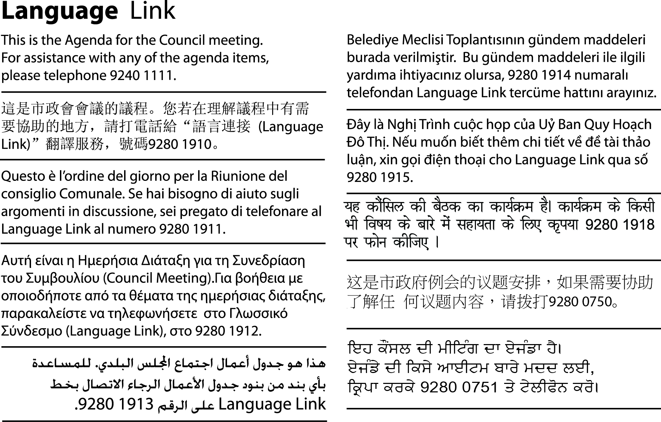
INFORMATION ABOUT COUNCIL MEETINGS
Council encourages its citizens to participate in the local government of Moreland. Accordingly, these notes have been developed to help citizens better understand Council meetings. All meetings are conducted in accordance with Council’s Meeting Procedure Local Law 2018.
WELCOME The Mayor, who chairs the meeting, formally opens the meeting, delivers an acknowledgement of country and welcomes all present. This Council meeting will be recorded and webstreamed live to Council’s website. This recording will also be available as Video on Demand. Although every care is taken to maintain privacy, gallery attendees are advised they may be recorded.
APOLOGIES Where a Councillor is not present, his/her absence is noted in the minutes of the meeting.
DECLARATION OF INTERESTS AND/OR CONFLICT OF INTERESTS Under the Local Government Act 1989, a Councillor has a duty to disclose any direct or indirect pecuniary (financial) interest, s/he may have in any matter to be considered by Council that evening.
CONFIDENTIAL BUSINESS Whilst all Council and Committee meetings of Council are open to its citizens, Council has the power under the Local Government Act 1989 to close its meeting to the general public in certain circumstances which are noted where appropriate on the Council Agenda. Where this occurs, members of the public leave the Council Chamber or Meeting room while the matter is being discussed.
CLOSE OF MEETING The Mayor will formally close the meeting and thank all present.
NEXT MEETING DATE The next Council meeting will be held on Wednesday 8 August 2018 commencing at 7 pm, in the Council Chamber, Moreland Civic Centre, 90 Bell Street, Coburg.

1. WELCOME
2. APOLOGIES
Leave of absence has been granted to Cr Riley - 31 July 2018 to 12 August 2018 inclusive.
3. DECLARATION OF INTERESTS AND/OR CONFLICT OF INTERESTS
4. Council Reports
Nil.
5. Confidential Business
DCS39/18 Proposed Acquisition of Land (D18/276491)
Pursuant to sections 77(2)(c) and 89(2)(h) this report has been designated as confidential by the Chief Executive Officer because it relates to a matter which the Council or special committee considers would prejudice the Council or any person.

