Council AGENDA

Monday 29 October 2018

Commencing 7 pm

Council Chamber, Moreland Civic Centre, 90 Bell Street, Coburg

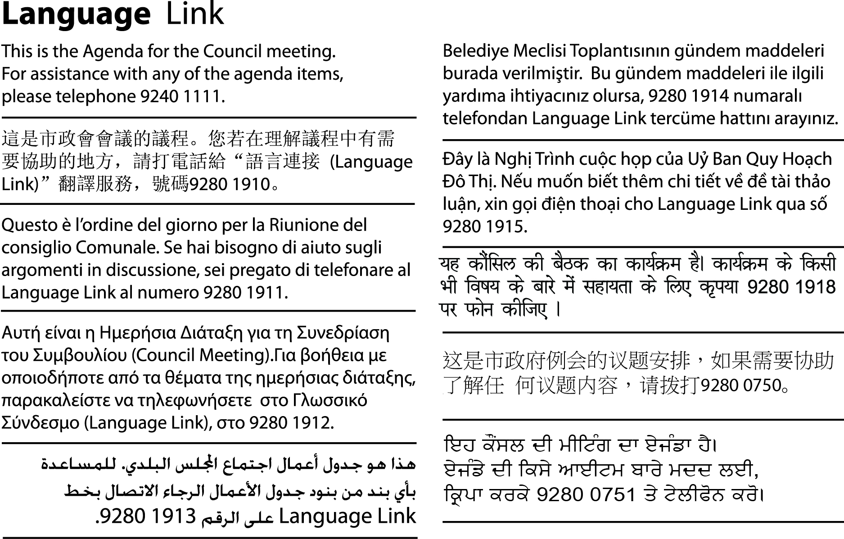
1. WELCOME
2. APOLOGIES
3. Election of Mayor for 2018/2019
4. CEREMONIAL MAYORAL SPEECH
5. position of deputy Mayor
6. election of deputy mayor for 2018/2019
7. PRESENTATION TO OUTGOING MAYOR

3. Election of Mayor for 2018/2019
Council annually appoints a Mayor in accordance with the Local Government Act 1989 and the Meeting Procedure Local Law 2018.
The role and functions of the Mayor include:
- Acting as the principal spokesperson for the Council;
- Leading and supporting good working relationships between Councillors; and
- Carrying out civic and ceremonial duties including chairing Council meetings and presiding over Citizenship ceremonies.
The Chief Executive Officer will call for nominations and preside over the election of the Mayor for the 2018/2019 Mayoral Year.
8. CEREMONIAL MAYORAL SPEECH
The purpose of the cermononial Mayoral speech is to outline the new Mayor’s priorities for the year ahead.
Based on the Council Plan 2017-2021, the speech will highlight items of particular focus for Council to meet it’s goals.
9. position of deputy Mayor
Council’s Meeting Procedure Local Law 2018 allows for Council to determine to have the position of Deputy Mayor for the same term as the Mayor.
Motion
That Council establishes the role of Deputy Mayor for the 2018/2019 Mayoral Year.
10. election of deputy mayor for 2018/2019
The Chief Executive Officer will call for nominations and preside over the election of the Deputy Mayor.
The role of the Deputy Mayor is to support the position of Mayor.
11. PRESENTATION TO OUTGOING MAYOR
A presentation will be made to the outgoing Mayor, Cr John Kavanagh.

