Council AGENDA

CEREMONIAL MEETING

Monday 14 November 2016

Commencing 7 pm

Coburg Town Hall, Moreland Civic Centre, 90 Bell Street, Coburg

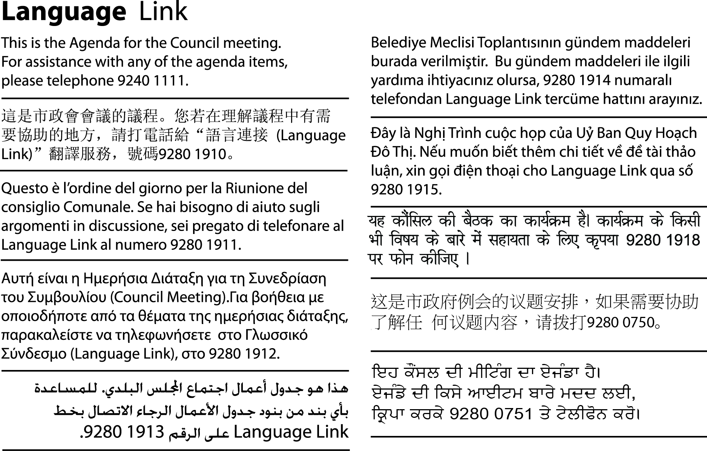

1. WELCOME
2. APOLOGIES
3. DECLARATION OF INTERESTS AND/OR CONFLICT OF INTERESTS
4. COUNCIL REPORTS
Corporate Services
DCS57/16 Appointment of Mayor, Deputy Mayor and Councillors to the Audit and Risk Managment and Urban Planning Committees (D16/379756) 3
DCS58/16 Presentation of Mayor's Speech 2016-2017 (D16/356888) 5

DCS57/16 Appointment of Mayor, Deputy Mayor and Councillors to the Audit and Risk Managment and Urban Planning Committees (D16/379756)
Director Corporate Services
Property and Governance

Executive Summary
Council annually allocates Councillors to the positions of Councillor Office Holder (Mayor, Deputy Mayor) and Councillors to the Audit and Risk Management Committee and the Urban Planning Committee. Councillors have a key role in the development of policy and decision-making. The appointment of Councillors to specific areas of responsibility provides a framework for relationships between Councillors and the administration of Council.
Resourcing of Councillors and the operation of these committees are supported from a number of budgets across Council.

Recommendation
Council resolves to appoint:
1. Cr as Mayor for the 2016-2017 mayoral year.
2. Cr as Deputy Mayor for the 2016-2017 mayoral year.
3. Crs to the Audit and Risk Management Committee for the 2016-2017 mayoral year.
4. Crs to the Urban Planning Committee for the 2016-2017 mayoral year.

REPORT

1. Policy Context
Councillors have a key role in the development of policy and decision-making. The appointment of Councillors to specific areas of responsibility provides a framework for relationships between Councillors and the administration of Council.
The Moreland Community Vision 2025 is an opportunity for Council to reform community engagement to meet the needs of citizens and suit the character of our diverse city. Advisory Committees, aligned with Council’s policies, plans and objectives, can fit into a clearly defined framework for citizen participation, giving all people a range of ways they can be part of achieving shared goals for the city.

2. Background
Council annually appoints Councillors to the positions of Mayor and Deputy Mayor and to the Audit and Risk Management and Urban Planning Committees.

3. Issues
The Urban Planning Committee has delegated authority from Council for its functions in the decision making structure. The specific purpose and function of this Committee is formalised in accordance with section 86 of the Local Government Act 1989. Appointments are also being made to the Audit and Risk Management Committee.
Council has the ability to vary any of these appointments during the year, as required.

Human Rights Consideration
The implications of this report have been assessed in accordance with the requirements of the Charter of Human Rights and Responsibilities.

4. Consultation
Appointment of particular Councillors to these positions has been determined with Councillors’ input.

5. Officer Declaration of Conflict of Interest
Council Officers involved in the preparation of this report have no conflict of interest in this matter.

6. Financial and Resources Implications
All costs and associated resourcing support will be met from existing budgets.

7. Implementation
Following adoption of the Mayor and Deputy Mayor and Councillors to the Audit and Risk Management Committee and Urban Planning, relevant officers will be advised of the appointed Councillor(s) so that they can be invited to attend future meetings in the 2016-2017 Mayoral year.

Attachment/s
There are no attachments for this report.
DCS58/16 Presentation of Mayor's Speech 2016-2017 (D16/356888)
Director Corporate Services
Property and Governance

Executive Summary
The Mayor’s Speech is a statement that highlights the achievements of the Council in the previous year and sets out the vision and key priorities for the year ahead in accordance with Council’s adopted Action Plan and budget.
The Mayor is presenting this speech to the Ceremonial Council meeting for adoption and this speech will be distributed following the Ceremonial Council meeting.

Recommendation
Council resolve that:
1. The Mayor’s Speech for the 2016-2017 mayoral year be received.
2. The Mayor will have a fully maintained fuel-efficient vehicle which, should it be required, is provided for the Mayor’s public and private use.

REPORT

1. Policy Context
The Mayors speech is traditionally informed by several Council documents, including the key priorities noted in the Council Plan and the Council Action Plan, the adopted 2016 budget and supporting financial strategy, as well as Council’s policies and strategies.

2. Background
The Mayor’s Speech highlights the key priorities and policy commitments for the upcoming year and is presented at each Ceremonial Meeting.

3. Issues
There are no issues associated with this report.

Human Rights Consideration
The implications of this report have been assessed in accordance with the requirements of the Charter of Human Rights and Responsibilities.

4. Consultation
No consultation was necessary in the preparation of this report.

5. Officer Declaration of Conflict of Interest
Council Officers involved in the preparation of this report have no conflict of interest in this matter.

6. Financial and Resources Implications
All costs and associated resourcing support arising from the Mayor’s Speech will be addressed within approved budgets.
7. Implementation
The Mayor’s Speech 2016-2017 will be distributed to the public and available on Council’s website following adoption of the speech.

Attachment/s
There are no attachments for this report.

