Council meeting AGENDA

special – Election of Mayor

Friday 20 November 2020
Commencing 7 pm

THE COUNCIL MEETING WILL BE LIVESTREAMED

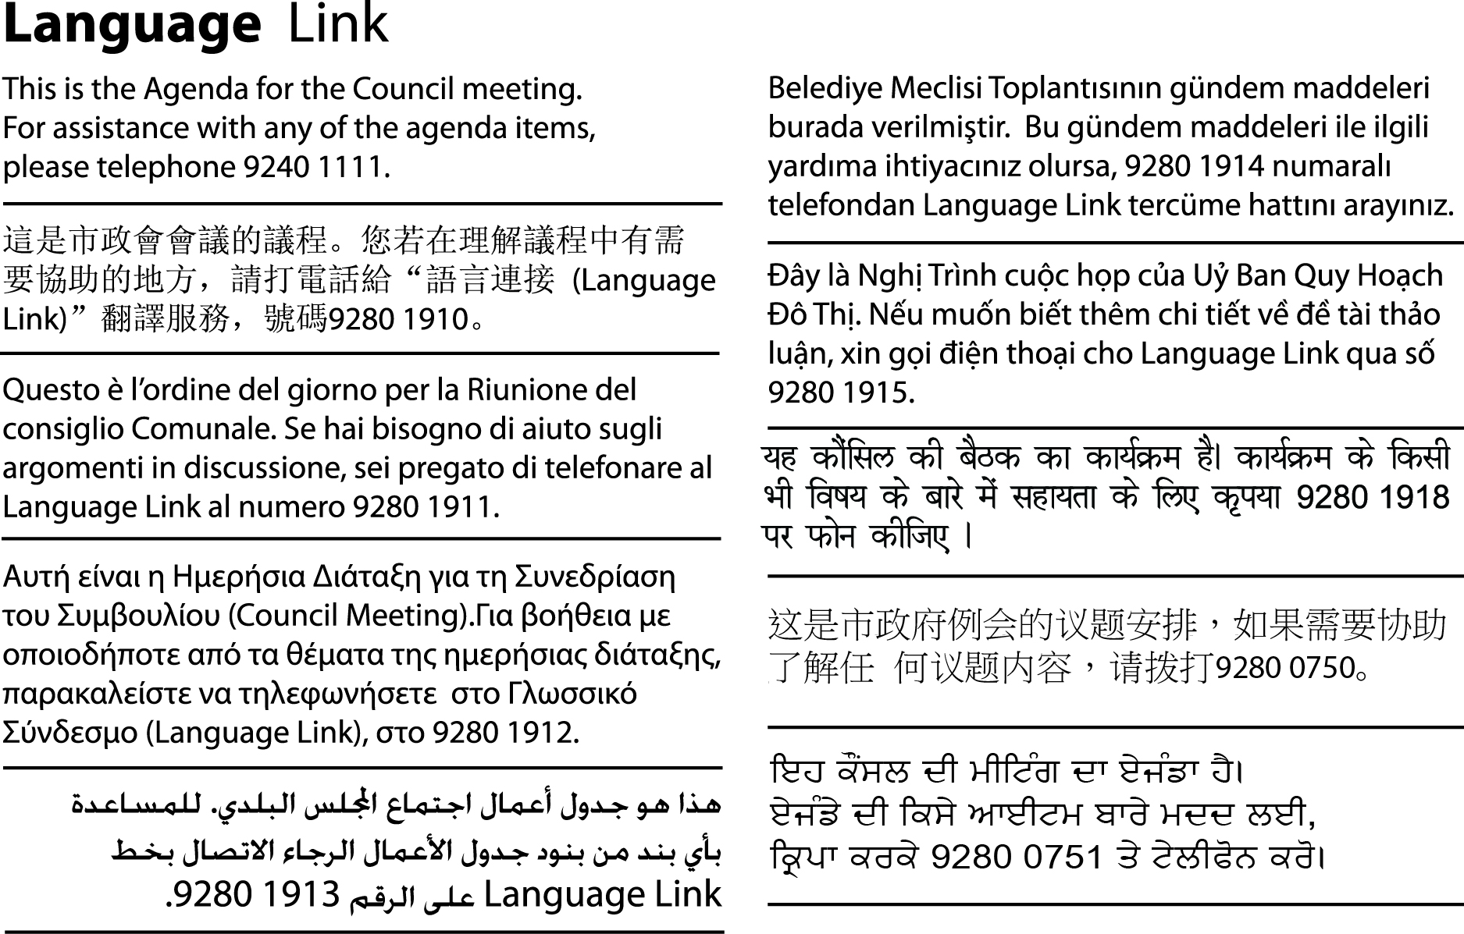

Acknowledgement of the traditional custodians of the City of Moreland
Moreland City Council acknowledges the Wurundjeri Woi Wurrung people as the Traditional Custodians of the lands and waterways in the area now known as Moreland, and pays respect to their Elders past, present, and emerging, as well as to all First Nations communities who significantly contribute to the life of the area.

Table of Contents
1. Welcome and Appointment of Interim Chair 4
2. Apologies 4
3. Declaration of Interests and/or Conflict of Interests 4
4. Term of Mayor 4
5. Role of the Deputy Mayor 4
6. Election of Mayor 5
7. Newly elected Mayor – Mayoral Chains and assuming of the Chair 5
8. Ceremonial Mayoral Speech 5
9. Election of Deputy Mayor 5
10. Adoption of Council meeting dates for 2021 5
11. Committee appointments – Audit and Risk Committee and Establishment of Community Planning Reference Group 7
12. Meeting close 9

1. Welcome and Appointment of Interim Chair

2. Apologies

3. Declaration of Interests and/or Conflict of Interests

4. Term of Mayor
To fulfil the statutory obligations of section 26(3) of the Local Government Act 2020 (the Act), before the election of the Mayor, a Council must determine by resolution whether the Mayor is to be elected for a 1 year or a 2 year term.
Historically, Moreland has elected a Mayor for a 1 year term only. The recommendation is that Council continues this precedent and sets a 1 year term for the 2020/2021 Mayoral year. However, it is open to the Council to determine a two year term instead.
In accordance with Council’s Governance Rules, the Mayoral term determined by Council will also apply to a Deputy Mayor
In accordance with section 26(4) the Act, the next election of the Mayor and any Deputy Mayor will be held as close as possible to the end of the 1 year term as possible.
Recommendation
That Council:
- Elects a Mayor for a one year term.
- Notes the term of any Deputy Mayor is identical to the term of the Mayor.

5. Role of the Deputy Mayor
In accordance with section 20A of the Local Government Act 2020 and sub-rule 3.5.1 of the Governance Rules, Council may establish an office of Deputy Mayor.
The Deputy Mayor must perform the role of the Mayor and may exercise any of the powers of the Mayor if the Mayor is unable for any reason to attend a Council meeting or part of a Council meeting, or the Mayor is incapable of performing the duties of the office of Mayor for any reason including illness, or the office of Mayor is vacant.
Recommendation
That Council:
- Establishes the office of Deputy Mayor for the term of the current Council
- At the meeting held to elect the Mayor each year of the term of the current Council, elects a Deputy Mayor.

6. Election of Mayor
The election of the Mayor is conducted by the Chief Executive Officer (CEO) in accordance with section 25 of the Local Government Act 2020 and Moreland’s Governance Rules.
The CEO will invite nominations for the office of the Mayor and confirm acceptance of each nomination with the nominee.
The Mayor must be elected by an absolute majority of Councillors. Moreland has eleven Councillors and an absolute majority of Councillors is six.
If only one Councillor is a candidate for Mayor, the CEO must declare that Councillor to be duly elected as Mayor. Where two or more candidates are nominated the CEO will conduct a series of votes until such time as a candidate receives an absolute majority of votes.

7. Newly elected Mayor – Mayoral Chains and assuming of the Chair
The Chief Executive Officer invites the newly elected Mayor to receive the Mayoral Chains and to assume the Chair.

8. Ceremonial Mayoral Speech
In accordance with sub-rule 3.5.4 of the Governance Rules, upon being elected, the Mayor may make a ceremonial speech, outlining the priorities of the year ahead based on the previously adopted Council Plan.

9. Election of Deputy Mayor
The election of the Deputy Mayor is conducted by the Chief Executive Officer in accordance with section 27 of the Local Government Act 2020 and the Governance Rules. The same provisions apply to the election of the Deputy Mayor as to the election of the Mayor with all necessary modifications and adaptations.
The CEO will invite nominations for the office of the Deputy Mayor and confirm acceptance of each nomination with the nominee.

10. Adoption of Council meeting dates for 2021
Council’s Governance Rules provide that Council fixes the date, time and place of all Council meetings for the following calendar year, including meetings designated for Planning and Related Matters.
Council by resolution, or the Chief Executive Officer, may change the date, time or place of, or cancel, any Ordinary meeting which has been fixed, or schedule an additional ordinary meeting and must provide notice of the change to the public.
The proposed Council Meeting Schedule (Schedule) for the period January to December 2021 has been drafted to enable Council to effectively carry out its decision-making functions for the year. The Schedule includes the times and dates for Council meetings and Council meetings designated for consideration of Planning and Related Matters.
Meetings are generally held on a Wednesday evening in the Council Chamber at the Moreland Civic Centre. Due to current public health orders and community safety, community access to Council meetings is via Council’s live streaming website or Facebook page.
The election of the Mayor must be held on a day that is as close to the end of the one year term as is reasonably practicable. It is proposed that the next meeting to elect the Mayor be held Monday 15 November 2021.
Date | Time | Meeting type
27 January 2021 | 6.30 pm | Council Meeting - Planning and Related Matters
10 February 2021 | 7 pm | Council Meeting
24 February 2021 | 6.30 pm | Council Meeting - Planning and Related Matters
10 March 2021 | 7 pm | Council Meeting
24 March 2021 | 6.30 pm | Council Meeting - Planning and Related Matters
14 April 2021 | 7 pm | Council Meeting
28 April 2021 | 6.30 pm | Council Meeting - Planning and Related Matters
12 May 2021 | 7 pm | Council Meeting
26 May 2021 | 6.30 pm | Council Meeting - Planning and Related Matters
9 June 2021 | 7 pm | Council Meeting
23 June 2021 | 6.45 pm | Council Meeting - Planning and Related Matters
14 July 2021 | 7 pm | Council Meeting
28 July 2021 | 6.30 pm | Council Meeting - Planning and Related Matters
11 August 2021 | 7 pm | Council Meeting
25 August 2021 | 6.30 pm | Council Meeting - Planning and Related Matters
8 September 2021 | 7 pm | Council Meeting
22 September 2021 | 6.30 pm | Council Meeting - Planning and Related Matters
13 October 2021 | 7 pm | Council Meeting
27 October 2021 | 6.30 pm | Council Meeting - Planning and Related Matters
10 November 2021 | 7 pm | Council Meeting
15 November 2021 | 7 pm | Ceremonial Meeting to elect the Mayor
24 November 2021 | 6.30 pm | Council Meeting - Planning and Related Matters
8 December 2021 | 7 pm | Council Meeting
15 December 2021 | 6.30 pm | Council Meeting - Planning and Related Matters

The adopted schedule of Council meeting dates will be published on Council’s website and made available at Council’s Customer Service Centres.
Recommendation
That Council:
- Sets the dates and times for Council meetings in 2021 as printed in the agenda and designates those meetings indicated for consideration of Planning and Related Matters in accordance with the Governance Rules.
- Sets the date and time for the election of the Mayor for 2021/22 as 15 November 2021 at 7 pm.
- Appends the schedule of Council meetings to the minutes, publishes it on the Council website and makes it available at Customer Service Centres.

11. Committee appointments – Audit and Risk Committee and Establishment of Community Planning Reference Group
Council annually appoints Councillors to the positions of Councillor Representatives on Committees. Some Committees are required to commence activity as soon as possible following the commencement of the Council term and have been prioritised for appointments at this meeting.
If required, Council may resolve to change the appointments during the year.
It is proposed the remaining appointments of Councillors to committees will made by Council at the 9 December 2020 Council meeting.
Audit and Risk Committee
The Audit and Risk Committee is a requirement of the Local Government Act 2020 and governed by the Audit and Risk Committee Charter, adopted in May 2020. It comprises 3 Councillor members and 4 independent and external members. The next meeting of the Audit and Risk Committee is scheduled for 15 December 2020 and requires the appointment of Councillor representatives to ensure the continued operation of the Committee.
Community Planning Councillor Reference Group
Council will develop and adopt 4 key plans following deliberative engagement with the community over 2021 and 2022. These plans are required by the Local Government Act 2020:
- Community Vision outlining the community’s long-term aspirations for Moreland (due October 2021)
- 4-year Council Plan outlining Council’s priority actions (due October 2021).
- 10-year Financial Plan outlining the financial resources required for assets and services (due October 2021)
- 10-year Asset Plan outlining the maintenance, renewal, acquisition, expansion, upgrade, disposal and decommissioning of Council assets (due June 2022).
In addition, a rolling four year budget will need to be adopted by June 2021 and this will require community engagement and alignment with other key plans above.
The Local Government Act 2020 is a principles-based Act and provides the opportunity for Council to develop these plans in a way that is tailored to, and meets the needs of Moreland. Underpinning the requirements for the plan is a requirement that Council undertakes deliberative engagement with the community for their development.
Developing and maintaining integrated key plans that closely reflect community input and aspirations will set the foundation for Council’s ongoing success and ensure quality outcomes that will meet current and future community needs.
In order to guide progress and Council decision making on development of these key plans, a Community Planning Councillor Reference Group (Reference Group) is recommended to provide an oversight role on the key plans to be developed, including the Community Vision, 10-year Asset and Financial Plans and 4-year Council Plan and Budget.
The Reference Group will provide advice and guidance about:
- Community engagement approach and options
- Reflection of community aspirations in key plans
- Integration between key plans; and
- Alignment with the principles of the LGA 2020.
Deliberative community engagement requires a long lead time. Recommendations about community engagement approach for the key plans will be considered at the 9 December Council meeting. As a result, this proposed reference group needs to be formed quickly.
The proposed terms of reference for the Community Planning Councillor Reference Group are included at Attachment 1.
Recommendation
That Council:
- Appoints Councillors ___________, ____________, _____________ to the Audit and Risk Committee for the period of one year or until otherwise resolved:
- Establishes the Community Planning Councillor Reference Group and adopts the terms of reference attached to the agenda.
- Appoints the Mayor as Chair and Councillors_____________, ________________, _______________ and ________________
to the Community Planning Councillor Reference Group for a period of 1 year or until otherwise resolved.

12. Meeting close

