# BYO food containers

## A guide for businesses

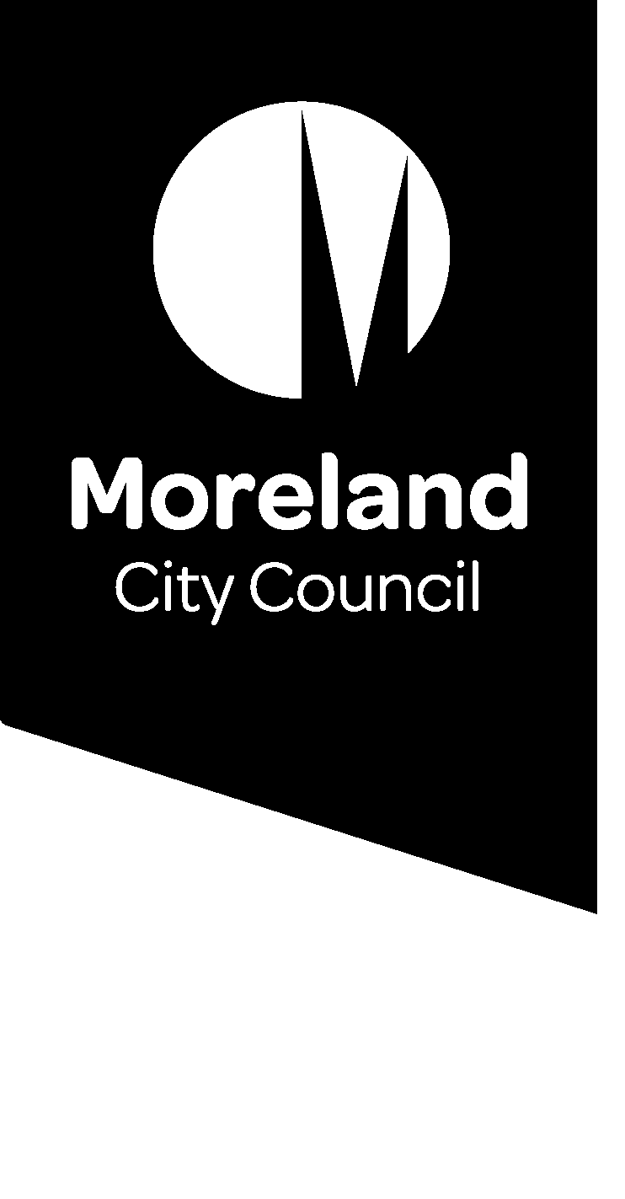

## Introduction

Merri-bek is home to many businesses that serve take away food and drinks. The great food culture we know and love sometimes comes at a cost to the environment. If you have a food business you can reduce the impact of single-use packaging on the environment, by supporting customers to use BYO containers.

On average, single-use food packaging is used for less than 12 minutes before being discarded. By being more mindful in how we consume products, as well as re-using and recycling the products we do purchase, we can help reduce pollution, conserve resources and potentially save money at the same time.

Understanding how to comply with relevant legislation and ensuring your food business isn't put at risk through accepting BYO containers can be complex. This guide can be used to help you decide what best suits your business.

### Why BYO containers?

By promoting customers to bring their own container, rather than use single-use products, consumers and food businesses can reduce their environmental impact. Many consumers are seeing the benefit of bringing containers and vessels from home to collect take away foods, as well as pantry staples.

BYO containers are growing in popularity as customers and businesses recognise their personal contribution to reducing waste and plastic pollution. BYO containers range from reusable coffee cups to lunch boxes for takeaway meals. They are brought into a food premises to facilitate the takeaway of food and drink without the need for single use plastic. BYO containers can allow some savings in packaging materials for businesses.

### Benefits for your business

Through this initiative businesses can attract new customers who are interested in supporting sustainability and waste reduction. A simple way to do this is to list your business on websites promoting sustainable cafés and food businesses. [Trashless Take Away](https://trashlesstakeaway.com.au/) and [Responsible Cafés](https://responsiblecafes.org/) are websites that have been established to promote businesses who support BYO containers and other sustainable practices.

### Are businesses allowed to accept BYO Containers?

Food Business operators can legally accept BYO containers for their food and drink products. [Sustainability Victoria](https://www.sustainability.vic.gov.au/recycling-and-reducing-waste/in-a-business-2/single-use-plastics-ban/accepting-reusables-at-your-business) provides information for businesses to support the shift to reusables, as an alternate option to single-use items. Council encourages food businesses do accept reusable cups and containers in a safe manner in line with the Food Standards Code. Allowing customers to bring their own containers can be a great step toward your business’s sustainability goals.

### Food Business Responsibilities

All food businesses must be registered with their local council and comply with the Food Standards Code Australia and New Zealand and Food Act 1984.

The Food Standards Code, Standard 3.2.2 - Food Safety Practices and General Requirements refers to the safe packaging of food products as well as appropriate cleaning and sanitising of specific equipment. Clauses 9 and 20 are particularly relevant when introducing BYO containers into your food business.

### Food Standards Code, Standard 3.2.2 - Food Safety Practices and General Requirements

**Clause 9             Food packaging**

**A food business must, when packaging food –**

**(a)          only use packaging material that is fit for its intended use;**

**(b)          only use material that is not likely to cause food contamination; and**

**(c)          ensure that there is no likelihood that the food may become contaminated during the packaging process.**

Businesses should carefully consider suitability before accepting a BYO container, to determine if it is appropriate for its intended use and is not likely to contaminate the product. For example, do not accept containers that are chipped, broken or damaged as this can contaminate the food/ beverage, or allow for contaminants to enter the container.

**Clause 20: Cleaning and sanitising of specific equipment**

**(1)           A food business must ensure the following equipment is in a clean and sanitary condition in the circumstances set out below –**

**(a)          eating and drinking utensils - immediately before each use; and**

**(b)          the food contact surfaces of equipment - whenever food that will come into contact with the surface is likely to be contaminated.**

Food businesses will need to ensure any containers provided to them are clean, sanitary and suitable for the food or drink being purchased. If a food business is not satisfied that a food container is clean and sanitary they may:

* choose not to accept the container, or
* offer to appropriately clean and sanitise the container before serving the customer.

Food business should also be mindful that unclean containers present a contamination risk and should be excluded from active food handling areas within the food premises.

## Reusables during Covid-19

Current advice for food businesses can be found on the [Victorian Government website](https://www.vic.gov.au/single-use-plastics), as part of information on the upcoming single-use plastic ban, February 2023. The advice states that ‘health advice supports the use of reusable items with appropriate cleaning’.

To support businesses to allow reusable coffee cups, Boomerang Alliance promoted a ‘[contacless pour’ method](https://www.boomerangalliance.org.au/newsletter_september_2020_byo_cups_under_covid_safe_restrictions), to enable hot beverages to be poured without needing to be touched by hospitality staff.

### Contact us if you want more information

If you would like to discuss BYO containers for your food business, please contact the Environmental Health Unit.

**Environmental Health Unit**

90 Bell Street Coburg 3058

Phone: 9240 1111

Email: [environmentalhealth@merri-bek.vic.gov.au](mailto:environmentalhealth@merri-bek.vic.gov.au)

Website: [www.merri-bek.vic.gov.au](http://www.merri-bek.vic.gov.au)