Moreland Trial Design Excellence Scorecard

What is the Scorecard?
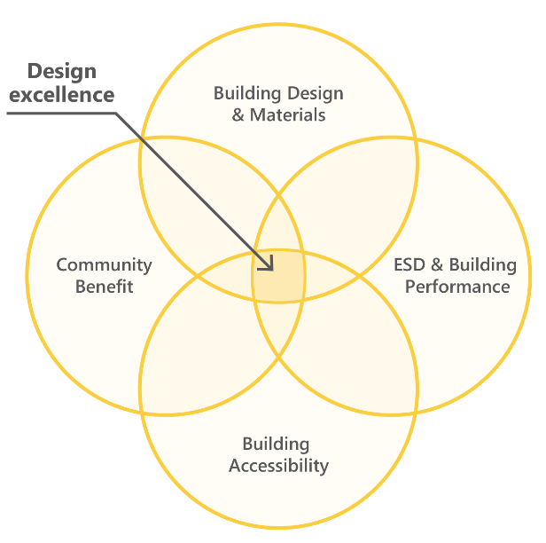
The Moreland Design Excellence Scorecard is a tool that establishes a benchmark and defines design
excellence in the City of Moreland.

It seeks to improve the design quality and liveability of medium and high-density residential development above the requirements of the Moreland Planning Scheme.

Participants in the voluntary scorecard process are provided with a range of benefits from Council, in exchange for significantly improved development outcomes for the community.

The scorecard focuses on the enhancement of four key areas: Building Design and Materials, Environmentally Sustainable Design and Building Performance, Building Accessibility and Community Benefit.

Where a proposal satisfies all four of these components, it is considered to achieve design excellence and is compliant with the requirements of the scorecard.

Why participate?
- Opportunity for additional pre-application meetings free of charge.
- The officer that you meet with at pre-application will manage the permit application.
- Support by senior officers and Planning Coordinators through the application process.
- Guaranteed decision by Council officers, not at a Council meeting, resulting in a potential time saving of 4 to 6 weeks.
- Meet with Council officers post-decision to facilitate endorsement of plans and reports.

How to qualify
- Arrange a pre-application meeting. This will increase the likelihood of qualifying for the Scorecard and save time during the application process.
- Ensure your application meets the objectives of the Moreland Planning Scheme and has in-principal support by Council officers.
- Submit a completed Scorecard (see reverse) along with all supporting documentation.
- Receive written confirmation from Council officers prior to public notice that the application meets the Scorecard.

What remains the same?
Scorecard applications are still subject to a standard permit application process, including public notice.

Public consultation meetings, which Councillors may attend, remain part of the process. Applications are subject to third party appeal rights and decisions may be reviewed at VCAT.

Moreland Trial Design Excellence Scorecard

Building Design and Materials
- Development must demonstrate design excellence in architectural form, facade design, materiality, building separation and articulation.
- Development must incorporate public-private interfaces which positively respond to the immediate context in a sensitive, attractive and engaging manner.
- This must be demonstrated through a detailed materials schedule and appropriately scaled elevations of all public-private interfaces.
- Commitment that the original architect or building designer will be retained from the planning permit process through to project completion.

ESD and Building Performance
The development must achieve a BESS score of 70% (with innovation points approved by Council).

The development must include at least three of the following:
- A rooftop with a mix of communal open space, landscaping and solar PV.
Alternatively, a rooftop with maximised solar PV may be provided.
- Gas-free dwellings (some gas fittings may be justified for non-residential uses).
- 7 star NatHERS average for medium-density dwellings and 7.5 star NatHERS average for high-density dwellings.
- Substantially exceed minimum requirements for Indoor Environmental Quality (IEQ).
- Other significant innovation not listed, as approved by Council.

Building Accessibility
The applicant must provide a report from a qualified assessor to demonstrate that 70% of dwellings meet ‘Silver Level’ liveable housing design guidelines.

Community Benefit
For developments of less than 10 dwellings:
- The applicant must provide increased canopy tree planting either on the site or within the road reserve beyond the requirements of the Residential Zone Schedule.
For developments of 10 or more dwellings, the applicant must provide one of the following, through a Section 173 Agreement or other secure provision:
- A contribution of affordable housing;
- Significant upgrade of existing community infrastructure or the delivery of new community infrastructure; or
- Substantially improved pedestrian environment through delivery of communal facilities, widened public footpaths, a landscaped park or plaza and pedestrian links that enhance connectivity and are open to the sky.
