Good Access is Good Business Guide

A guide for small business and retailers



(Cover photo)

This guide contains basic information to help you understand what Good Access is, why it is important and how you can make your business more accessible for people with disabilities.

For more detailed information on providing good access, please contact Moreland City Council’s MetroAccess Officer, ph: 9240 1111, or visit moreland.vic.gov.au/community-services/disability-services/good-access-good-business.html

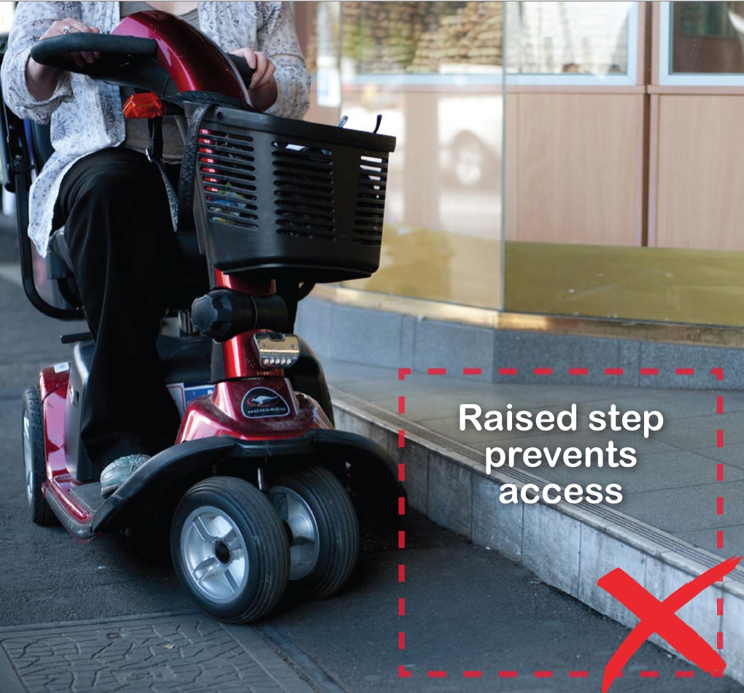

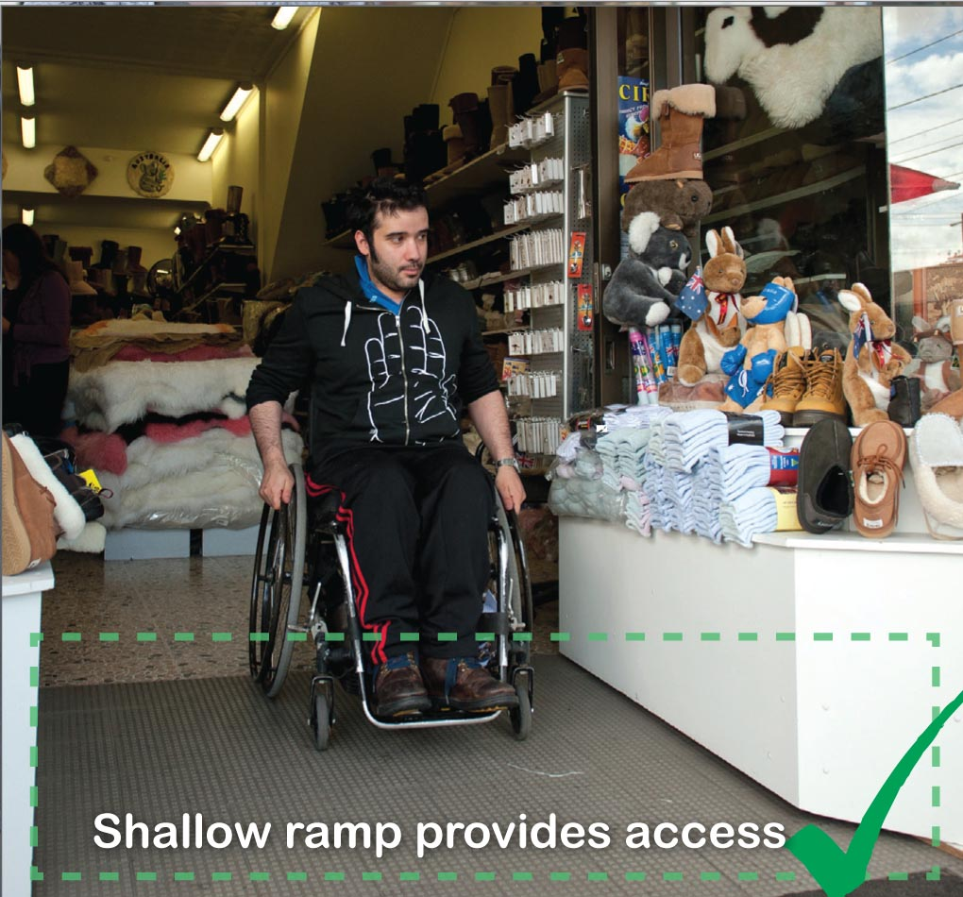

Contents
Good Access is Good Business Guide 1
A guide for small business and retailers 1
WHO Are We Talking About? 4
WHY is Good Access Important? 6
WHAT is Good Access? 7
HOW to provide Good Access through CUSTOMER SERVICE 8
How you can show respect and help to improve your customer service: 9
HOW to provide Good Physical Access – INSIDE 11
HOW to provide Good Physical Access - OUTSIDE 13
WHERE to next? 16
Universal Access Sticker 16
Accessible Communication Symbol 16
The RECHARGE Scheme™ 16
Acknowledgements 17

(Please note, if the font or font size is changed from Arial 12 point, these page numbers will no longer match the content headings)

WHO Are We Talking About?

Nearly 20% (1/5) of Australians have a disability. Over 22,000 of those people are residents of Moreland. There are 25,000 Moreland residents over the age of 65. These people, their families and friends choose places to shop and socialise based on how accessible those places are. These people could be your customers.
When we say ‘disability’ we are talking about people who:
- Are blind or have trouble seeing
- Are deaf or have trouble hearing
- Have trouble moving around and use
a wheelchair, electric scooter, walking frame, crutches, etc.
- Have trouble reaching and holding things
- Have trouble speaking
- Have trouble understanding
- Need to rest often due to illness or injury
Providing Good Access also helps:
- Older people
- Parents or carers with young children, prams or strollers
- People who are short statured
- People with heavy bags or shopping jeeps
- Delivery people
- Staff wellbeing and safety.

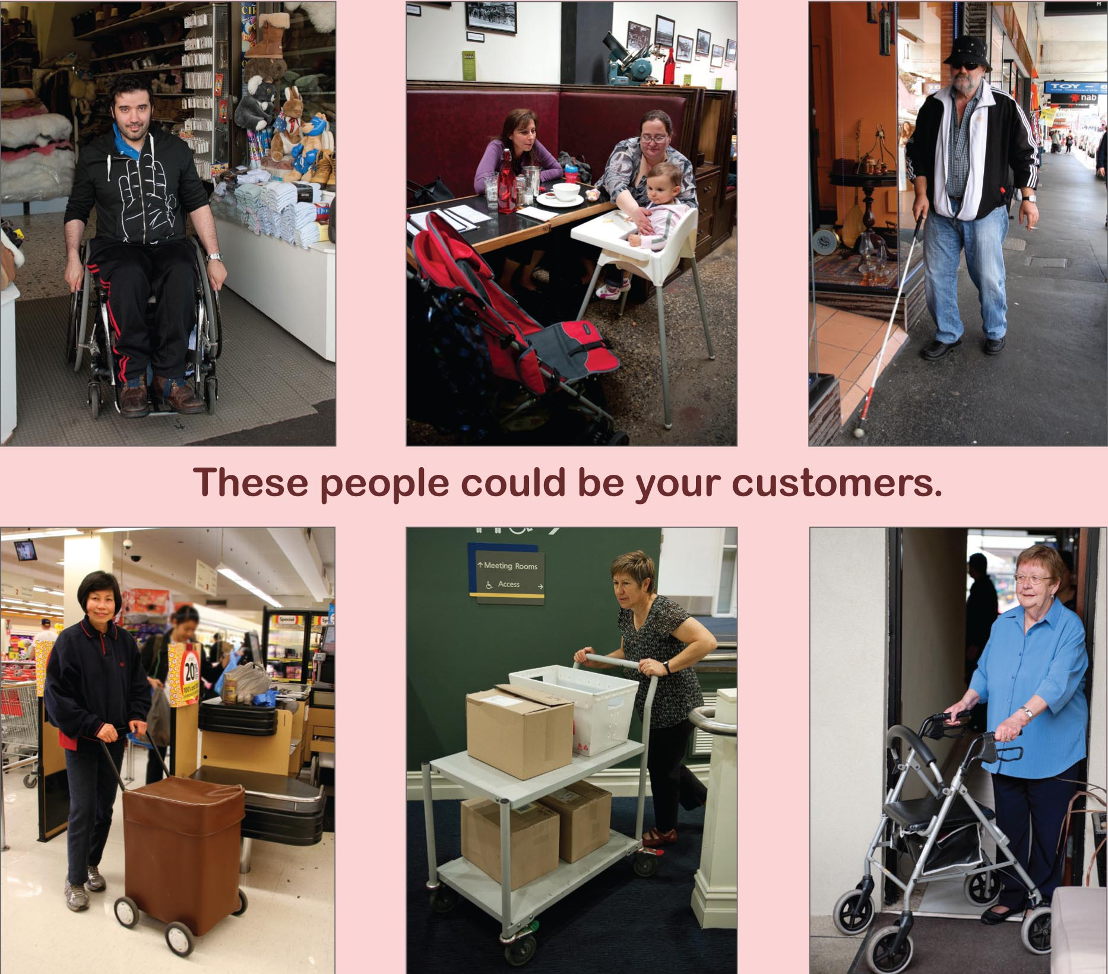

WHY is Good Access Important?
Providing good access makes your business available for people of all ages and abilities. Not only will it help you attract customers, you will be supporting people with disabilities, who often face barriers as part of their everyday lives.
Improving access to your business will also help you meet your legal responsibilities.
Australian law says that customers with disabilities should be able to access your goods or services just like any other customer. If a customer with a disability cannot do this they could make a complaint of discrimination under the Victorian Anti-Discrimination Act or Federal Disability Discrimination Act.
There are also Local Laws regarding the use of footpaths for trading. Keeping the footpath and entrance clear of obstacles will help you meet Council’s requirements.
Making your business more accessible also makes it safer for customers and staff.
This helps you meet your public liability and workplace safety responsibilities.

For more information:
Human Rights Commission
Phone: 1300 369 711 or visit their website: hreoc.gov.au
Victorian Equal Opportunity and Human Rights Commission
Phone: 1300 292 153 or visit humanrightscommission.vic.gov.au
Moreland’s Footpath Trading Policy
Phone: 9240 1111 or visit moreland.vic.gov.au

WHAT is Good Access?
Good Access means there are no physical or social barriers that prevent customers from finding your business, moving around easily and receiving good service.

Good Access allows everyone to:
Find your business
Move around safely outside and inside
Find and pay for goods and services
Get assistance if required
Feel welcome.
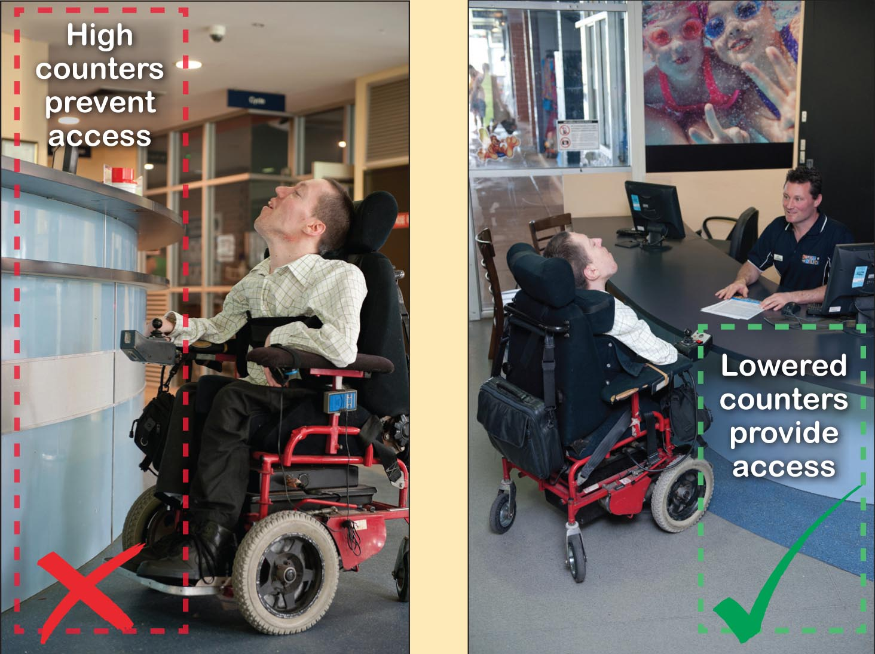

HOW to provide Good Access through CUSTOMER SERVICE

One of the greatest obstacles people with a disability face is negative attitude of others. A good customer service experience can be rewarded with word of mouth business and customer loyalty. But a bad experience can mean no future business from that person, their family, friends or carers.

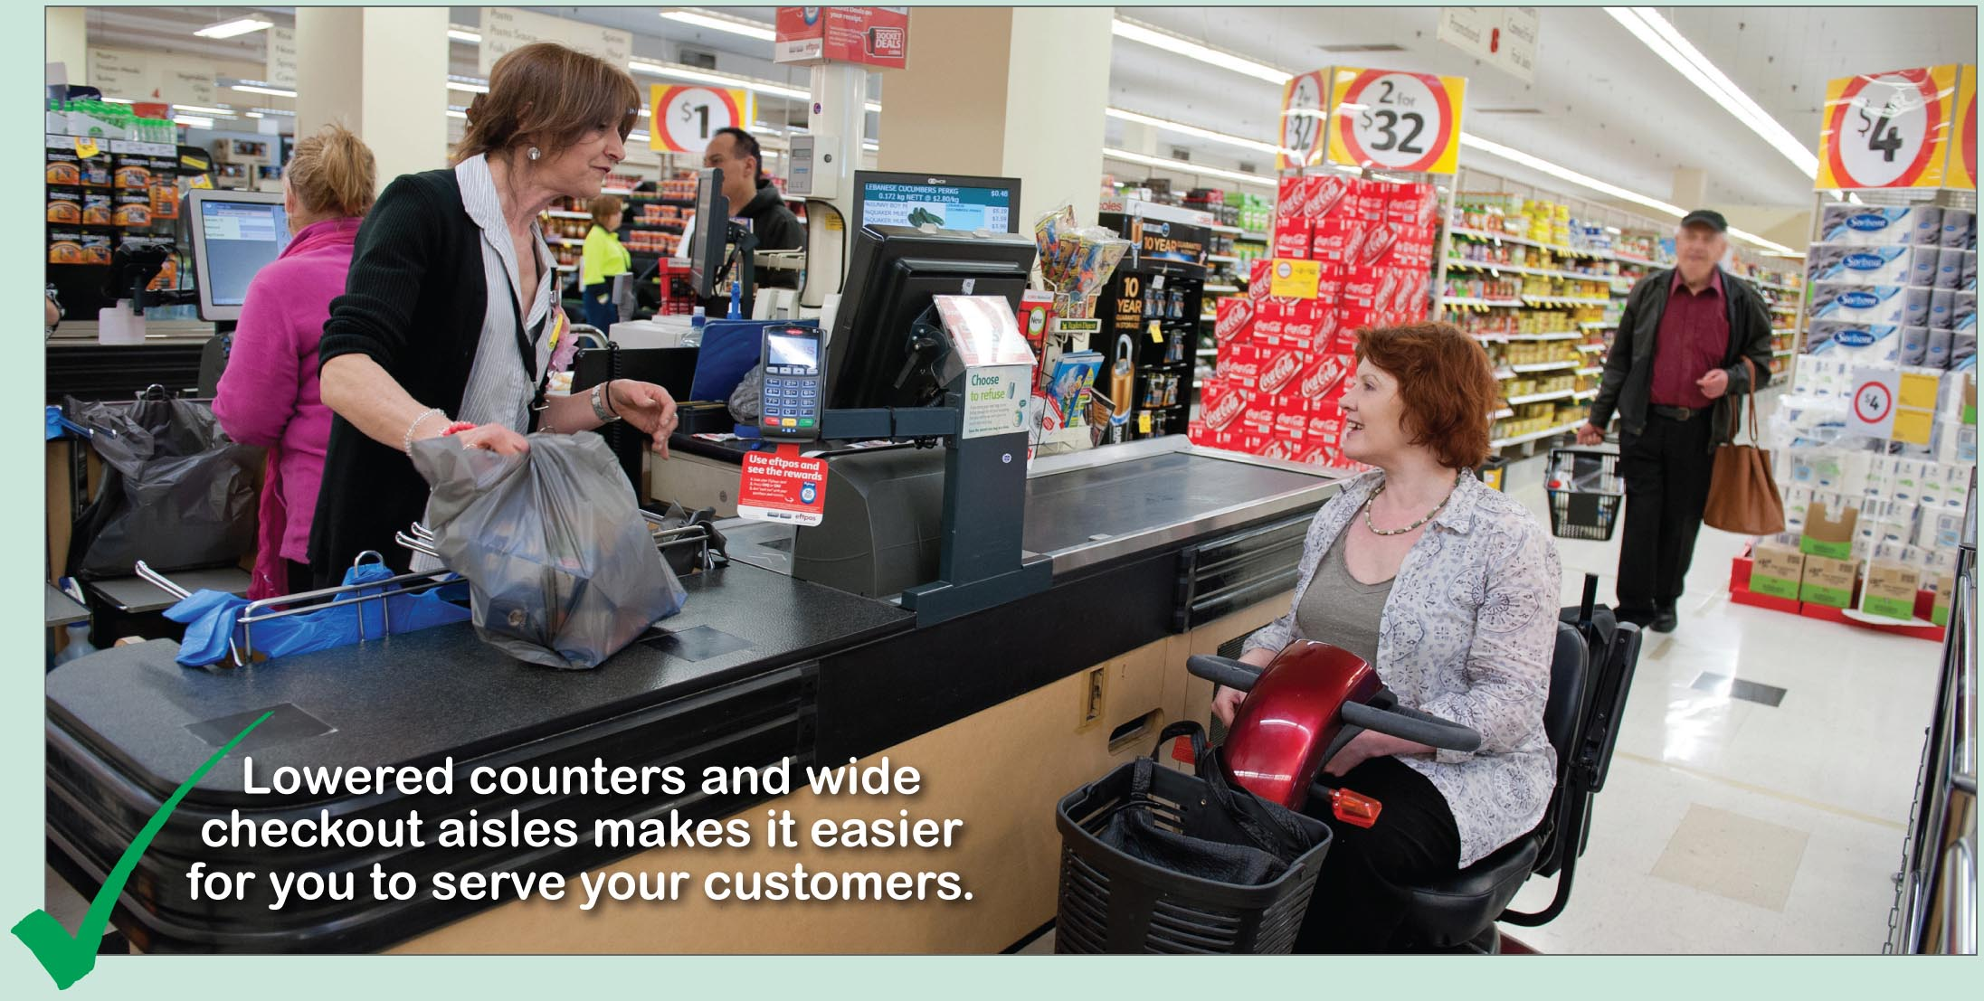

How you can show respect and help to improve your customer service:
- Speak directly to the person with the disability, not to their interpreter or support worker.
- Ask how your customer would like goods or services to be provided, if required.
- Speak clearly, listen carefully and check for understanding.
- Give your customer time to respond to your questions or offers of service.
- Provide a pen and paper for alternative method of communication.
- If your customer is deaf, face them so they can lip read. Speak normally, do not shout.
- If your customer is blind, identify yourself and ask for their name so they know when you are talking to them.
- If your customer asks for assistance to move somewhere, offer your arm so that they can hold it just above your elbow.
- Never pat or distract a guide dog when it is working. It is illegal to deny entry to a guide dog.

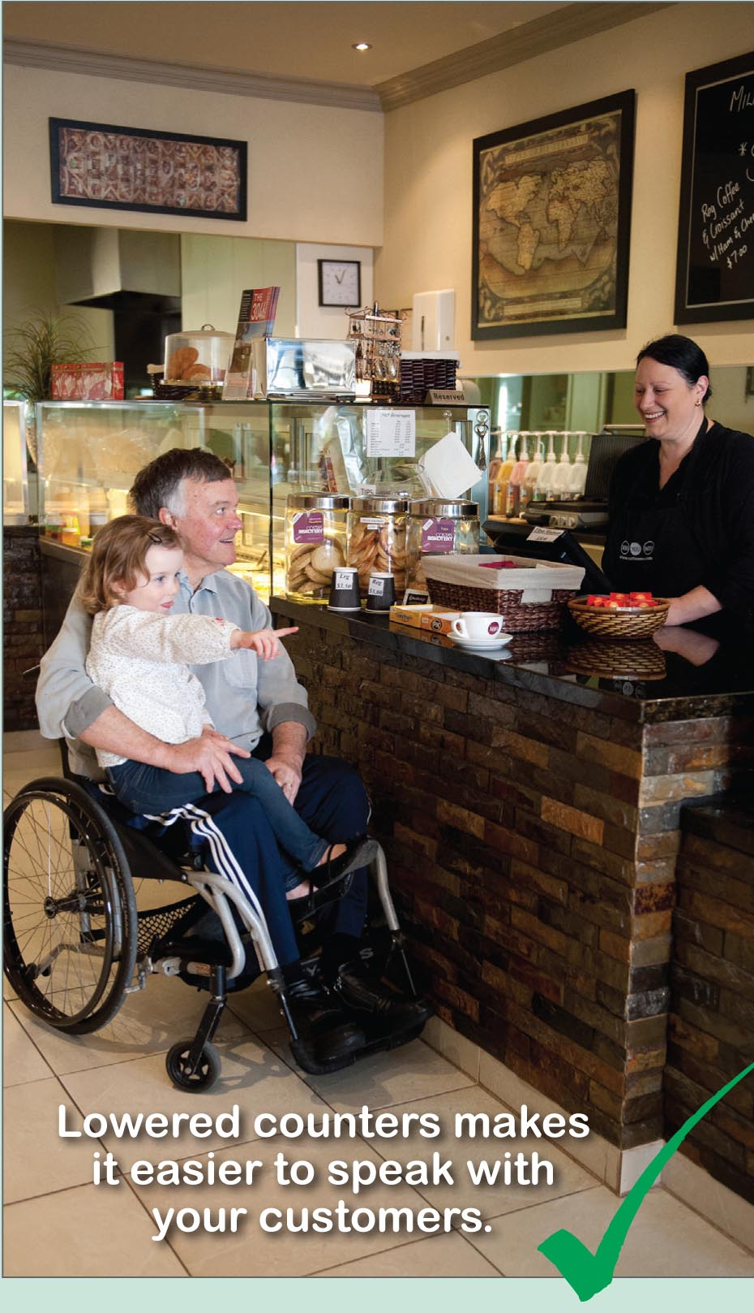
HOW to provide Good Physical Access – INSIDE
Everyone should be able to move around your business, find products or access services, browse, reach goods and pay for them.
They should also be able to get assistance easily if required.
Inside Check list:
- Clear doorways with no trip hazards
- Hand rails if there is a ramp or stairs
- Clear sight line from entrance to service counter
- Seat provided for people to rest
- Good lighting in all areas
- Aisles 1.2m wide, with no protruding or overhanging obstacles
- Passages are clear, dry and slip resistant.
- Signs and menu boards are well positioned.
- Information is in large, clear writing with good contrast
- Low height counter areas, 750 - 800m high.
- Shops with checkout aisles have at least one aisle 1.2m wide.
- EFTPOS unit is user friendly and has long cord
- Hearing Loop for service counters
- Background noise kept to a minimum
- Music kept low, and easily turned off if required
- Accessible toilet provided, or directions to nearest accessible toilet. Toilet map www.toiletmap.gov.au

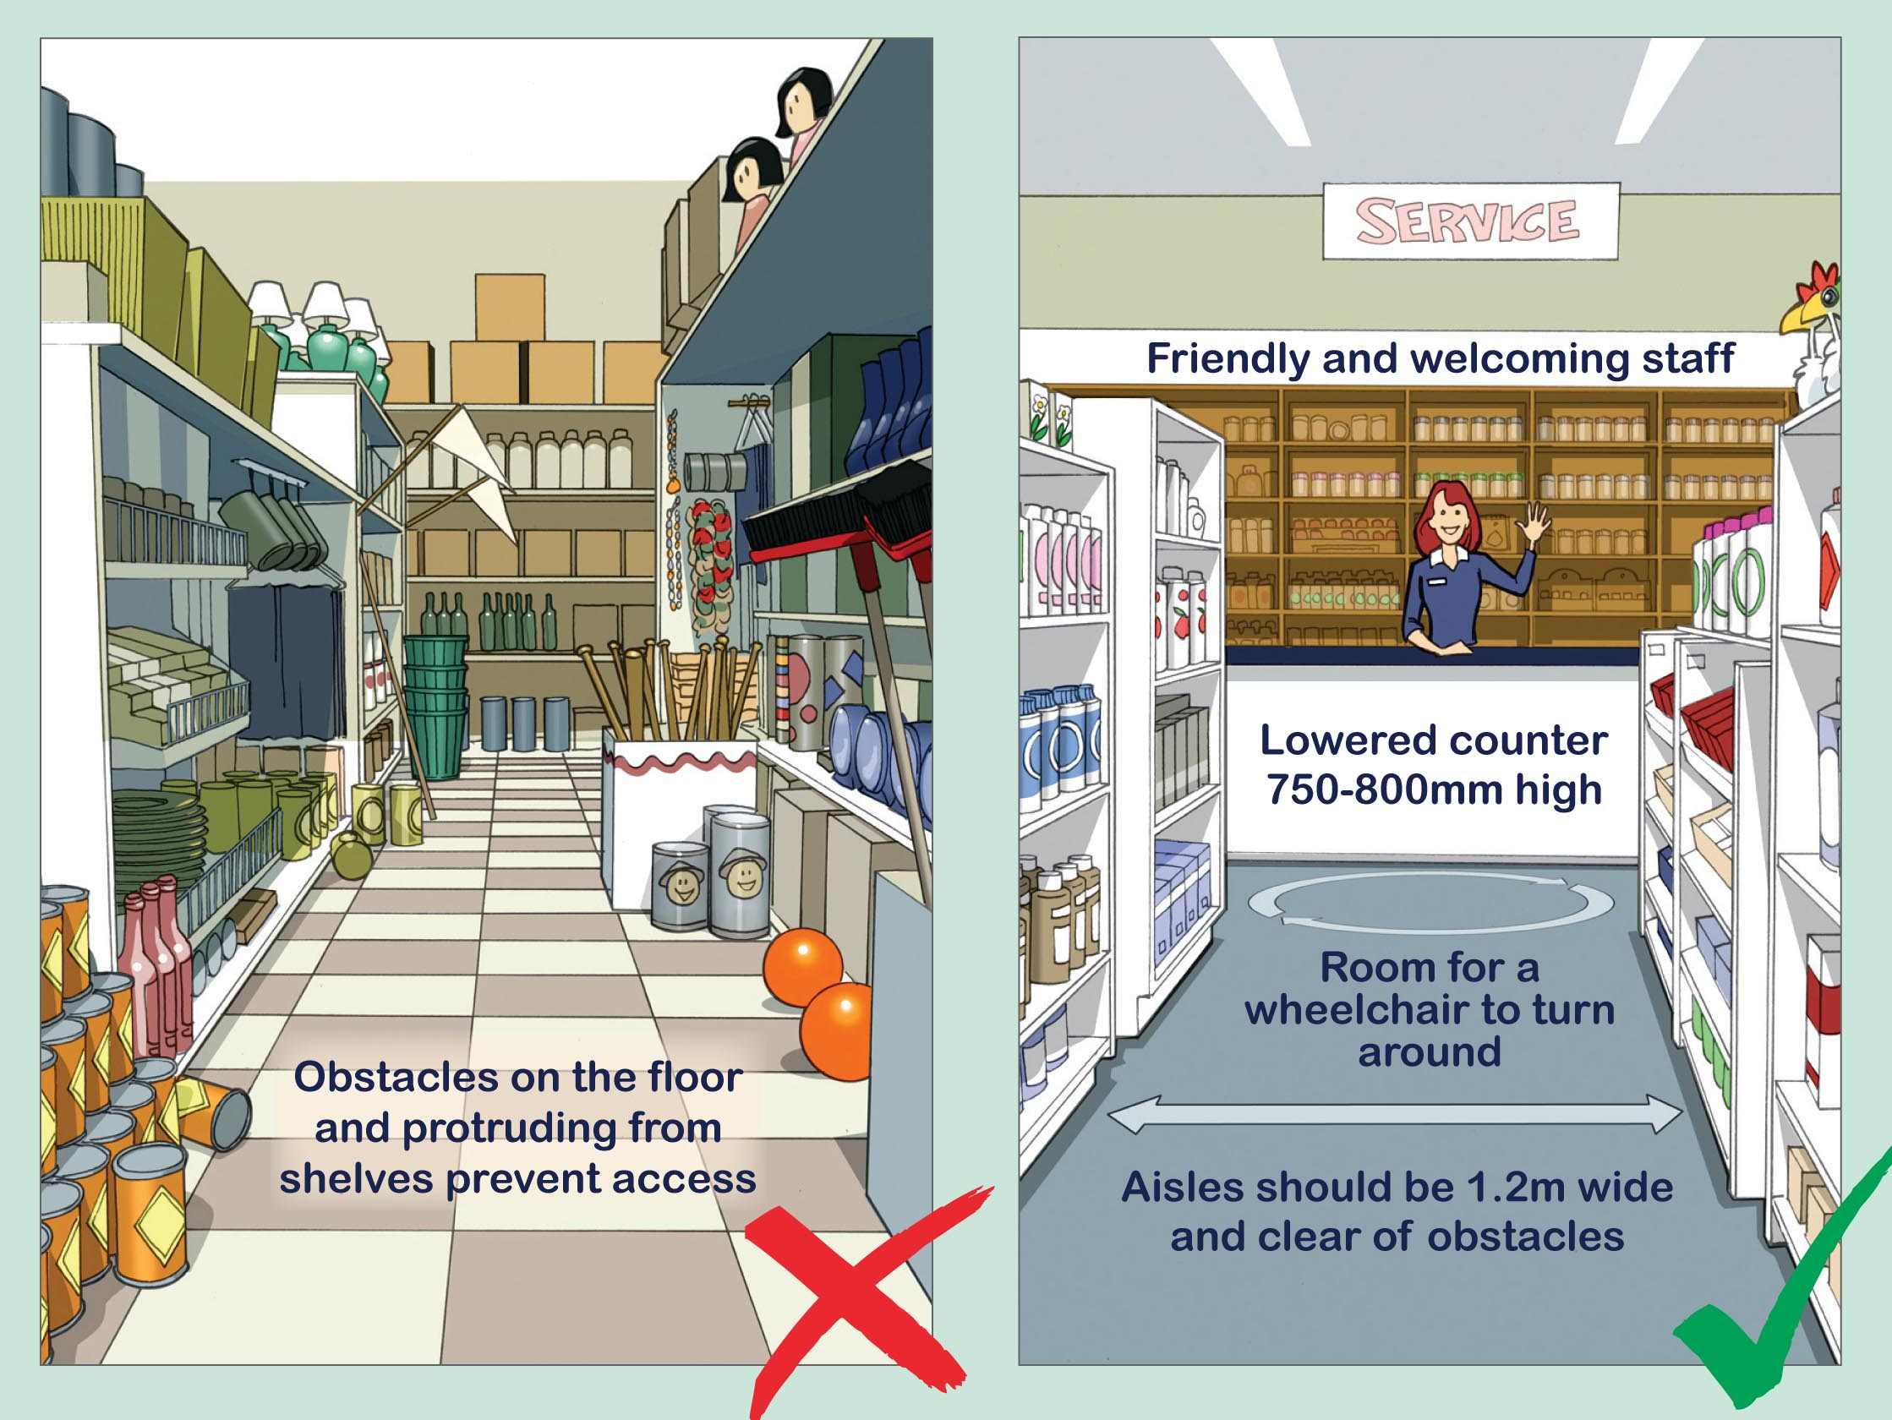
HOW to provide Good Physical Access - OUTSIDE
Everyone should be able to find your business and gain entry. All people should be able to move past your business along a clear path of travel. Which means there should be nothing blocking their way.

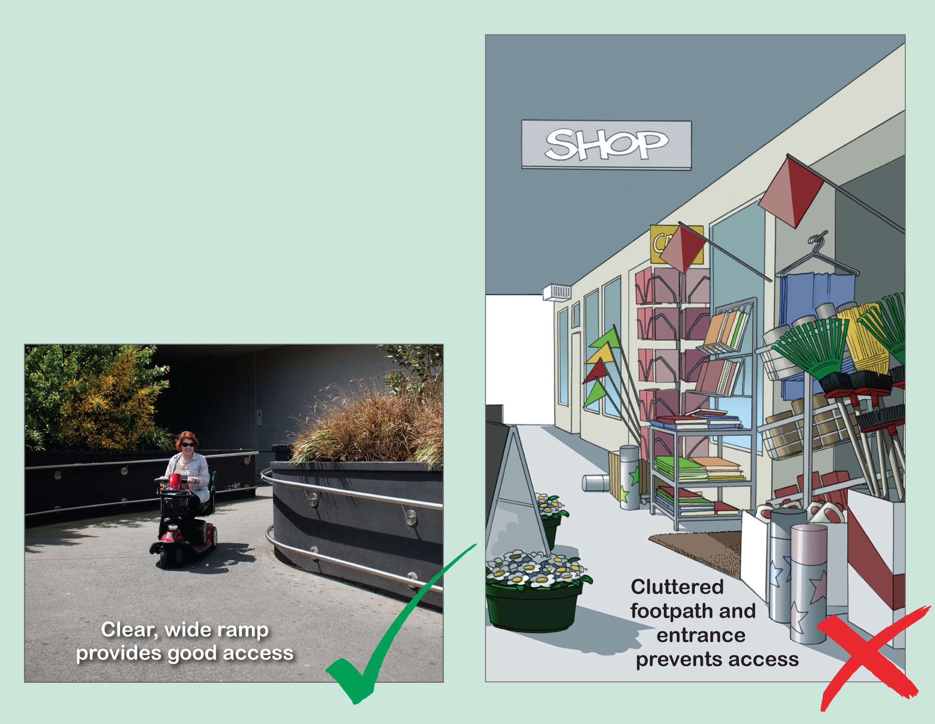
Outside Check list:

- Signage is clear, well positioned and well lit
- Signage has large font and good contrast
- Footpath is clean and clear of obstacles,
- Pedestrian Zone is 1.5m-1.8m wide.
- Entrances are wide and can be easily seen
- Glass window and doors have safety markings
- Doorways should be 800mm-850mm wide
- Doors are easy to open: automatic or light weight and have low set
D-shaped or flat handles)
- Doorways are clear of obstacles
- Level or Ramped entrance instead of stairs
Note: Ramps must meet Australian Standards.

Please speak to Council to discuss:
- a ramped entrance to your business
- wider car spaces for people with disabilities
- wider or safer pathways outside your business
- better lighting of pathways or car-parks
- obtaining a footway permit.
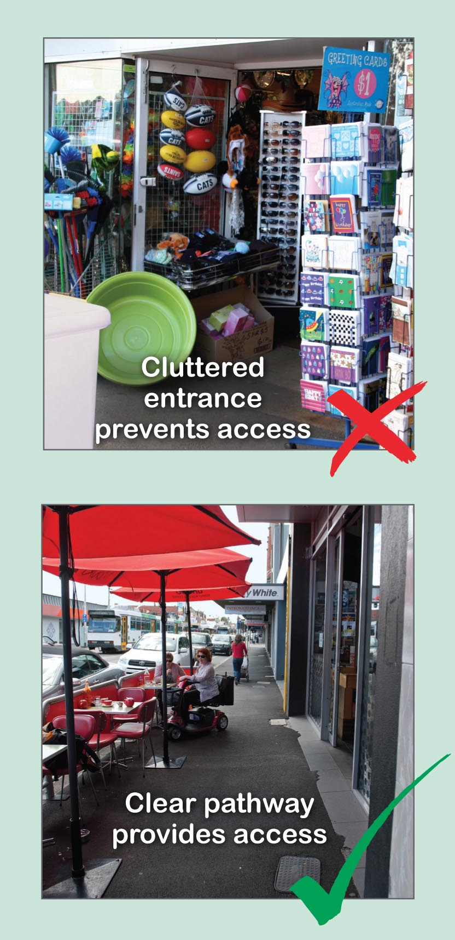

WHERE to next?

Universal Access Sticker
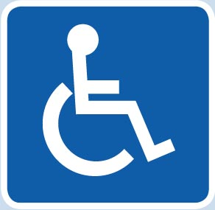
If your business has good access you should let people know through your advertising and promotions. To find out if your business is eligible for a Universal Access Sticker please contact the Council’s MetroAccess Officer ph: 9240 1111

Accessible Communication Symbol
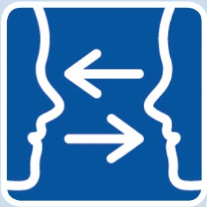
If your business has accessible communication options, then you should promote this with the Accessible Communication Symbol on your advertising and promotions.
Please contact the Council’s MetroAccess Officer ph: 9240 1111.

The RECHARGE Scheme™
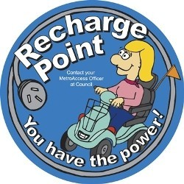
Local businesses provide a power point specifically for people to recharge the battery of their electric wheelchair or scooter, if needed. RECHARGE stickers are displayed at the entrance and also next to the allocated RECHARGE power point for use by people to recharge their electric wheelchairs or scooters.
It costs less than 30 cents to charge an electric scooter or wheelchair for one hour. For a very small cost, your business could make a very big difference in the lives of people who use an electric scooter or wheelchair.
The Scheme was first developed in the Shire of Nillumbik, and there are thousands of participating businesses in Victoria. To become a RECHARGE Scheme™ partner contact the Council’s MetroAccess Officer ph: 9240 1111.

Acknowledgements
This guide has been developed by Moreland City Council’s MetroAccess initiative. MetroAccess is a partnership between local government and the Department of
Human Services Victoria.
Some of the content in this booklet is based on material developed by Marrickville Council and the Human Rights Commission.
Moreland City Council would like to thank the Moreland Disability Advisory Committee for its contribution to this publication. Special thanks go to the local businesses and community members who kindly volunteered to be models for the photographs used
in this publication.

If you have any questions or require further information, please contact Moreland City Council’s MetroAccess Officer on 9240 1111

For information about this guide in languages other than English, please call the Community Development and Social Policy Unit on 9240 1111.

